Ions logic puzzle

Learning objectives
- Recognise descriptions of ions based on charge and group number.
- Draw electron configuration diagrams for ions.

Introduction

A teacher set a homework task to draw electron configurations for different ions. Six of the students who handed in their homework sheets forgot to add their names. The students can’t remember which ion they drew but they can remember some of the characteristics of those ions. The teacher has labelled each of the anonymous homework sheets with a letter A–F.

Instructions

Use the clues to solve the logic puzzle to find out which student submitted which card for their homework.

You should not need a periodic table to help you to solve most of the logic puzzle. You should use your knowledge of group numbers and ion charges.

Solution
 | Amira | Ben | Cordelia | Daniel | Emmett | Florian
Ion
Charge
Group

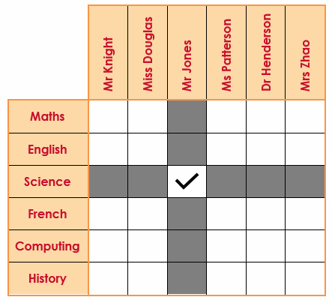
How to solve a logic puzzle

The logic puzzle is solved by following a list of clues and recording the true and false statements in a grid. Each item is matched to one other item in each category. Work through the clues one at a time. Use a tick to record the true statements and a cross or a shaded square to record the false statements. Here is an example:

Clue: Mr Jones is a teacher of science.

Logic puzzle (challenge)
 | [Li]⁺ | [Be]²⁺ | [Sr]²⁺ | [F]⁻ | [S]²⁻ | [At]⁻ | Amira | Ben | Cordelia | Daniel | Emmett | Florian
Sheet A
Sheet B
Sheet C
Sheet D
Sheet E
Sheet F
Amira
Ben
Cordelia
Daniel
Emmett
Florian

Clues
- Neither homework sheet A nor homework sheet E are negative ions.
- The homework sheet with an alkali metal was given to Florian.
- Emmett, who had either homework sheet C or homework sheet F, had drawn a non-metal.
- The ion on homework sheet D is in group 7 and was given to Amira.
- Ben was given a non-metal that was not homework sheet A or homework sheet F.
- Homework sheet E was given to Cordelia.
- Homework sheet A has a lower charge than the ion completed by Daniel or Cordelia.
- Homework sheet C has a positive charge and was given to Daniel.
- Homework sheet F is in group 6.
- The ion on homework sheet C has a smaller atomic mass than the ion on homework sheet E.
- The ion on homework sheet D is the lightest of the halogens.

Follow up task

Using the solution to the logic puzzle, complete the six anonymous homework cards. Draw the electron configuration for each ion. Remember the symbol and the charge.
A Student name: ________________  Name of ion:  Symbol of ion:  Charge of ion:  Periodic table group: | B Student name: ________________  Name of ion:  Symbol of ion:  Charge of ion:  Periodic table group:
C Student name: ________________  Name of ion:  Symbol of ion:  Charge of ion:  Periodic table group: | D Student name: ________________  Name of ion:  Symbol of ion:  Charge of ion:  Periodic table group:
E Student name: ________________  Name of ion:  Symbol of ion:  Charge of ion:  Periodic table group: | F Student name: ________________  Name of ion:  Symbol of ion:  Charge of ion:  Periodic table group:

Logic puzzle (support)
 | [Li]⁺ | [Be]²⁺ | [Sr]²⁺ | [F]⁻ | [S]²⁻ | [At]⁻
Amira
Ben
Cordelia
Daniel
Emmett
Florian

Clues
- Daniel drew a positive ion.
- Florian’s ion is in group 1.
- Ben’s ion had the opposite charge to Florian’s.
- Neither Emmett nor Amira drew a 2+ ion.
- Emmett’s ion is in group 6 and has twice the charge of Ben’s ion.
- Ben’s ion is not in the same group as Cordelia’s ion.
- Amira’s ion is the smallest of the halogens.
- Daniel’s ion has a smaller atomic mass than Cordelia’s.

