Phytomining: storyboard

Learning objectives
- Sequence the processes involved in phytomining using a story board.
- Use keys words to describe the processes involved in phytomining.
- Recall advantages and disadvantages of phytomining.

Introduction

In today’s technological society, there is an increasing need for valuable metals to use in computers and mobile phones. When the concentration of metal ore is too low for conventional mining, then phytomining, using plants, can be used to extract the metals. This storyboard worksheet will enable you to identify the different stages in the process of phytomining, and describe what is happening using key words.

Instructions

Create a storyboard to describe the processes involved in phytomining. A storyboard contains an illustration and a short section of text underneath to describe what is happening in the picture. The storyboard shows a sequence of events.

Key words
☐ absorb ☐ advantage ☐ ash
☐ burnt ☐ concentrated ☐ disadvantage
☐ displacement ☐ economic ☐ electrolysis
☐ impure ☐ roots ☐ slow
☐ toxic ☐ hyperaccumulators

What does a storyboard look like?

Use the table to show how the stages progress in the following order:
1 | 2 | 3 | 4
5 | 6 | 7 | 8

Complete the storyboard. Use the keywords from the instruction sheet if you need additional support.
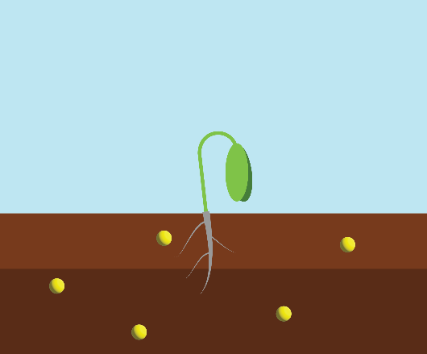 | 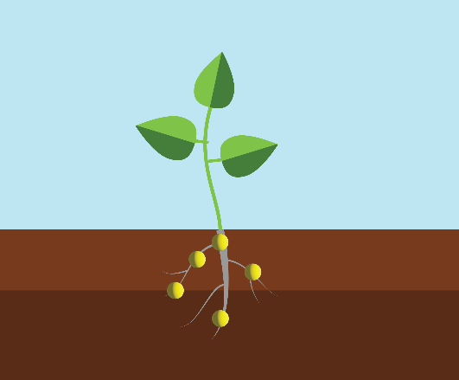 | 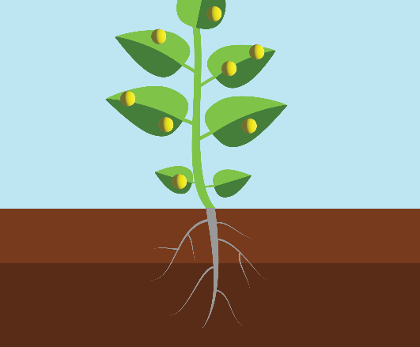 | 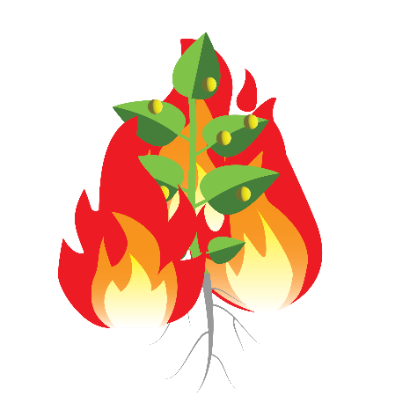
Plants called ___________________ are grown in contaminated soil, where small amounts of minerals (____________________) are found. | Plants __________________ the minerals (low grade ore) via their ____________. The minerals are not ______________ to the plant. | The plants use the minerals to grow. Excess minerals are stored and _____________________ in their leaves. | When the plants are big enough, they are _____________ in air to form __________.
 | 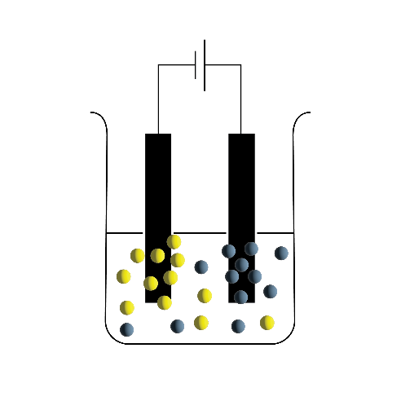
The _______________ metal compound is found in the __________. | Chemical processes such as ____________________ and ____________________ are used to then purify the metal from the ash. | One ____________ of phytomining compared to traditional mining is it can extract valuable metals from low grade ores when it is not usually ________________ to do so. | One _____________________ of phytomining compared to traditional mining is it is a ____________ process as you need to wait for the plants to grow.

Complete the storyboard. Use the keywords from the instruction sheet if you need additional support.

Complete the storyboard. Try to use all the keywords. You must include one advantage and one disadvantage of phytomining.

Plants called hyperaccumulators are grown in contaminated soil, where small amounts of minerals (low grade ores) are found.

Complete the storyboard. Try to use all the keywords. You must include one advantage and one disadvantage of phytomining.

Support

Use these images to complete the storyboard. You will need to put them into the correct order in the sequence.

