The treatment of oil spills – student sheet
In this experiment you will be looking at an unusual and interesting way of chemically treating a microsize oil spill.
Students must wear eye-protection. Avoid inhaling fumes from paraffin.

Procedure

- Half-fill a 100 cm3 beaker with water.
- Using your pipette, add some oil or paraffin to the beaker to give a thin layer on top of the water.
- Cut off the end of a pipette to form a scoop as shown below.
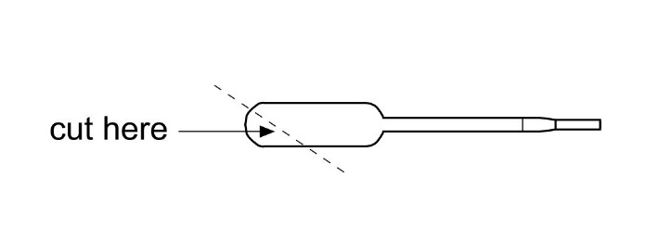
- Add two scoops of polymer powder to the beaker and stir with the end of the pipette.

Student questions

- What do you observe?
- How do you explain your observations?
- If you were to do this experiment on a large scale to try to deal with an oil slick at sea, what would be the advantages of using this polymer powder and what difficulties might you encounter?

Health, safety and technical notes

- Read our standard health and safety guidance here https://rsc.li/3LNbkfo
- Students must wear suitable eye protection (splash proof goggles to BS EN166 3)
- Avoid inhaling fumes.
- Paraffin is FLAMMABLE, ensure no naked flames or other sources of ignition (see CLEAPSS Hazcard HC045b).

