The leaky bottle

The leaky bottle demonstration: A demonstration video can be viewed at rsc.li/3yUFHJd
The investigation allows learners to explore air pressure for themselves along with viewing the leaky bottle demonstration.

Age group: 7–9

Learning objectives
- To develop a simple definition of pressure in terms of force.
- To develop an awareness that the air around us exerts pressure on the objects it comes into contact with.
- To appreciate, through practical experimentation, that although air pressure is not often felt, its actions can be seen and explained.

Background science
Learners may think of the term pressure as being a sort of stress. They need to be encouraged to find examples of its use in science, related to forces. From the moment we are born, we all experience air pressure – the push of air on surface areas. However, because we are so used to it, it goes unnoticed until the pressure acting upon us changes for some reason. When in an aircraft, for instance, we can detect changes in the air pressure around us. We tend to want our ears to ‘pop’ in order for the pressure of the air, which is naturally trapped in our inner ear, to equalise with the reducing air pressure during climbing. When on a trip to the swimming pool, many learners will enjoy sitting on the bottom of the pool. When doing so, pressure, in this case caused by the water, is felt against the body in a more obvious way than when out of the pool in the air pressure we’re used to.
Learners may have heard of a ‘pressure washer’ – a hosepipe that spurts water with greater force than a garden hose. This uses an electric pump to force the water to flow more quickly.

Prior learning
Learners should already know that force is a push or a pull and that area is the space occupied by a flat shape or an object’s surface.

Links
The concept of air pressure is also explored in Sticky cups and Anti-gravity bottle.

Key words and definitions
Air – a mixture of gases that surround us and which we breathe. It is not ‘nothing’ as some learners may describe it, but is a gas made up of physical matter. It consists of approximately 78% nitrogen; 20% oxygen; less than 1% argon; less than 1% carbon dioxide and other gases and the rest is water vapour.
Force – a push, pull, or combination of both which occurs whenever objects (solids, liquids or gases) come into contact with each other. A force can cause an object to speed up, slow down or change direction.
Pressure – a measure of a force over a specific area. A force on a large area creates less pressure than the same force on a much smaller area. So, air pressure is the amount of force exerted by the air on a given area.
Gravity – the force which pulls all objects downwards towards the centre of Earth.
Teachers may wish to hide the meanings/examples on the PowerPoint slide and discuss the learners’ ideas first.

Equipment list
Leaky bottle demonstration (or per group if desired):
- Plastic water bottle with screw-top lid
- Map / push pin
- Plastic tray to catch excess water
- Water to fill bottle
Main investigation (each group will need):
- 30 cm ruler
- Two identical sheets of newspaper
- Clear table top with a straight edge
Pound or discount stores often stock cat litter trays which are excellent as they tend to have high sides and can be used over and over again in class.
You may wish to distribute safety goggles for the pupils. However, the risks are very low. The investigation can be carried out quite safely with supervision.

Method
Ask the learners if they have ever heard anyone say that they are ‘under pressure’. Let them pair and share to discuss what it may mean. Slides 5–7 in the PowerPoint can help with these discussions. As the pairs report back, you can record ideas on the board.
Explain that today, when we are talking about ‘pressure’, we’ll be referring to its scientific meaning. Explain that pressure is a measure of an amount of force pushing on an area. If necessary, discuss what is meant by a force. Use sitting on the bottom of the swimming pool as an example of where you may experience a different pressure – in this case pressure due to the force of the water.
Demonstrate the leaky bottle as in the video or allow students to try it in groups.

Main Investigation
- Place a 30 cm ruler at the edge of the table. Ensure that 10 cm is hanging over the edge.
- Scrunch up a sheet of newspaper into a ball and place on the ruler portion resting on the desk.
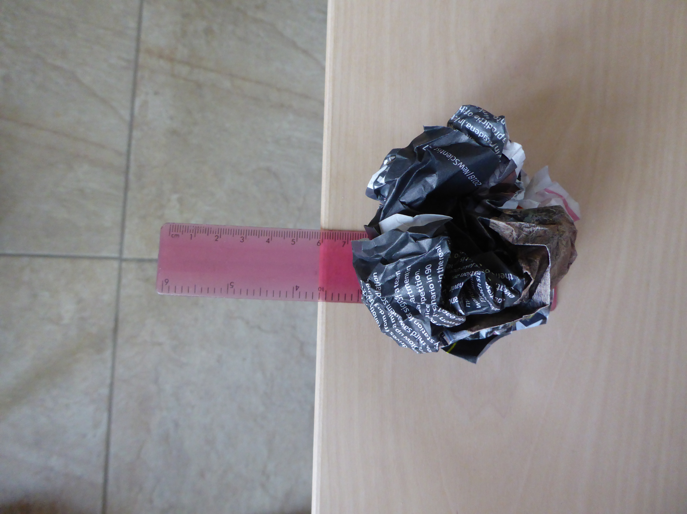
- Firmly strike the overhanging ruler downwards with the edge of the palm.
- Place the ruler on the table again (as point 1).
- Spread a sheet of newspaper over the part of the ruler resting on the table. Make sure that the ruler has a roughly equal amount of paper on either side of it.
- Smooth the paper down on to the table, especially around the ruler.
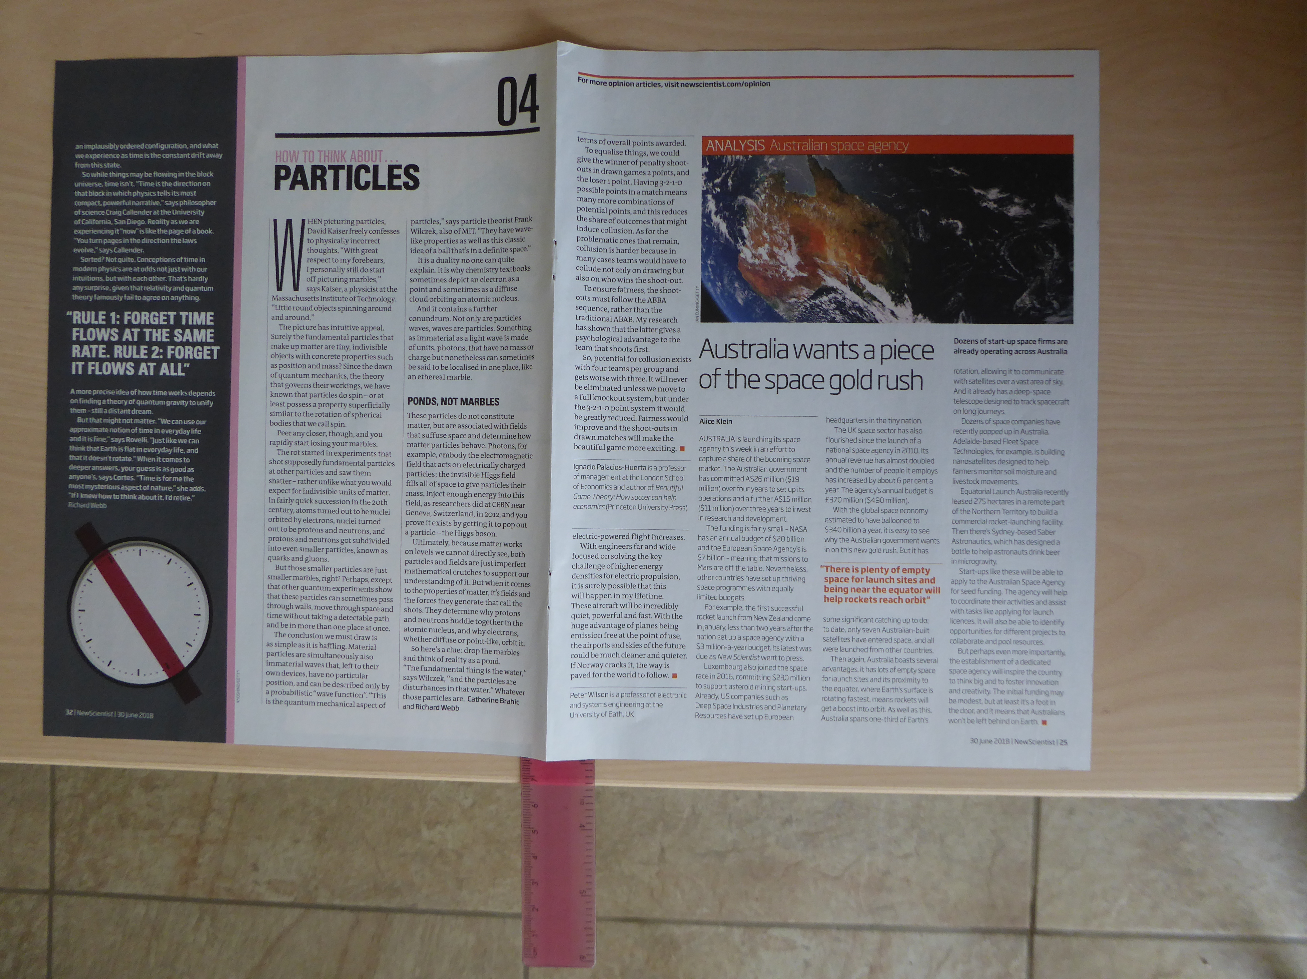
- Firmly strike the protruding end downwards and observe what happens this time.
Whilst the ball of paper is catapulted forward (be prepared for some class ‘mayhem’) the ruler under the flattened sheet will hardly move.
Draw out that the same amount and type of paper is used, the ruler protrudes the same distance and the force applied should be roughly the same. The only thing that changes is the amount of air pressing against the paper. In the case of the smoothed-out paper, the air pressure is exerted over the entirety of its large surface area. The scrunched ball, however, has much less air pressure acting upon it due to its reduced surface area.
Supplementary
The learners may never forgive you if they don’t get to try the ‘leaky bottle’. It can be tricky to set up. An easier way is to fill and seal the plastic bottle, then use the push pin to make some holes. No water should leak as it is held in place by external air pressure. Unless, that is, the lid is loosened to allow the air pressure entering the bottle neck to force the water out.

Question prompts
Main investigation
- What’s the only thing that’s being changed in this activity?
The only thing that has changed is the paper. The first time it was scrunched into a ball and the second time it was laid flat. The paper being changed is called a variable.
- Why is it important to only make one change?
It is important to change only one thing as then we can compare the results effectively.
- Can you see what is holding the large sheet of paper to the desk? If you can’t, what’s the only thing that it can be? What’s above the paper?
You can’t see anything above the paper, but you know that air is all around us so you must assume that there is air above the paper.
- What words could we use to name the forces that pull the paper down?
Force, pressure and gravity: see above for definitions.
- Why does the same amount of paper flick into the air when it’s been scrunched up?
The most important reason is that crumpling decreases the surface area of the paper, which decreases the air resistance.

Leaky bottle
- What stops the water leaking out?
Air outside the bottle creating pressure against it.
- Why does loosening the lid make a difference?
Air can enter the bottle and increase the pressure inside it to overcome the pressure from the outside.

FAQs
- Why do I need to smooth out the paper?
Smoothing out the paper means that the maximum area of desk is covered, giving a greater area for the column of air pressure to act upon. It also means that there is less air under the paper which could push in the opposite direction.
- I can’t see the air, so how does it ‘press’?
Air is a mixture of gases. Although the particles that make up a gas are quite far apart, they are still there. They move around and bump into each other and surfaces and will exert a pressure against any other object.
- Why do I have to use newspaper? Won’t it work for anything else?
You could test this! It’s not the type of paper that’s important but the area it covers. Too little paper means that there is a smaller area for the air to exert pressure upon, so it won’t be able to hold the paper in place when the ruler is flicked.

Images © Royal Society of Chemistry.

