Could you design better smartphones?
Education in Chemistry
September 2018
rsc.li/2vVc3Vi
Adam Boxer

Chemists are at the cutting edge of product design and manufacture. Read the article Super-slimmed smartphones (rsc.li/2vVc3Vi) about how some chemists are developing a new type of battery that could also serve as a phone screen, then answer the questions below using the article and your own knowledge.
- Explain in terms phone design why having a two-in-one battery and screen is an advantage.

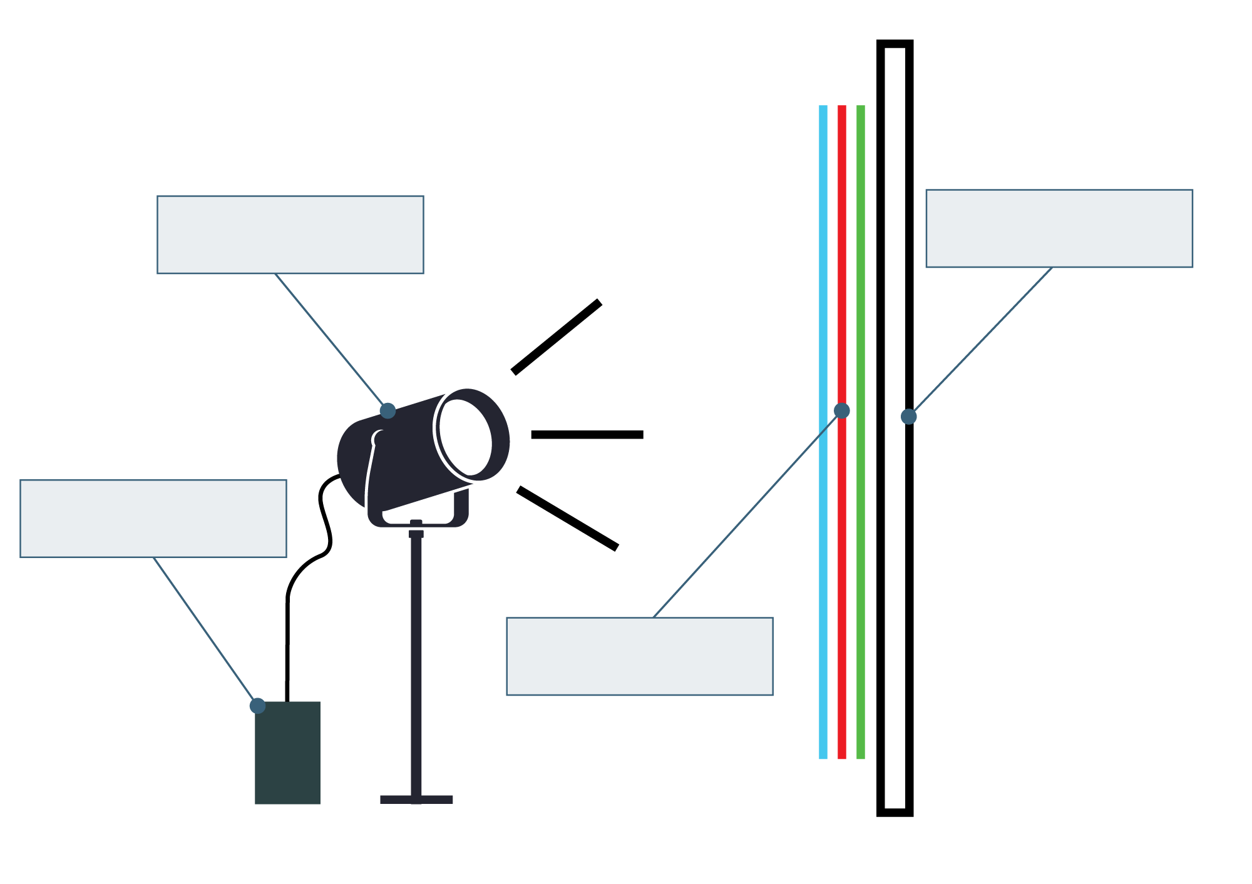
- Below is a schematic diagram of a conventional (normal) phone screen. Use the article to write labels to the diagram.
- Phone screens need to be tough, transparent, unreactive and conductors of electricity.
Answer these questions about the properties of solid potassium chloride.

- Is potassium chloride tough or brittle?

- Is potassium chloride transparent?

- What might happen if potassium chloride is put into water?

- Does solid potassium chloride conduct electricity?

Do you think potassium chloride would be an appropriate material to use for phone screens? Explain your answer.

- Some scientists have tried to attach a layer of graphene to a transparent material. By discussing the structure of graphene, explain why you think they have done this.

- The screen-battery anode and cathode have a ‘hair comb’ shape:

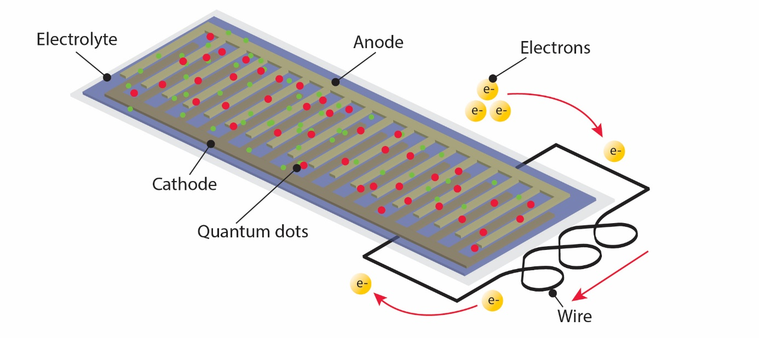

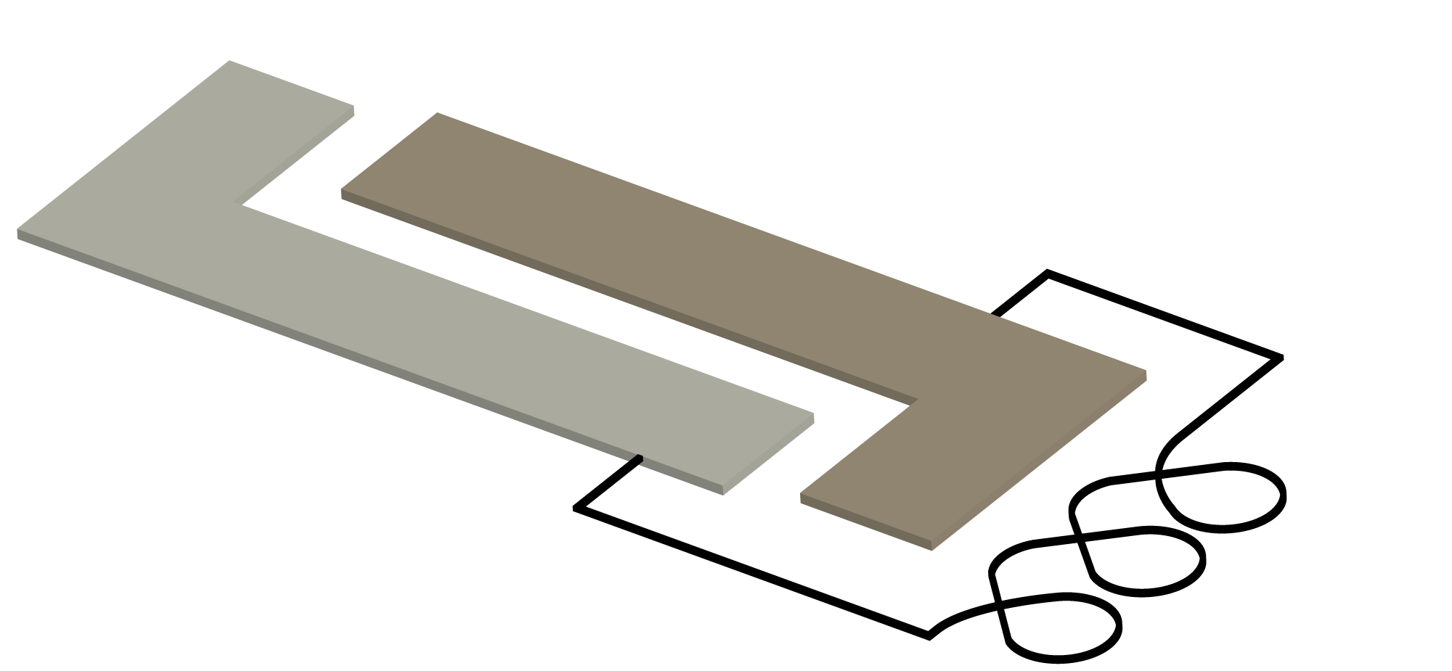
Suggest why the scientists chose a ‘hair comb’ shape instead of the shape shown below for the anode and cathode.

- Explain why a chemical cell with one electrode made of magnesium and another made of copper will produce a larger potential difference than a cell where one electrode is zinc and the other is copper.

- Read the section of the article Super-slimmed smartphones under the subheading ‘A touch of quantum glow’.
List the properties and components the new screen-battery has that are different to conventional batteries.

- Read the last paragraph of the article Super-slimmed smartphones. Environment-poisoning is where harmful chemicals in everyday products end up in the ecosystem. Explain why this should be considered as part of a device’s design and life cycle assessment.

