Chromatography challenge

This resource accompanies the article How to teach chromatography at post-16 in Education in Chemistry which you can view at rsc.li/436trpQ and gives you common misconceptions, tips and ideas for teaching the topic.

Learning objectives
- Plan a chromatography investigation to separate coloured components in a variety of samples, such as sweets.
- Identify whether each sample contains more than one component.
- Compare and contrast the components from each sample using R_{f} values.
- Understand how chromatography can be a powerful identification tool when coupled with other analytical techniques, eg spectrometry and spectroscopy.

Introduction

Many confectionery products contain additives for a variety of purposes. These might be to help improve the consistency and texture of the product, improve the flavour, prolong the shelf life or improve the appearance, often by adding dyes.

This resource provides learners with opportunities to apply their understanding of chromatography principles, and plan and carry out an investigation using the known context of sweets. They will identify and compare the coloured additives in various sweets and decide whether the dyes used by different manufacturers are the same. Learners will then work through a research activity and assess their understanding via the questions.

You may like to provide M&M’s®, Smarties®, red liquorice and jellybeans. Remind learners they must not eat or lick the sweets as they are for laboratory use only. You could allow learners to choose other products to investigate. They will also need to decide if they want to use paper or thin-layer chromatography (TLC).

Download the Chromatography of sweets resource from rsc.li/3UVtYrX for a similar investigation aimed at 11–16 learners. Read How to teach practical planning skills at rsc.li/49usvgL to guide your leaners’ investigations too.

Adaptive teaching

The activity provides learners with opportunities to develop their knowledge of more advanced applications, such as where chemists follow chromatography with another analytical technique to identify a mixture’s components. Adapt the task and support given for individuals as required. Vary the open-endedness of the activities, such as providing a list of available chromatography equipment.

Technician notes

Read our standard health and safety guidance, available from rsc.li/3TddCJX, and carry out a risk assessment before running any live practical.

Equipment (per individual or group)

As this is a planning investigation, learners may request alternative equipment to the list below.

- Beaker, 250 cm³
- Small soft paint brush, cocktail stick or melting point tubes
- Paper clip
- Chromatography paper or TLC plate
- Pencil
- Ruler
- A supply of sweets, eg M&M’s, Smarties, red liquorice and jellybeans
- Solvent
- Access to tap water in a beaker to use with the paint brush
- Spotting tile (optional)
- Hairdryer (optional)

Preparation
- As an alternative to using a paint brush, learners can add three drops of water to each sweet on a spotting tile and transfer the coloured liquid to the paper or plate using melting point tubes or cocktail sticks.
- Whatman chromatography paper works best for this experiment but, if unavailable, cut large sheets of filter paper or TLC plates instead.
- Learners can carry out the investigation with liquid food colourings or powdered food colourings dissolved in water (available from scientific suppliers only). Do not use gel food colouring. Chromatography of Smarties is less successful than the other suggested sweet types as they contain natural food colourings.

Safety and hazards
- Learners should wear safety glasses if they use a hazardous solvent.
- Check packaging for any possible allergens or hazards. Do not use Peanut M&M’s due to the risk of allergic reaction from peanuts.
- Learners must not eat or lick the sweets.

Disposal
- Dispose of the used sweets with general waste.
- Wash and reuse melting point tubes (if used).
- Dispose of waste liquid food colouring suitable for food consumption (if used as an alternative) down the drain with plenty of water.

Planning the investigation

Before learners begin their investigation, ask them to consider the following questions:
- What chromatography technique will you use: paper chromatography or TLC?
- Are you working independently or in a group? If you decide to work with others, how will you distribute tasks and collaborate?
- What equipment will you use? Are you going to do repeats? If so, you may need more apparatus.
- Have you considered a risk assessment? CLEAPSS has student safety sheets and SSERC may also have information that you can apply to your investigation.
- If you want to compare R_{f} values for each component, do you know how to do this? Do you have (or could you produce) standards for food colourings? (Maybe use common food dyes that contain paprika, turmeric and anthocyanins).

You may want to adapt these questions for your learners, either as a whole group or for smaller groups/individuals.

Once learners have produced and analysed their chromatograms, ask them questions to help them draw conclusions. For example, ask what coloured dyes different sweets contain? Are the dyes used in different sweets the same?

Get learners to write up their findings as a scientific report (they may need to research what this looks like, or they may prefer to create their own style) or poster. You could provide a template, such as the Teaching science skills: presenting investigations PowerPoint available from rsc.li/4bU0noO, to scaffold this task.

Research activity

It is important that learners understand that chromatography is just one of a range of techniques chemists use when they want to separate and identify components in a mixture. They will research other analytical techniques, such as mass spectrometry, infrared spectroscopy, ultraviolet spectroscopy and nuclear magnetic resonance spectroscopy that chemists use to help identify colour components.

Remind learners that chemists can only use chromatography to identify components using R_{f} values if these are standardised. Chromatography can also be useful in estimating relative abundances of components in a mixture. Scientists can use a range of analytical techniques for identification of components once they’ve separated the mixtures. They can use combinations of techniques very effectively to identify reaction products, for example in the synthesis of medicines, and in forensic science.

Answers

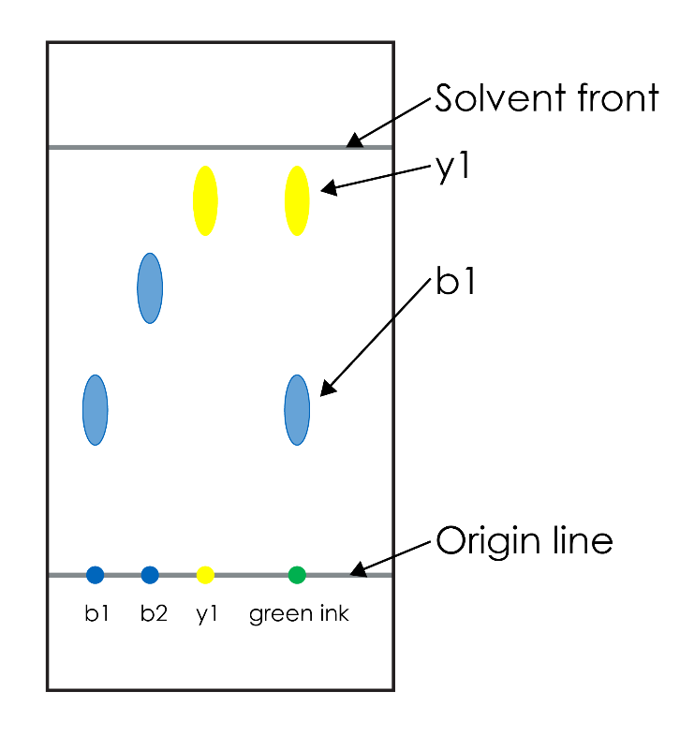
- Five components (the original spot might also contain an insoluble component). You could identify the components using coupled techniques such as mass spectrometry, nuclear magnetic resonance spectroscopy, ultraviolet spectroscopy and infrared spectroscopy.
- The need to use more than one solvent is often related to the individual components having different affinities (solubilities) in the solvents. For example, if the first solvent was non-polar it would have greater affinity to non-polar components and it would be unlikely to be able to separate any polar components. To separate these, you would need to use a polar solvent.

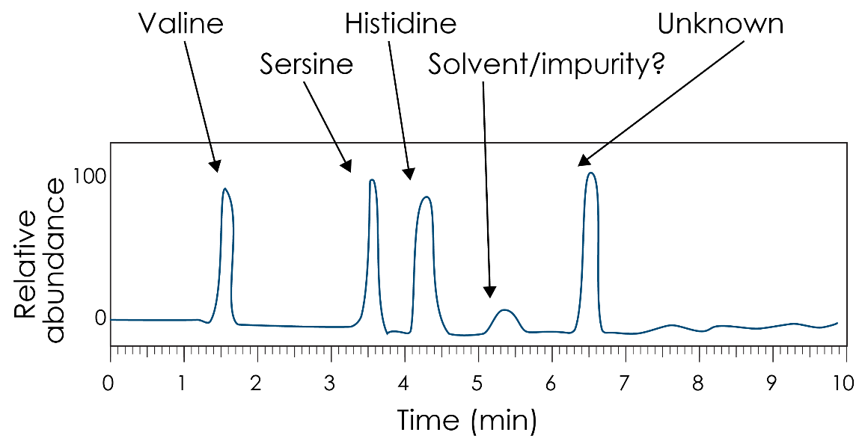

- Measurement method will determine the greatest errors, for example the accuracy of a ruler. You can improve this by magnifying the images before measurement.

- Retention times are: theobromine = 3.3 to 3.4 minutes and caffeine = 8 minutes.
- Chromatogram B has an absorption peak at 8 minutes similar to the standard and a small peak around 3.3 to 3.4 minutes. Chromatogram C has a narrow peak at 3.3 to 3.4, a small peak just above 8 minutes and another little peak around 4.2 minutes. We often refer to small amounts as trace amounts.
- There are several possibilities:
- There is more than one analyte that has similar affinities to the mobile and stationary phases and so separation is poor.
- The construction of the chromatography system allows ‘drift’ of the analyte to occur which means that their movement is in a range of directions (random). Molecules that move in the most direct motion arrive first. Those that deviate, and so travel further, will arrive later. If you do some research on these effects, you might want to consider eddy diffusion and longitudinal diffusion.
- For gas chromatography, it can also be a result of prolonged injection times. Injection of the mixture into the instrument needs to be quick. A delay will mean that components will enter the system at different times, and this will result in their delayed appearance on the chromatogram.
- The chromatograms show that leaf tea extract contains more caffeine compared to drinking chocolate extract. Whereas drinking chocolate extract contains more theobromine than leaf tea extract.

All images © Royal Society of Chemistry

