Microscale reactions of hydrogen sulphide – student sheet

Instructions

- Cover the worksheet with a clear plastic sheet.
- Place the base of the Petri dish directly over the circle below. Place the reaction vessel in the centre.
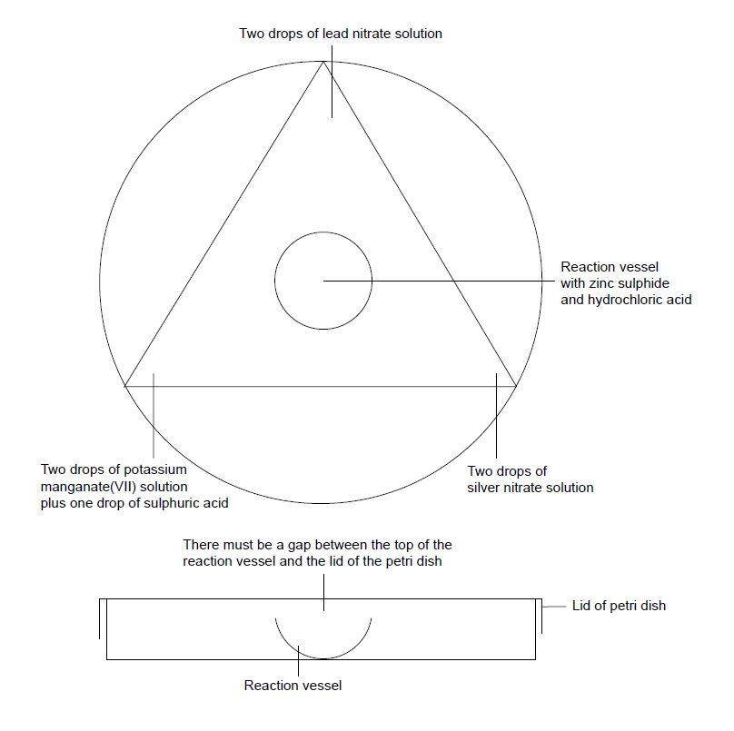
- At the corners of the triangle add drops of the test solutions as indicated in the diagram above.
- Add a small quantity of zinc sulfide powder to the reaction vessel followed by three drops of hydrochloric acid. Quickly replace the lid on the Petri dish.
- Record all your observations over the next 15 minutes. When you have finished add three drops of sodium hydroxide solution to the reaction vessel to stop the reaction.

Questions

- What explanations can you give for your observations?
- Why does sodium hydroxide stop the reaction?

Health, safety and technical notes

- Wear eye protection throughout (splash-resistant goggles to BS EN166 3) and work in a well-ventilated room.
- Hydrogen sulfide is an extremely poisonous gas but because it can be detected by smell at very low concentrations it is much less dangerous than other gases such as carbon monoxide which, although less poisonous, cannot be detected by smell.
- Zinc sulfide, hydrochloric acid and potassium manganate(VII) at the concentration used are of low hazard.
- Sulfuric acid at the concentration used is a skin/eye irritant.
- Lead nitrate, Pb(NO₃)₂ (aq), at the concentration used is a reproductive toxin, causes eye damage, causes damage to organs (especially the CNS) and is harmful to the aquatic environment. Avoid inhalation and skin contact.
- Silver nitrate at the concentration used causes eye damage and is harmful to the aquatic environment.

