Trends in the periodic table

Period 3

Period 3 Melting points

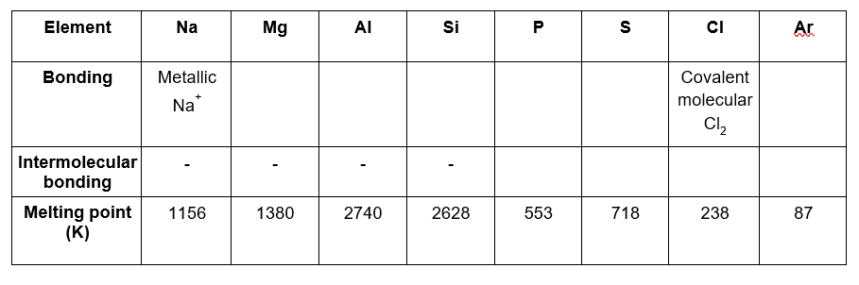
1. Fill in the table above to show how melting point changes across Period 3 according to bonding type.
(6 marks)
2. Explain the differences in melting point between the following pairs of elements
(a) Magnesium and aluminium
(2 marks)
(b) Phosphorus and sulfur
(2 marks)

Period 3 ionisation energy
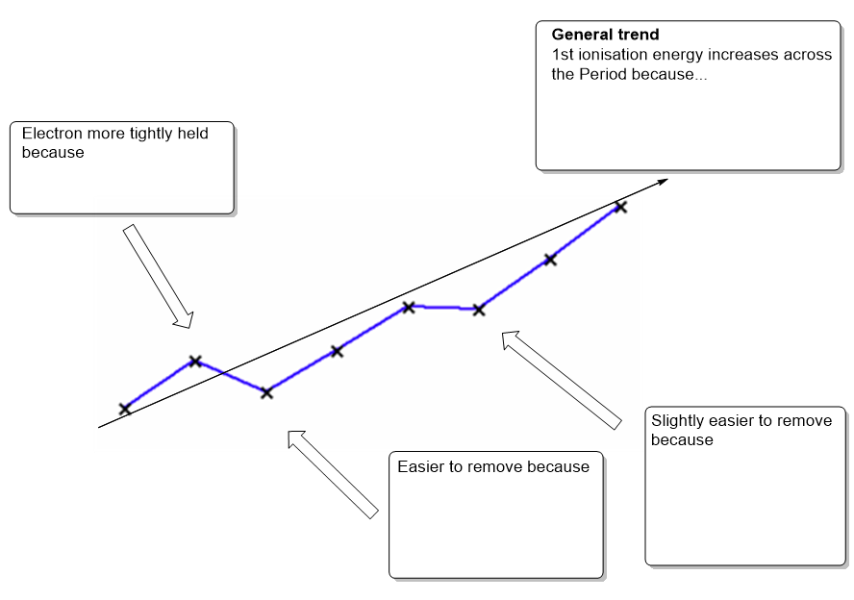1. The diagram shows the trend in 1st ionisation energy across the Period 3 elements. Complete the diagram giving the explanations for the trends seen.
(7 marks)
2. Define the term 1st ionisation enthalpy and illustrate with an equation.
(3 marks)

Atomic radius across period 3

- State and explain the general trend in atomic radius across Period 3 (excluding Argon).
- marks)

- Atomic radius is a general term. Measurements are taken of metallic radii for metals and covalent radii for molecules. Draw a diagram to show how you could calculate the atomic radius of 2 covalently bonded atoms.
(3 marks)

- Why does Argon not follow the trend?
(2 marks)

- State the effect of atomic radius on the first ionisation energy of an element.
(1 mark)

Group 2
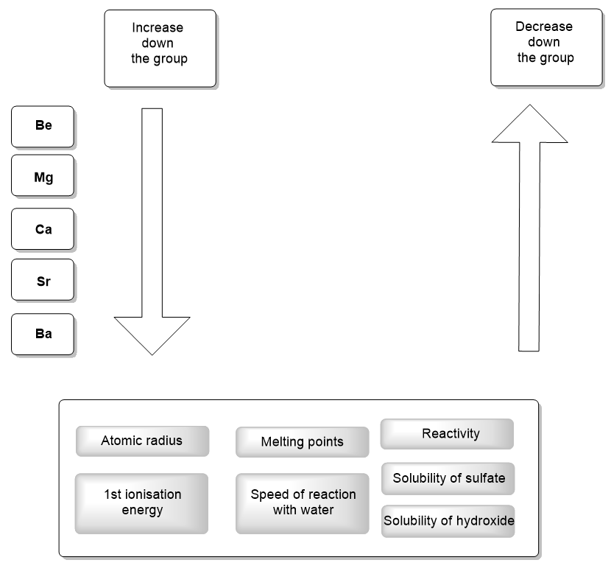
- Complete the diagram showing the general trends in Group 2 by choosing properties from the grey boxes to annotate the arrows.
(7 marks)

- The trend in solubility of the sulfates is useful as it provides a test for the sulfate anion. Describe how this test is carried out, what is observed when the test is positive for sulphate ions and write an equation including state symbols for this test.
(3 marks)

Group 7
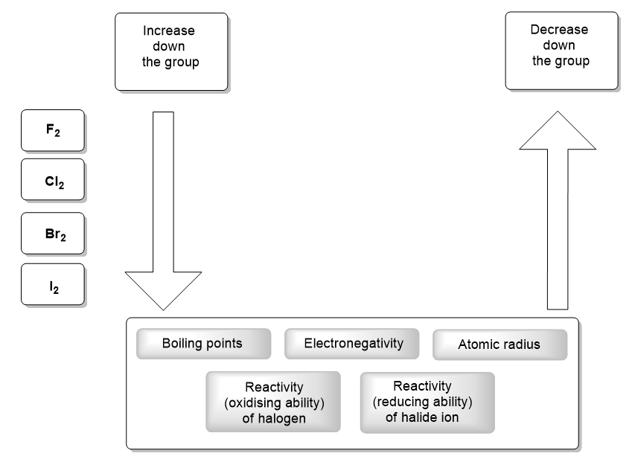
1. Complete the diagram showing the general trends in Group 7 by choosing properties from the grey boxes to annotate the arrows. (5 marks)

2. The trend in the reducing ability of the halide ions can be illustrated by the reaction of sodium halides with sulphuric acid. Illustrate this trend using the equations for NaF and NaI and the O.S numbers for sulfur. Write a conclusion stating what your equations show.
(5 marks)

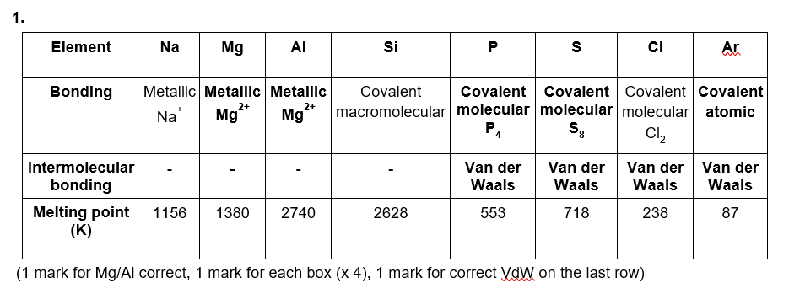
Trends in the periodic table – Answers
2. (a) Magnesium and aluminium
Increase in charge on the ion from 2+ (Mg) to 3+ (Al)(1 mark), more electrons in delocalised system (1 mark) therefore strength of metallic bonds increases.

(b) Phosphorus and sulphur
S₈ molecules have more atoms and therefore electrons than P₄ molecules therefore more VdW forces

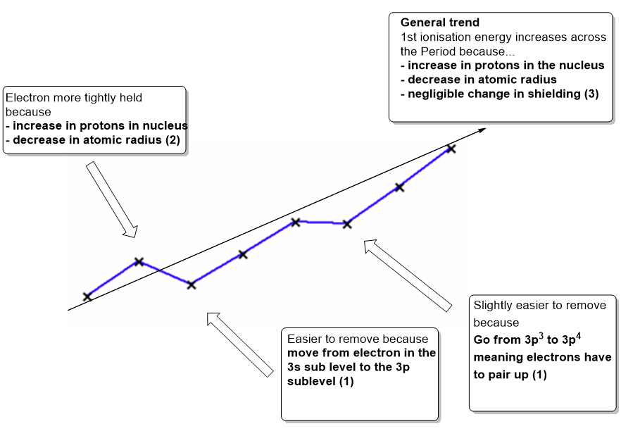
2. The enthalpy change when one mole of electrons is removed (1) from one mole of gaseous atoms (1) to give one mole of gaseous unipositive ions. Eg, M (g) → M⁺(g) + e⁻ (1)

1.
Atomic radius decreases across the Period (1 mark)
More protons in the nucleus (1 mark)
Negligible increase in shielding as electrons are in the same main energy level (1 mark)
Greater attraction between the outer electrons and the nucleus/greater effective nuclear charge therefore electrons ‘pulled’ in. (1 mark)

2.
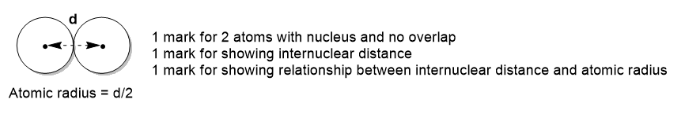

3. Argon is not bonded (1 mark) therefore it is not ‘squashed’ and has a true atomic radius
- mark)

4. As atomic radius decreases the 1st ionisation energy increases (or converse)
(1 mark)
1. (1 mark for each correct)

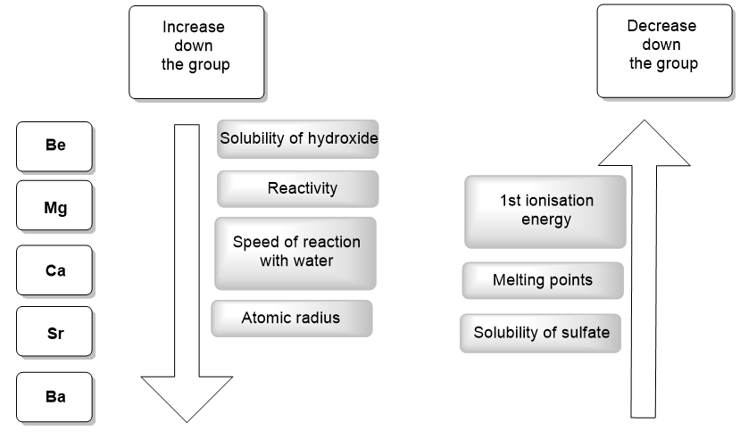
2. Barium chloride solution (BaCl₂) is added to the test solution
(1 mark for identification of chemical)
If sulphate ions are present a white precipitate is formed
(1 mark for observation)
Ba²⁺(aq) + SO₄²⁻(aq) → BaSO₄(s)
(1 mark)

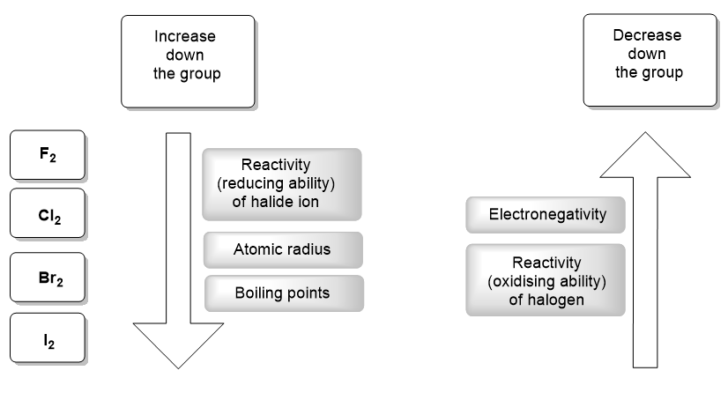
2.
