Rates of reaction

Determine rates of reaction through monitoring how fast a reactant is used up or how fast a product is formed, using initial rate and continuous monitoring methods. Watch a video of the investigation, plus find technician notes and more resources, at rsc.li/3BMJQR2

Initial rate method: the iodine clock

Equipment (per group, for five different concentrations of hydrogen peroxide)

- 1 x volumetric flask, 1 dm³
- 5 x conical flask, 100 cm³
- 5 x beaker, 100 cm³
- 1 – 5 x white tiles
- 1 x burette, 50 cm³
- 5 x measuring cylinder, 50 cm³
- 1 x pipette, 10 cm³, to measure 20 cm³
- 3 x plastic dropping pipette, 3 cm³
- 1 x beaker, 400 cm³ for waste solutions
- 1 x timer or digital stopwatch
- Balance to 1 or 2 decimal places
- Marker pen for labelling

- Soluble starch, 2% w/v
- Sulfuric acid, 1.0 mol dm⁻³ (DANGER: irritant)
- Solution X (containing potassium iodide and sodium thiosulfate)
- Hydrogen peroxide, 20 volume (WARNING: irritant)
- Distilled water
- Waste beaker containing sodium carbonate solution, 0.5 mol dm⁻³

- Safety equipment: safety glasses

Safety
Wear eye protection throughout. Refer to CLEAPSS Student safety sheet SSS022, SSS034, SSS035 and SSS057, available from bit.ly/3X8yi5A, for further details.

Method
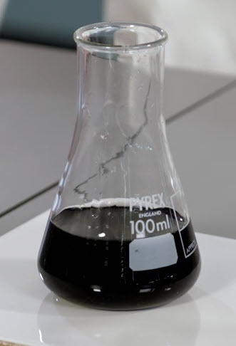
- Place five conical flasks on white tiles and label them A to E.
- Add 20cm³ solution X (potassium iodide and sodium thiosulfate) to each flask using a pre-rinsed 20 cm³ pipette.
- Add 2 cm³ of 2 g/100 cm³ solution of starch to each conical flask using a pipette.
- Add 10 cm³ of 1.0 mol dm⁻³ sulfuric acid into five beakers using a clean burette.
- Measure 30 cm³ of 20 vol hydrogen peroxide in a measuring cylinder. Repeat for 25 cm³, 20 cm³, 15 cm³ and 10 cm³ in separate measuring cylinders and add distilled water so that each cylinder contains 30 cm³ liquid.
- Pour the hydrogen peroxide solutions into the five beakers at the same time. Then pour the contents of the five beakers into the five conical flasks and start your stopwatch straight away.
- Record the time it takes for each solution to turn blue/black in a table.
- Dispose of your iodine solutions by pouring them into a waste beaker containing sodium carbonate solution.
- Repeat steps 1 to 7 at least twice more to ensure your results are reliable.

Disposal
- Always dispose of chemicals carefully following your teacher’s instructions.
- Pour your iodine solutions into a waste beaker containing sodium carbonate solution.

Continuous monitoring method: volume of gas

Equipment (per group)

- 1 x gas syringe, 100 cm³
- 1 x delivery tube
- 1 x sidearm boiling tube with bung (or boiling tube and delivery tube attached to bung)
- 1 x volumetric pipette and pipette filler, 20 cm³ or measuring cylinder, 25 cm³
- 1 x timer or digital stopwatch
- 1 x clamp and stand
- 1 x syringe holder (to be clamped)
- 1 x thermometer or temperature probe
- 1 x water bath or suitable alternative
- 1 x balance to 1 or 2 decimal places

- Magnesium ribbon, 0.09 g (per repeat) (DANGER: flammable)
- Hydrochloric acid, 1.0 mol dm⁻³

- Safety equipment: safety glasses

NB: an alternative to collecting the gas produced is by displacement of water using an inverted burette, a trough and a beehive-shelf (optional).

Safety
Wear eye protection throughout.
Refer to CLEAPSS Student safety sheet SSS020 and SSS081, available from bit.ly/3X8yi5A, for further details.

Method
- Measure 20 cm³ of 1.0 mol dm⁻³ hydrochloric acid using a volumetric pipette into a sidearm boiling tube.
- Record the temperature of the hydrochloric acid.
- Make sure the plunger can move freely in the syringe by moving it in and out.
- Measure 0.09 g magnesium ribbon and fold it into a v shape.
- Hold the sidearm boiling tube at a shallow angle and place the magnesium ribbon just inside the top.
- Place the bung into the tube. Record any movement of the plunger out of the gas syringe. This will be your starting value.
- Tilt the tube and start the stopwatch immediately.
- Measure the volume every 10 seconds until you have three readings of the same value.
- Repeat the steps 1 to 8 at different temperatures using a water bath. Alternatively, use a Bunsen burner, beaker of water, tripod and gauze.
- Process your results to determine the rate of reaction.

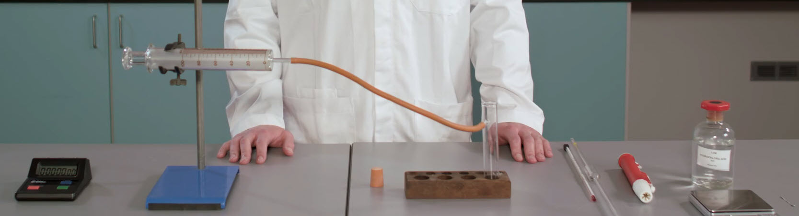

Disposal
- Always dispose of chemicals carefully following the instructions from your teacher.
- Do not throw the waste solution down a foul-water drain.

