Shapes, surface areas and volumes in chemistry
Education in Chemistry
November 2020
rsc.li/3ddLrUJ
This resource includes diagnostic exercises, maths problems, algebra questions and chemistry problems, all involving 2D and 3D shapes. Students will have different levels of confidence, and you can structure the algebra questions, for example, to tailor to your students’ needs. For more able students, you can provide less scaffolding and even ask them to define the surface area to volume ratio of a cube in purely algebraic terms.

Diagnostic exercises
- Name the following polyhedra:
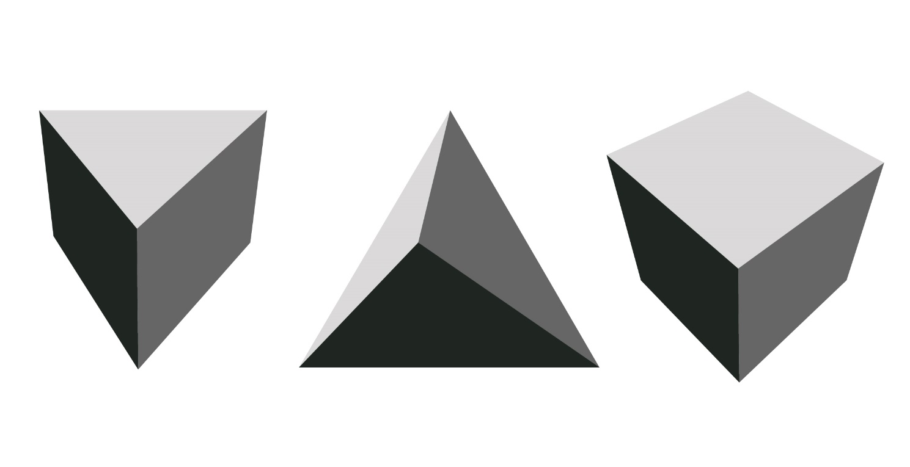
- What is the surface area of this cube?

1.5 cm

- 2.25 cm²
- 3.375 cm²
- 13.5 cm²
- 4.5 cm²

- Which of the following shapes is identical to Shape A?
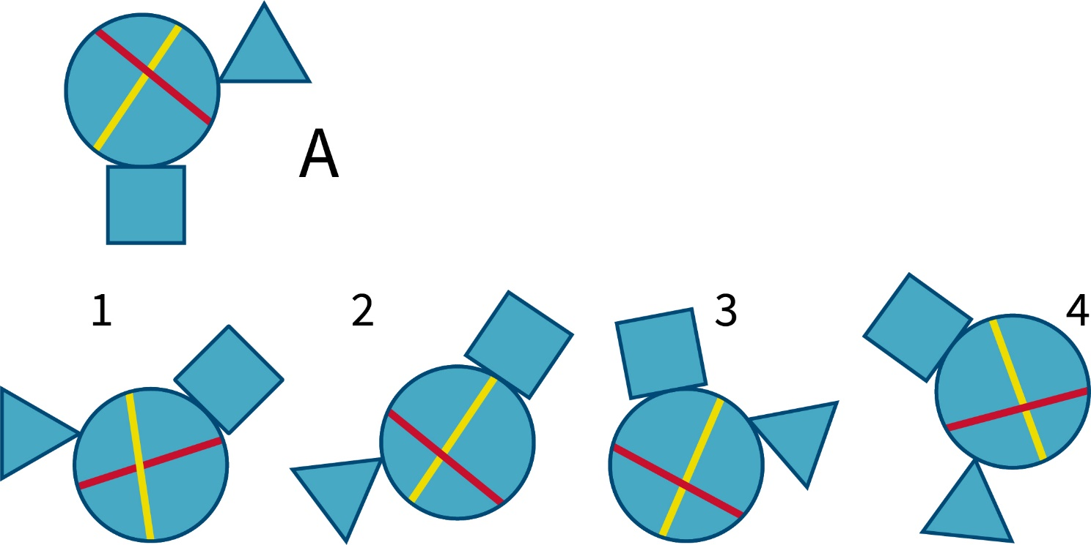

- Which cube cannot be based on the following net?
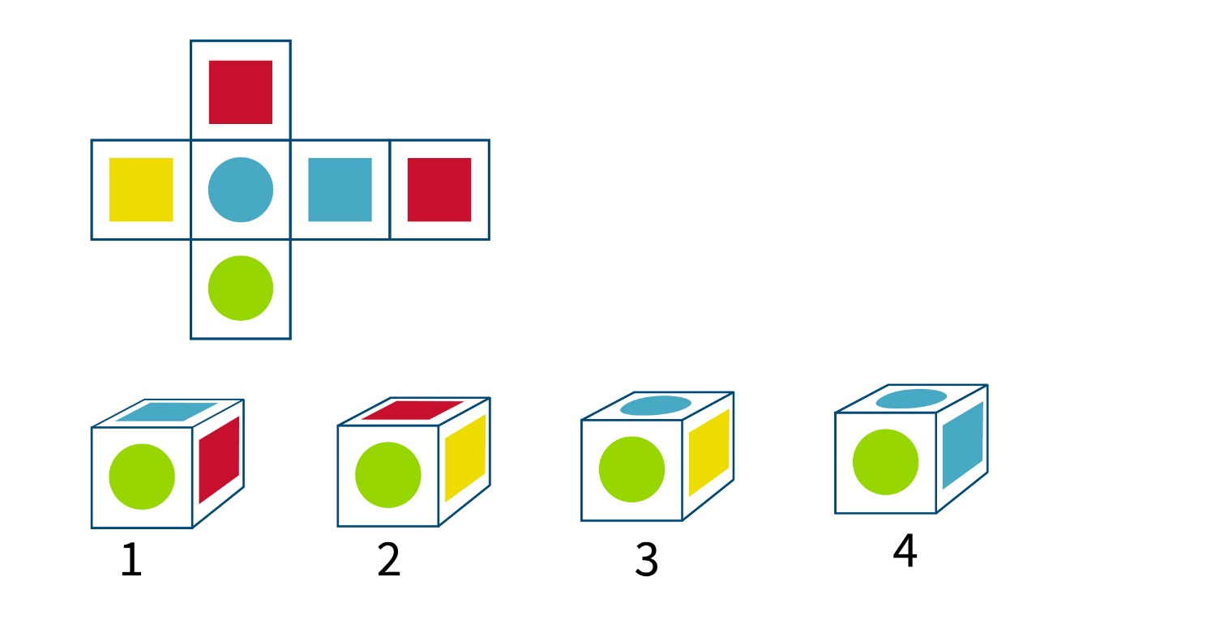

Maths problems
- What is the area of this triangle?
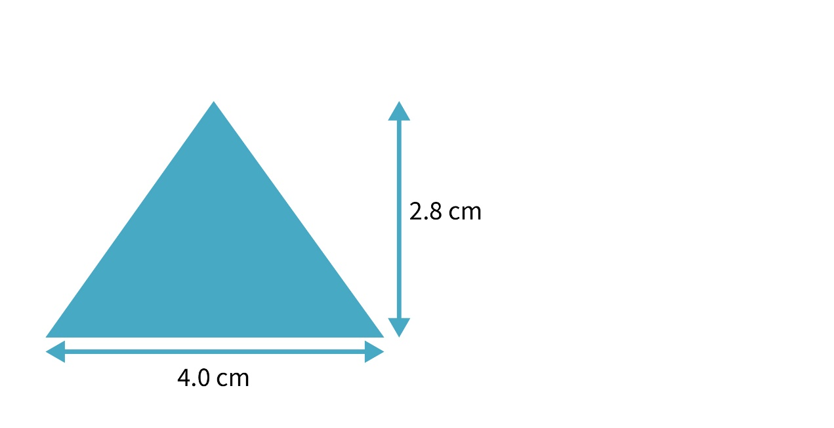
- What are the units of surface area if the lengths are given in centimetres?
- What are the units of volume if the lengths are given in centimetres?
- The surface area (SA) to volume (V) ratio is calculated as SA/V. What are the units?
- A cube has sides of 10 cm in length.
- What is the surface area?
- What is the volume?
- What is the surface area to volume ratio?

- A cube has sides of 1 cm in length.
  - What is the surface area?
  - What is the volume?
  - What is the surface area to volume ratio?

- Describe what happens to the surface area: volume ratio as the size of the cube decreases by a factor of 10.
- Complete the following table:
Cube side length | Surface area (SA) | Volume (V) | SA/V
2 cm
4 cm
6 cm
8 cm
10 cm

Algebra
1. A cube has sides of length l cm. What is the surface area of the cube expressed in terms of l?
2. A cube has sides of length l cm. What is the volume of cube expressed in terms of l?
3. A cube has sides of length l cm. What is the surface area: volume ratio expressed in terms of l?

Chemistry problems

Rates of reaction
Marble chips were reacted with dilute hydrochloric acid and the reaction was continuously monitored by measuring the volume of gas evolved. The experiment was repeated a second time using marble chips of a different size. The results of the experiments were plotted below.
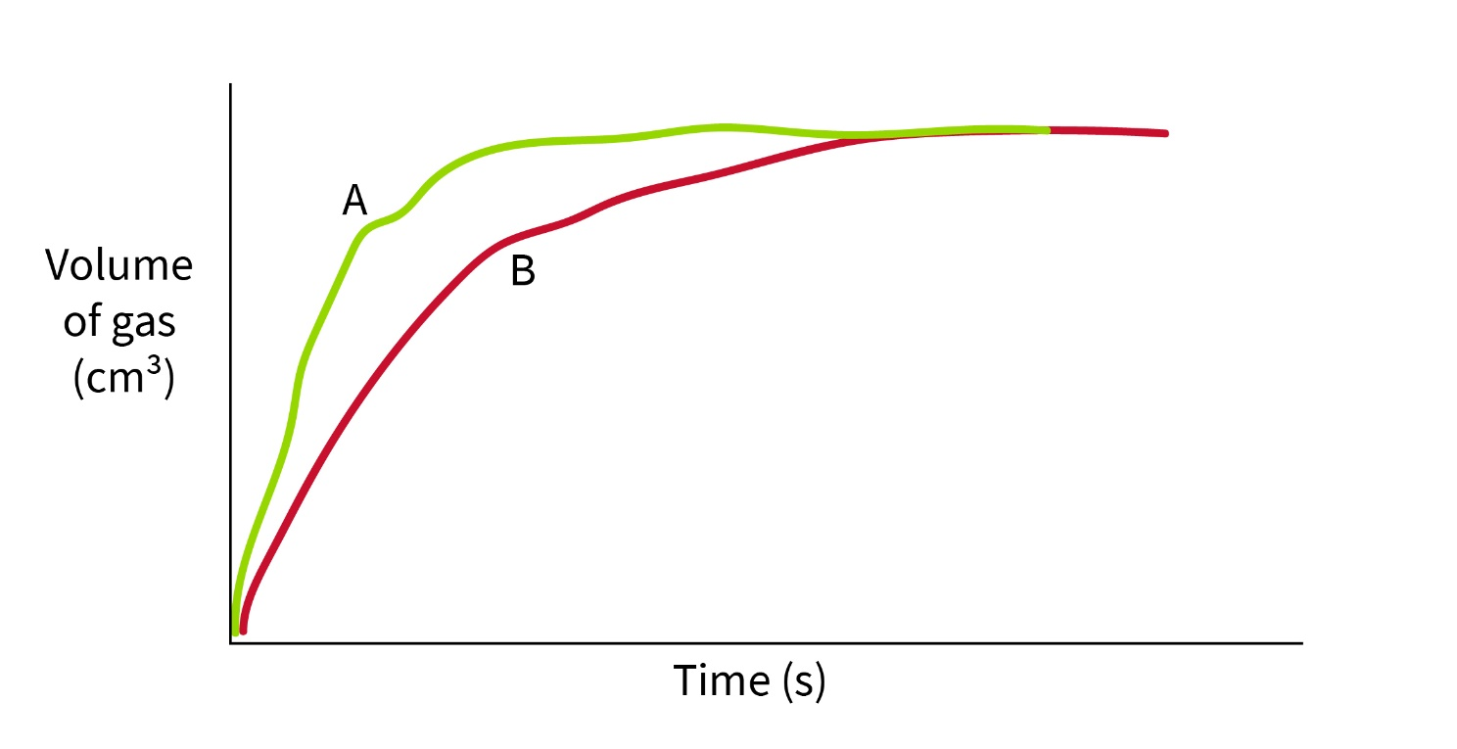
- Why does the plotted graph flatten out into a straight line?
- Which of the experiments (A or B) had the fastest rate of reaction. How can you tell?
- The marble chips in the first experiment can be modelled as cubes with sides of length 0.5 cm.
  - What is the surface area of a single marble chip?
  - What is the volume of a single marble chip?
  - The surface area (SA) to volume (V) ratio is calculated as SA/V. What is the surface area to volume ratio?
  - How is the rate of reaction related to the surface area to volume ratio? Why?
  - Were the marble chips used in B smaller or bigger than those used in the first experiment? How can you tell?

Isomerism
1. Which of the following molecules is not identical but is an isomer?
C
Cl
HO
H₃C
H
C
Cl
H
HO
CH₃
C
Cl
H₃C
HO
H
C
H
H₃C
HO
Cl

