SOLO taxonomy
What is SOLO taxonomy?
Education in Chemistry
rsc.li/EiC-solo

Stage | What you know | At this level, you can … | When asked ‘What is atomic mass?’, you might say something like …
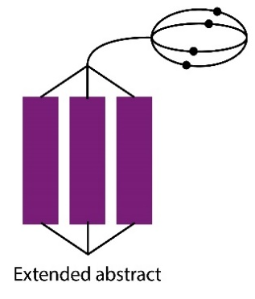 | You can apply your knowledge of this topic to other topics and can see how different topics link together. | Create  Formulate  Generate  Hypothesise  Reflect  Theorise  Generalise  Predict  Evaluate | Atomic masses can be used to balance equations.  You can work out empirical formulae from atomic masses and experimental data.  A balanced equation and experimental data can be used to work out percentage yield and therefore evaluate an experimental method.
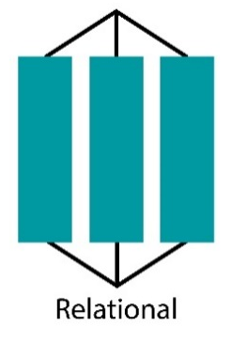 | You can see the big picture. You can link together all the things you know about the topic. | Analyse  Apply  Argue  Compare and contrast  Criticise  Relate  Justify | Atomic masses of elements can be decimals to accommodate isotopes.  Relative atomic mass can be calculated from the atomic masses of isotopes and relative abundance.  The atomic mass of a molecule is the sum of the atomic masses of its constituent atoms.  Mass is conserved in chemical reactions.
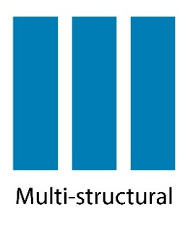 | You know several pieces of information to do with the topic, but can’t link them together yet. | Combine  Describe  Enumerate  List  Classify  Follow the multiple steps in this procedure | The periodic table contains information about elements.  The atomic mass of an element in grams is the mass of one mole of those atoms.  Atomic mass is equal to the number of protons and neutrons in an element’s nucleus.
 | You know one or two isolated bits of information about the topic | Identify  Name  Recall  State  Follow a simple procedure | Matter is made up of atoms.  Different kinds of atoms are called elements.  Atoms are made up of protons, neutrons and electrons.
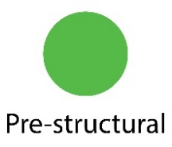 | You are not confident with any aspect of this topic and need lots of teacher support. |  | I don’t know.

