Period products: information sheets
Education in Chemistry
March 2021
https://rsc.li/3sYKC8T
A life-cycle assessment (LCA) looks at every stage of a product’s life and assesses the impact it has on the environment.

Use the information included on the following sheets to complete the life-cycle assessment on the student worksheet (available as a separate download).
Challenge: Ask learners to consider why the information in the sheets is followed by superscript numbers (references). What is a reference? How can references help us to separate fact from opinion? Why is it important that the date is included in references?

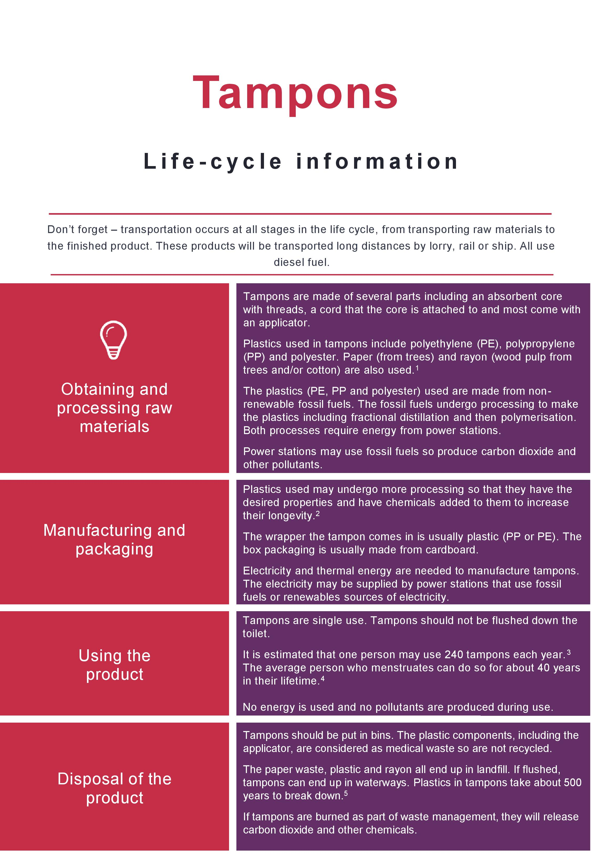
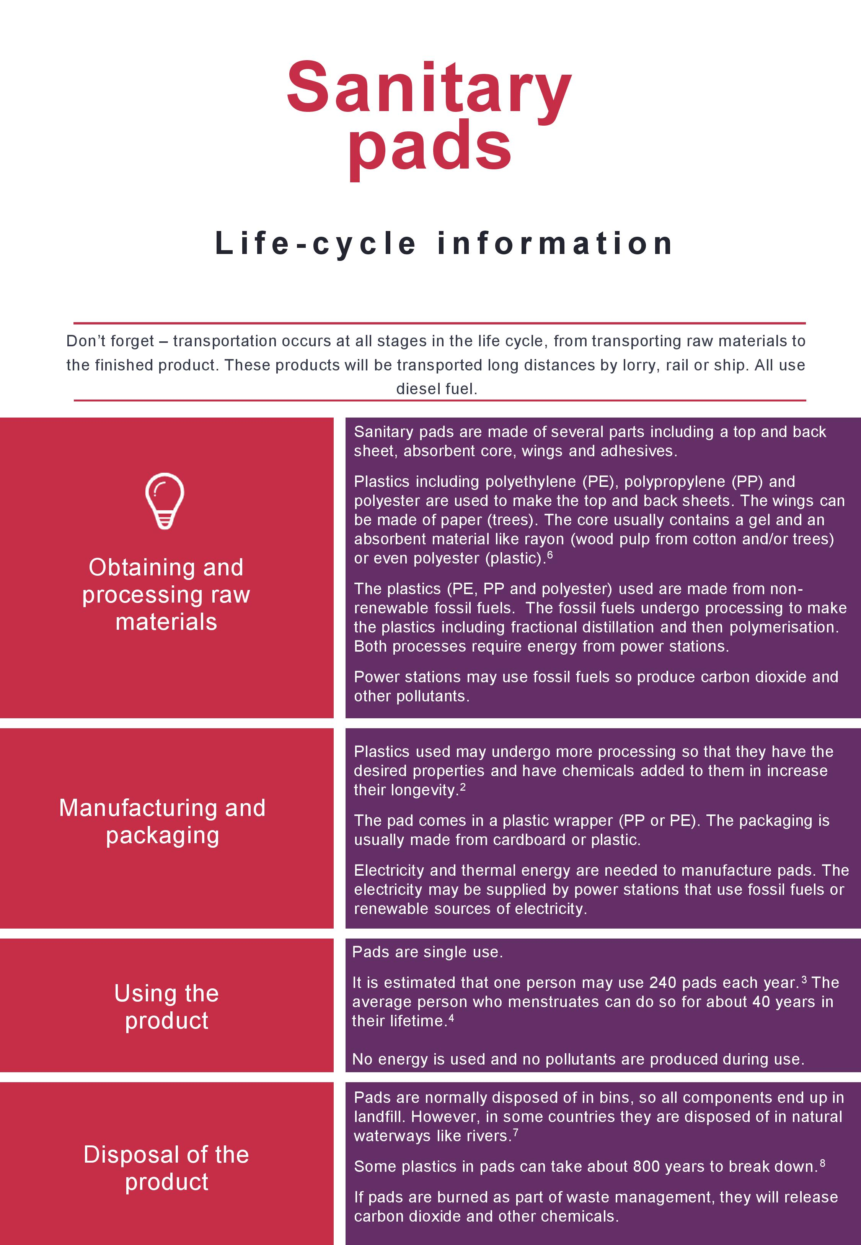
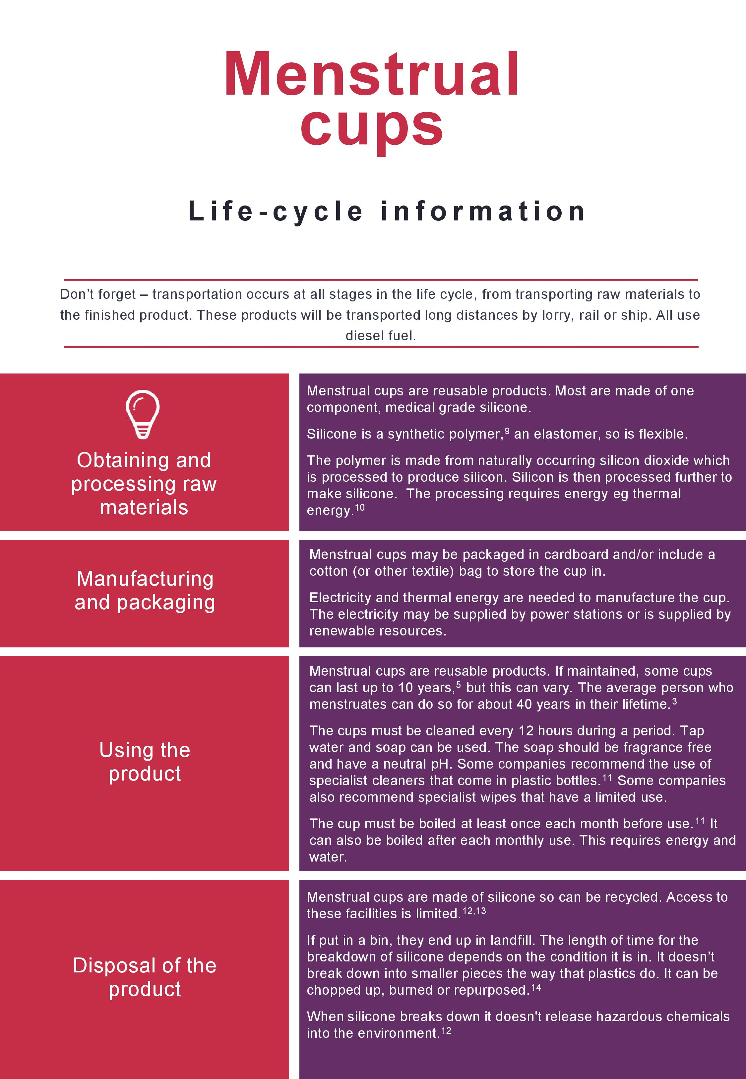
References
- Tampax, 2021, https://tampax.co.uk/en-gb/tampax-articles/women-s-health/what-are-tampax-tampons-made-of?gclid=EAIaIQobChMIs62Vp5nO7gIVdIBQBh2CxAv5EAAYASAAEgL3VPD_BwE (Accessed February 2021), © 2021 Procter & Gamble.
- A. Chamas et al, ACS Sustainable Chem. Eng., 2020, 8, 3494–3511. https://doi.org/10.1021/acssuschemeng.9b06635
- A. Hait and S. Powers, Data in Brief, 2020, 28, 104851. https://doi.org/10.1016/j.dib.2019.104851
- A. Borunda, 2019, National Geographic, https://www.nationalgeographic.com/environment/2019/09/how-tampons-pads-became-unsustainable-story-of-plastic/ (Accessed February 2021).
- L. Winter, 2019, Glamour, https://www.glamourmagazine.co.uk/article/period-product-waste (Accessed February 2021).
- Always, 2021, https://always.com/en-us/about-us/what-are-always-products-made-of (Accessed March 2021), © 2021 Procter & Gamble.
- S. Garikipati, ZME Science, 2020, https://www.zmescience.com/science/women-sustainable-menstrual-products-crisis-pandemic/ (Accessed February 2021).
- Duquesne University, https://onlinenursing.duq.edu/master-science-nursing/the-ultimate-guide-to-feminine-hygiene/ (Accessed February 2021).
- J. Castro, 2013, https://www.livescience.com/37598-silicon-or-silicone-chips-implants.html (Accessed February 2021).
- How Products are Made, http://www.madehow.com/Volume-6/Silicon.html (Accessed February 2021).
- Diva Cup, 2021, https://divacup.com/ (Accessed February 2021), © 2021 Diva International Inc.
- MCA Online, 2019, https://www.menstrualcupsaustraliaonline.com.au/how-to-dispose-of-your-old-menstrual-cup/ (Accessed: February 2021).
- The Waste Management & Recycling Blog, 2019, https://www.forgerecycling.co.uk/blog/a-guide-to-reusable-eco-friendlier-period-products/ (Accessed February 2021), © 2021 Forge Waste & Recycling.
- Pixie Cup, 2020, https://www.pixiecup.com/blog/how-to-recycle-a-menstrual-cup/ (Accessed February 2021), © 2020 Pixie Cup, LLC.
The Guardian, 2015, https://www.theguardian.com/sustainable-business/2015/apr/27/disposable-tampons-arent-sustainable-but-do-women-want-to-talk-about-it (Accessed February 2021).

