Composition of the Earth

This resource accompanies the infographic poster The Earth’s structure in Education in Chemistry which can be viewed at: https://rsc.li/3tU4lwq

Learning objectives
- Identify and label the layers of the Earth.
- State the properties of each layer of the Earth.
- Deduce the most abundant elements and their proportion in each layer from incomplete information.

Introduction

Use this resource as a Directed Activity Related to Text (DART) alongside the infographic poster and fact sheet available at the link above.

How to use this resource

The resource comes in three parts:
- Information cards for learners to add properties and statistics to, relating to the different layers of the Earth.
- A diagram with blank spaces where learners can cut out and glue their completed cards into the appropriate space.
- A set of pie charts for learners to complete.

Learners can find the information through their own independent research or by looking at the RSC Education in Chemistry infographic poster and fact sheet in class.

Scaffolding

Three versions of the student sheet are provided. The unscaffolded worksheet, indicated by three stars in the header, contains blank information cards and no prompts. It also contains a template for learners to draw their own pie charts.

The fully scaffolded and partially scaffolded worksheets both include partially completed information cards and labels in a table at the bottom of the page. The fully scaffolded worksheet contains the names of all the elements so learners only need to add the data. The pie charts are pre-segmented on both scaffolded sheets with some data included on the fully scaffolded version.

Answers: the composition of the Earth

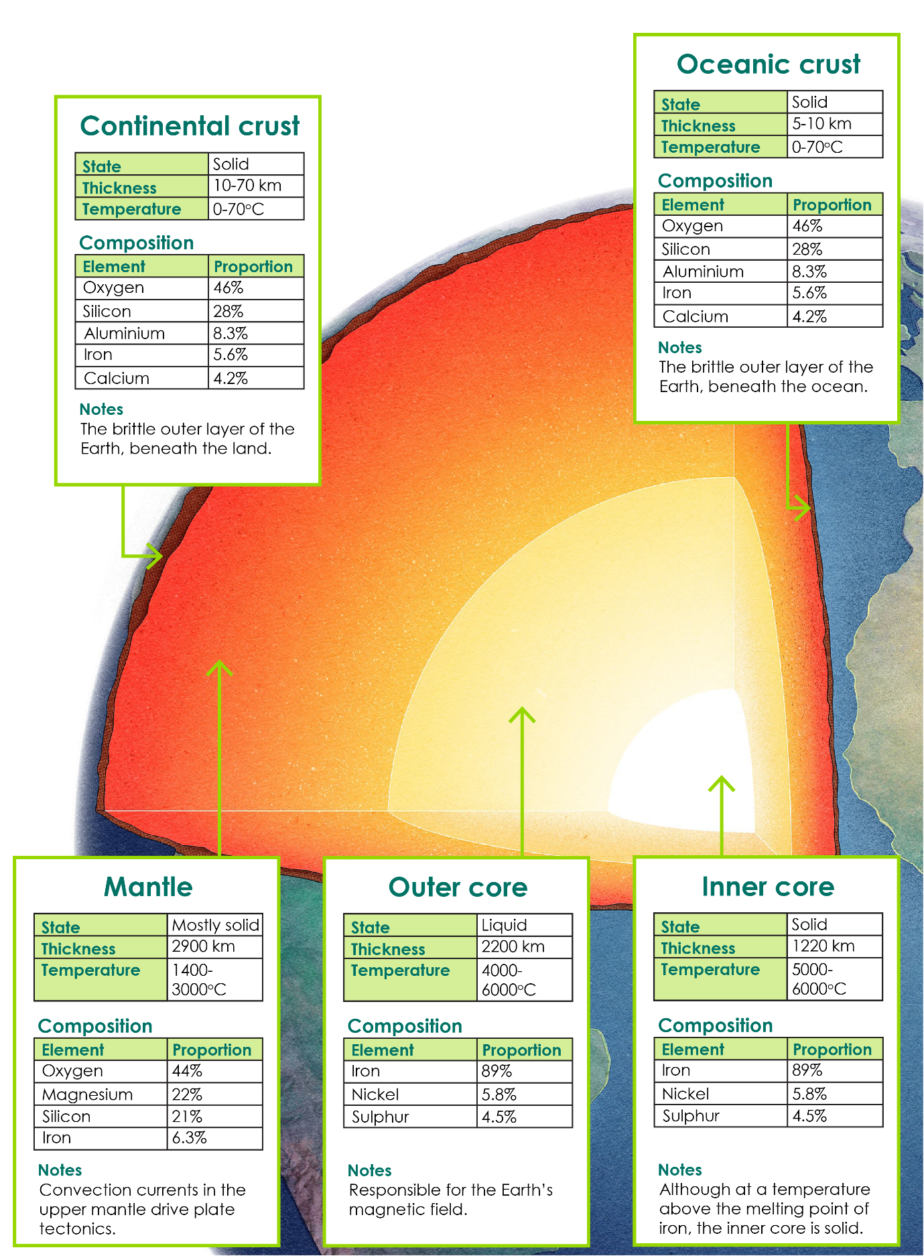

Answers: the most abundant elements in the Earth

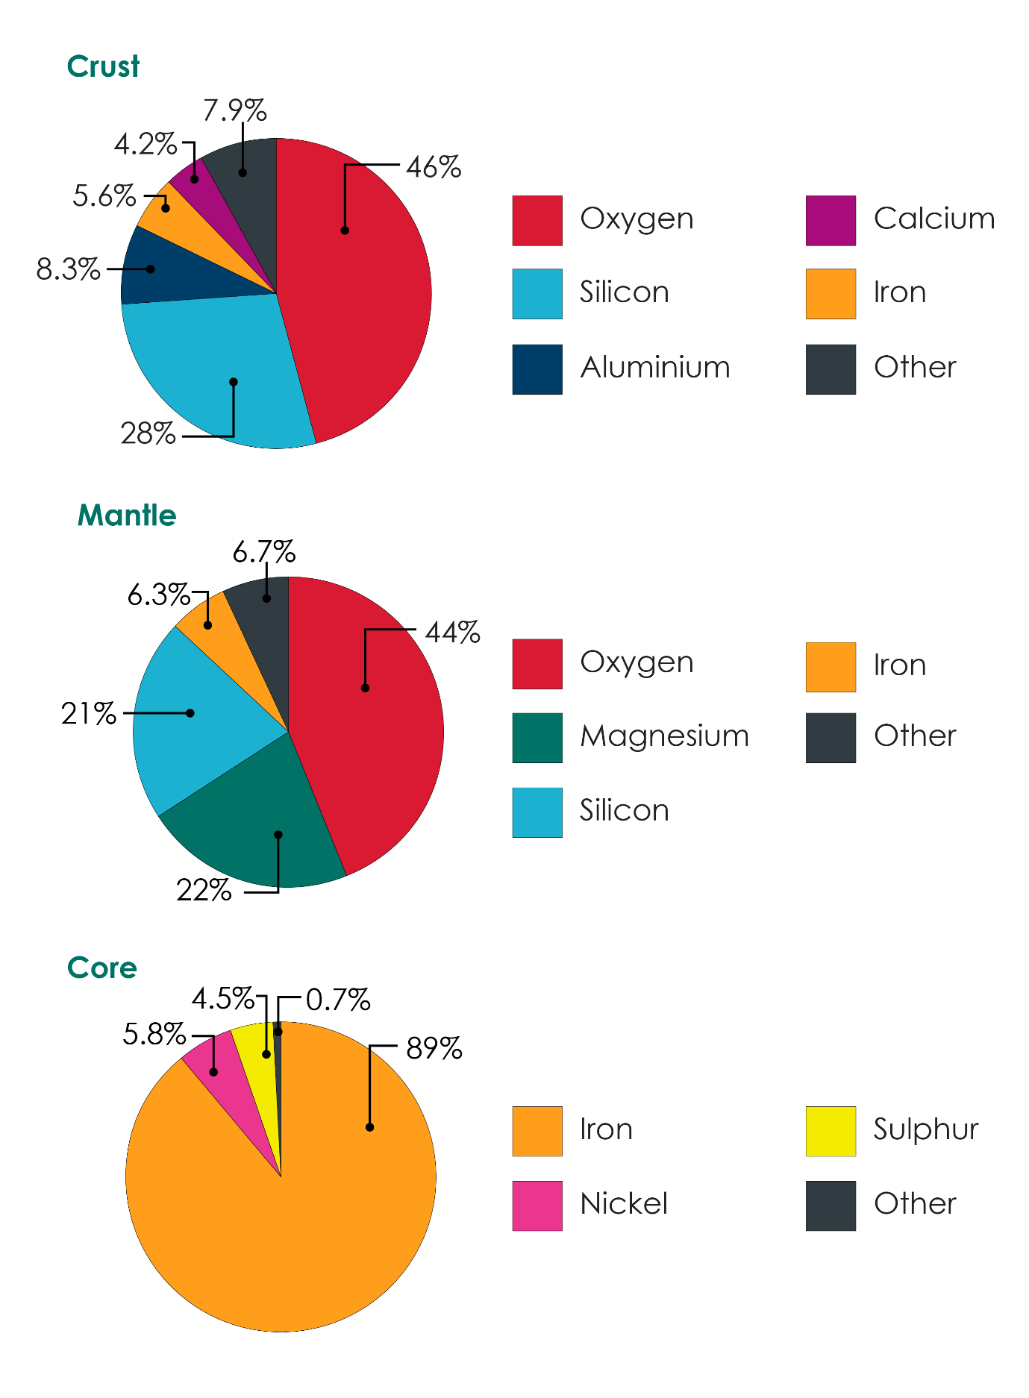

Printer friendly answers: the most abundant elements in the Earth

