The ‘breathalyser’ reaction

This resource accompanies the article Crime-busting chemical analysis in Education in Chemistry which you can view at: rsc.li/3T27kfh. The article explores the chemistry behind some of the latest breakthroughs in forensic science, from dog detectives to artificial intelligence.

Learning objectives
- Observe an application of the oxidation of primary alcohols using acidified potassium dichromate solution.
- Recall the colour change of the chromium-containing species in the ‘breathalyser’ reaction and the products of oxidation of primary alcohols.
- Understand that you can use the reaction as an analytical test to identify (primary or secondary) alcohols.
- Write redox equations and review transition elements’ properties.

Introduction

This is a teacher demonstration which takes under 10 minutes to perform. Use it to provide context when teaching the properties of alcohols. The ‘breathalyser’ reaction is also a good opportunity to discuss the dangers of drinking and driving, although modern ‘breathalysers’ use electronic methods to detect and measure alcohol concentration.

Find more details on how chemists use infrared spectrometry to detect alcohol in drivers’ breath on page 82 of Modern chemical techniques: infrared spectroscopy, available from rsc.li/3SOErUL.

Learners will require prior knowledge of redox, oxidation states and properties of transition elements, in addition to the oxidation of alcohols.

Questions 1–7 of the student worksheet rehearse the essential chemical facts of the reaction. Question 8 gets learners to think about the way the application of the reaction in the breathalyser works. Questions 9–13 lead learners to understand how using [O] in oxidation questions works and how much that simplifies the equations.

Adaptive teaching

Questions 1–8 are designed to be accessible to post-16 learners with little support. Questions 9–13 are more challenging and may not be appropriate for all. You can do them as a class so you can give help and check answers as you go through them. To further challenge your learners, set Q5 from the 2005 Olympiad paper (download at rsc.li/49pIs7x).

Technician notes

Download the technician notes, available from rsc.li/3Utqblt, for full preparation and disposal information.

Equipment (per demonstration)
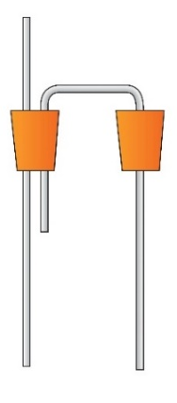
- Measuring cylinder, 25 cm³, x 2
- Boiling tube
- Boiling tube with side arm
- Rubber bung x 2, one with two holes, to fit boiling tubes
- Glass tubing x 2, one straight and one with a double bend (u shape)
- Filter pump attached to the side arm of the boiling tube
- Clamp stand, boss and clamp x 2
- Access to a water tap
- Safety equipment: splashproof goggles and chemical-resistant nitrile gloves

Chemicals, safety and hazards

Read our standard health and safety guidance, available from rsc.li/49bHlZG, and carry out a risk assessment before running any live practical.

Refer to SSERC/CLEAPSS Hazcards and recipe sheets. Hazard classification may vary depending on supplier.

Wear splashproof goggles and chemical-resistant nitrile gloves.
Chemicals supplied for the practical | Safety and hazards
Ethanol or IDA (industrial denatured alcohol), 95%, $C_{2}H_{6}O(l)$  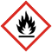  DANGER | Highly flammable liquid and vapour. Harmful if swallowed. May cause damage to organs.  See CLEAPSS Hazcard HC040a (bit.ly/42uO520).
Potassium dichromate(VI) solution in $1.4 mol {dm}^{-3}$ sulfuric acid, $0.1 mol {dm}^{-3}$, $K_{2}{Cr}_{2}O_{7}(l)$  DANGER | Corrosive to skin and eyes. Harmful if swallowed. Respiratory irritant. Skin and respiratory sensitiser. Serious health hazard (RE). Serious health hazard (CMR).  See CLEAPSS Hazcards HC098a (bit.ly/3Oz7Q2M) and HC078c (bit.ly/42GygWh).  See CLEAPSS recipe sheets RB098 (bit.ly/3OyW9t1) and RB070 (bit.ly/3SO9RdX).
Potassium dichromate(VI) solid, $K_{2}{Cr}_{2}O_{7}(s)$  (Needed to prepare the $0.1 mol {dm}^{-3}$ potassium dichromate(VI) solution)  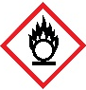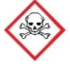  DANGER | May intensify fire; oxidiser. Toxic if swallowed. Harmful in contact with skin. Causes severe skin burns and eye damage. May cause allergic skin reaction. Fatal if inhaled. May cause allergy or asthma symptoms or beathing difficulties if inhaled. May cause cancer or genetic defects. May damager fertility or the unborn child. Causes damage to organs through prolonged or repeated exposure. Very toxic to aquatic life with long-lasting effects.  See CLEAPSS Hazcard HC078c (bit.ly/42GygWh) and recipe sheet RB070 (bit.ly/3SO9RdX).
Sulfuric acid solution, $1.4 mol {dm}^{-3}$, $H_{2}SO_{4}\left(aq\right)$  (Needed to prepare the $0.1 mol {dm}^{-3}$ potassium dichromate(VI) solution)  WARNING | Causes severe skin burns and eye damage.  See CLEAPSS Hazcard HC098a (bit.ly/3Oz7Q2M) and recipe sheet RB098 (bit.ly/3OyW9t1).

Products
- Ethanal (acetaldehyde), ${CH}_{3}CHO(l)$: extremely flammable, harmful – see CLEAPSS Hazcard HC034 at bit.ly/3HMQnAa.
- Ethanoic acid solution (acetic acid), ${CH}_{3}COOH(aq)$: irritant – see CLEAPSS Hazcard HC038a at bit.ly/3SyRB6W.

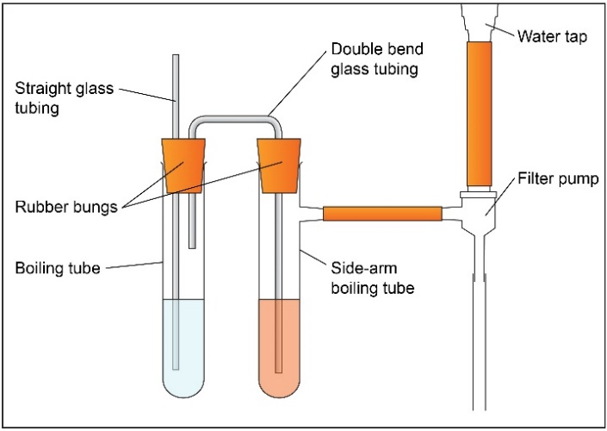
Procedure
- Wearing chemical-resistant nitrile gloves and eye protection, pour sufficient acidified potassium dichromate solution to submerge the glass delivery tube into the side-arm boiling tube.
- Pour ethanol into the second boiling tube so that the longer of the two glass tubes is below the surface of the ethanol and the shorter glass tube is not.
- Attach the side arm of the boiling tube to the pump fitted to the tap.
- Secure all the equipment using bosses, clamps and stands.
- Gently turn on the water tap so that air bubbles steadily pass through the ethanol and the acidified potassium dichromate solution.
- Draw the air containing ethanol vapour slowly through the acidified potassium dichromate solution for several minutes until you can see sufficient green colour. Keep a sample of the unreacted orange acidified potassium dichromate solution next to the side-arm boiling tube to compare the colour change.
- Turn off the water tap.

Answers

- The colour of the acidified potassium dichromate reagent is orange.
- The ion that gives the orange colour is the dichromate(VI) ion, ${Cr}_{2}O_{7}^{ 2-}$.
- The oxidation state of the chromium in ${K_{2}Cr}_{2}O_{7}$ is +6.

Workings: remembering the oxidation number rules the oxidation state, the potassium ion will be +1 and the oxygen ion will be -2. The total sum of the oxidation numbers will be equal to the overall charge (0) so:

$(2 × +1)+2Cr+\left(7 × -2\right)=0$

$+2+2Cr-14=0$

subtracting 2 from both sides gives: $2Cr-14=-2$ adding 14 to both sides gives: $2Cr =+12$

dividing both sides by 2 gives: $Cr=+6$

- The final colour of the oxidising agent is green.
- The ion responsible for the green colour is ${Cr}^{3+}$.
- The oxidation state of the chromium in ${Cr}^{3+}$ is +3.

- The brown colour comes from a mixture of orange and green. Some of the dichromate(VI) is reduced to chromium(III) ions but not all, so both coloured species are present.

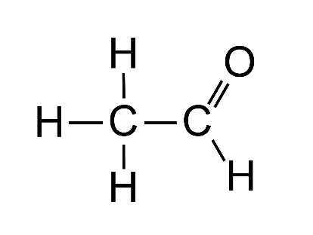
- Ethanal.

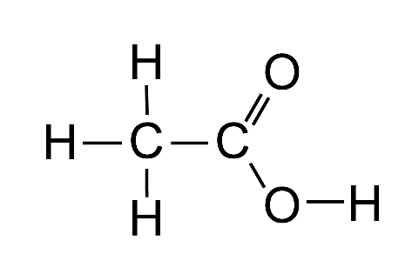
- Ethanoic acid.

- Primary and secondary alcohols, not tertiary.
- Aldehydes.

- Transition metals tend to form coloured compounds and often have variable oxidation states.

- The balanced equations:
- $C_{2}H_{5}OH + 2\left[O\right]→{CH}_{3}COOH+H_{2}O$
- $C_{2}H_{5}OH+\left[O\right] →{CH}_{3}CHO+H_{2}O$

- The amount of acidified dichromate in the tube is calibrated to change colour when a set volume of breath over the alcohol limit is breathed through it. It changes colour based on the total number of moles of ethanol blown through rather than the concentration of ethanol in the breath. If you blow less breath through there might not be enough ethanol to react with the dichromate even though its concentration is high enough to exceed the legal limit.

Challenge
- $\left[O\right]+2H^{+}+2e^{-} → H_{2}O$

- $C_{2}H_{5}OH → {CH}_{3}CHO+ {2H}^{+}+2e^{-}$

- ${Cr}_{2}O_{7}^{ 2-}+ 14H^{+}+6e^{-} → 2{{Cr}^{3+}+ 7H}_{2}O$

- The two half-equations are:

$C_{2}H_{5}OH → {CH}_{3}CHO+ {2H}^{+}+2e^{-}$

${Cr}_{2}O_{7}^{ 2-}+ 14H^{+}+6e^{-} → 2{{Cr}^{3+}+ 7H}_{2}O$

To make the electrons balance we use three times the ethanol half-equation:

$3C_{2}H_{5}OH → {3CH}_{3}CHO+ {6H}^{+}+6e^{-}$

Combining the two half-equations we get:

$$3C_{2}H_{5}OH+{Cr}_{2}O_{7}^{ 2-}+ 14H^{+}+6e^{-} → {3CH}_{3}CHO+ 2{{Cr}^{3+}+ 7H}_{2}O + {6H}^{+}+6e^{-}$$

Now cancelling down:

$$3C_{2}H_{5}OH+{Cr}_{2}O_{7}^{ 2-}+ 148H^{+}+6e^{-} → {3CH}_{3}CHO+ 2{{Cr}^{3+}+ 7H}_{2}O + {6H}^{+}+6e^{-}$$

Gives us:

$$3C_{2}H_{5}OH+{Cr}_{2}O_{7}^{ 2-}+ 8H^{+}→ {3CH}_{3}CHO+ 2{{Cr}^{3+}+ 7H}_{2}O$$

- An advantage of using [O] is that it makes this kind of equation more flexible and easier to produce – for example it would be the same if you used a different oxidising agent. It also focuses your attention on the change happening in the organic reactant and clearly shows oxidation in terms of gain of oxygen and loss of hydrogen. However, it misses out some of the detail of the reaction as it does not show the reduction of dichromate(VI) to chromium(III) ions, nor why acid is required for this reaction. The full balanced equation could help you relate back to the colour change (orange to green) when the coloured species appear in the equation. It could also enable you to get the correct stoichiometry to ensure you use the right amount of dichromate(VI).

