- The torch used to start the modern Olympic Games uses a mixture of propane and butane.
When propane and butane burn in air, they produce heat energy, and a flame.
- Propane and butane are chemical compounds.
Name the two elements that make these compounds.
Source: Envato Elements
Answer: Hydrogen and carbon.
- State the name of the compounds that contain the elements in part a).
Answer: Hydrocarbons.
- To which homologous series do propane and butane belong?
Answer: The alkanes.
- Below are the incomplete molecular structures for propane and butane.
Complete these structures.
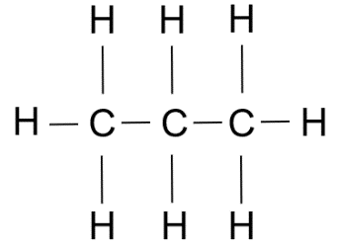
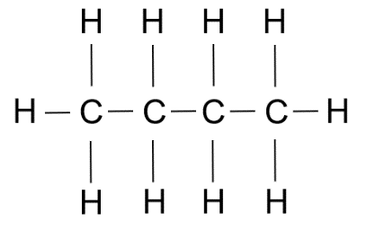

Butane
Propane

- Using your answers to part d), explain what is meant by the word ‘saturated’.
Answer: Hydrocarbons containing carbon single bonds only.
- When propane and butane burn in air, the same two products are made in each case.
State the names of the products formed.
Answer: Carbon dioxide and water.
- Complete the word equation to show what happens when these gases burn in air:

Propane + oxygen carbon dioxide + water

Butane + oxygen carbon dioxide + water
- The chemical formula for propane is C₃H₈.
Complete the symbol equation below to show propane burning in air.
C3H8 + 5O2 3CO₂ + 4H₂O

The ratio in which propane and butane are mixed together as a fuel in the torch (by volume) is 2 : 1.
- What fraction of the fuel is butane?
Answer: $\frac{1 }{3}$
- An Olympic torch contains 37.8 cm³ of fuel.
Calculate the volume of butane in the fuel.
Show your working.
Answer: $\frac{1 }{3}$ x 37.8 = 12.6 cm³

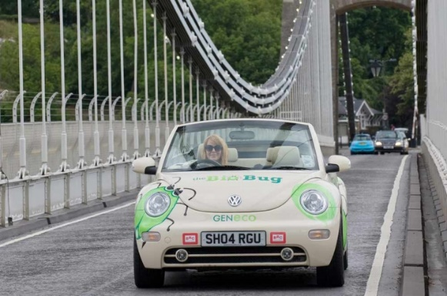
- The image to the right shows a car called the ‘Bio-Bug’.
Source: GENeco
You can find out more at www.geneco.uk.com/Case_study_Bio_bug/.
Solid human waste decomposes to make a gas that powers the car.
This gas is a hydrocarbon containing only one carbon atom.
The gas is the first member of the alkane homologous series.
Source: Wessex Water
- What is the name of the gas?
Answer: Methane.
- State the chemical formula for the gas.
Answer: CH₄
- Explain how the gas powers the car.
Answer: Methane burns in oxygen (from the air) to form heat energy. The car’s engine converts most of that heat energy to kinetic energy, powering the car.
- Complete the symbol equation to show the gas burning in air.
Methane + oxygen carbon dioxide + water
- Suggest why this car is considered to be more environmentally friendly, or ‘greener’, than a car that runs on petrol or diesel.
Answer: Petrol and diesel come from crude oil and this is a finite resource. However, methane (in this case) comes from human waste and is therefore renewable. The energy costs will be lower in the latter case.

- When 16.0 g of methane burns, 890 kJ of heat energy is produced.
Calculate how much heat energy is produced when 1.00 kg of methane burns.
Give your answer in MJ and to 3 significant figures.
Show your working.
Answer: Unit conversion: 1.00 kg = 1000 g.
1.00 g of methane produces $\frac{890}{16}$ kJ = 55.625 kJ.
1000 g of methane produces 55.625 kJ × 1000 = 55,625 kJ or 55.6 MJ (to 3 significant figures).

