Hard water challenge
Contents
- Learning objectives
- Activity 1: measuring calcium concentrations
- Activity 2: investigating ion-exchange filters
- Activity 3: using dipsticks to measure the hardness of water

Acknowledgements
This resource was originally developed by Nottingham Trent University to support outreach work delivered as part of the Chemistry for All Project.
To find out more about the project, and get more resources to widen participation, visit our Outreach resources hub: rsc.li/3CJX7M3.

Learning objectives
By the end of this session, you will be able to:
- Explain the construction and use of a look-up chart.
- Follow instructions for carrying out a procedure to test hard water.
- Compare the effectiveness of different water filters.
- Describe the domestic and health issues associated with hard water.
Introduction
In this practical, you will work in pairs or groups of three to measure the concentration of calcium ions, in parts per million (ppm), in some solutions of known concentration. Using the results, you will create a look-up chart. This will allow you to measure the hardness of a range of unknown water samples. You will then investigate how well different water filters remove calcium ions from a solution with a very high concentration: 500 parts per million (ppm).
The concentration of dissolved calcium ions (otherwise known as the ‘hardness’ of the water) can be determined by taking one kilogram of water (approximately one litre) and finding the mass of dissolved calcium ions in milligrams.
A 1 kg sample of water containing 0.100 g (100 mg) of calcium ions has a concentration of 100 ppm.
The table shows the classification of the hardness of water samples according to the concentration of calcium ions dissolved in the water. You will need to refer to these numbers during Activities 1, 2 and 3.
Classification | Concentration/ppm
Soft | < 60
Moderately hard | 60–120
Hard | 120–180
Very hard | > 181

Activity 1: measuring calcium concentrations
You will measure the calcium ion concentration in a range of solutions and assess their ‘hardness’ by adding a coloured indicator and a reagent called ethylenediaminetetraacetic acid (EDTA). When the indicator is added, it binds with the calcium ions, producing a red colour. As EDTA is then added, the calcium leaves the indicator and bonds with the EDTA, producing a blue colour.
The higher the concentration (in ppm) of the calcium ions in the solution, the higher the number of drops of EDTA needed to cause a colour change. The indicator you will use (Eriochrome-T-black) works best in a weakly alkaline solution. You will use a buffer to keep the solution at a pH value around 10.
Equipment (per group)
- 6 × boiling tubes
- 1 × boiling tube rack
- 5 cm³ measuring cylinder or plastic syringe
- 1 cm³ pipette
- Dropping pipette
- Permanent marker pen
- Graph paper
- Safety glasses
Chemicals (per group)
- EDTA solution, 0.01 mol dm^{–3}
- 30 cm³ buffer solution pH 10 per round of testing
- Eriochrome-T-black indicator solution in ethanol or IDA (hazard dependant on the solvent used – take care when using it as ethanol liquid and vapour are highly flammable and IDA is highly flammable, harmful if swallowed and may cause damage to organs)
- 2 cm³ calcium chloride solutions of five different concentrations of calcium:
100 ppm; 200 ppm; 300 ppm; 400 ppm; 500 ppm per repeat
- 2 cm³ distilled water per repeat for testing and extra for cleaning pipettes

To do
- Preparing your samples
You will be testing six samples in this activity. You will use calcium chloride solutions with concentrations of 100 ppm, 200 ppm, 300 ppm, 400 ppm and 500 ppm. You will also test a sample of distilled water that has a 0 ppm concentration because the calcium ions have all been removed.
- Collect six clean and dry boiling tubes and place them in a rack.
- Label each boiling tube with the concentration of the solution to be tested.
- Carefully add 5 cm³ of the buffer solution to each boiling tube using the measuring cylinder.
- Add two drops of indicator solution to each tube – the indicator will remain blue.
- Carefully rinse the long 1 cm³ pipette with plenty of distilled water.
- Draw up a 1 cm³ sample of the 100 ppm solution into the pipette and then dispose of this sample into the sink. This will rinse the pipette and remove any contaminants.
- Draw up a second 1 cm³ sample of the 100 ppm solution and transfer this into the first boiling tube containing the buffer solution and indicator. The contents of the tube will turn to a purple/pink circle and may turn cloudy.
- Repeat steps 4–6 with each of the other solutions.

- Testing the samples
You should test the 500 ppm solution first as this takes the longest time.
- Using a dropping pipette, add one drop of EDTA solution to the purple/pink mixture in the boiling tube and swirl the tube gently to mix the contents.
- Look carefully for a permanent colour change (to blue).
- If the solution remains purple/pink, add another drop of EDTA. Keep adding drops until the mixture turns blue. Make sure that you keep a count of how many drops you add, swirl the tube after adding each drop and try to keep the size of each drop used the same.
- Once the solution has turned blue, wait for 30 seconds to see if the colour lasts or if you need to add any more drops of EDTA.
- Record the total number of drops used in the table.
- Repeat steps 1–5 with each of the other calcium solutions (100–400 ppm) and the distilled water.
Calcium concentration/ppm | Number of drops of EDTA
- If you have time, repeat the procedure and calculate the average number of drops added for each concentration.

- Creating the look-up chart
Plot your results on a graph like the one shown below to create a look-up chart. Add a line of best fit.
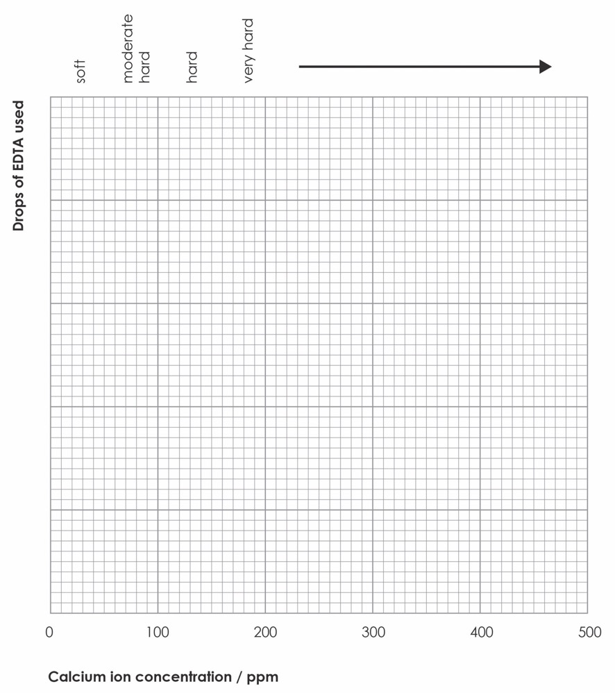

To answer
- How easy was it to tell that a colour change had taken place?

- How confident are you with your results?

- Do your results fit a straight-line (linear) relationship?

- Why might some people prefer soft water in their homes?

Laboratory analyst
Meet Joseph, a laboratory analyst and higher degree apprentice, who works at Thames Water and carries out vital safety tests on drinking water for 15 million people. Watch his video job profile on slide 6 or at rsc.li/3Fm1fnC.
Activity 2: investigating ion-exchange filters
For this experiment, you need to use the 500 ppm solution only. You will pour samples of this solution through different water filters and measure the calcium concentration of the filtered water. If you have time, you could investigate how well the filters work with repeated use of the same sample.
Equipment (per group)
- 1 × boiling tube per filter tested
- 1 × boiling tube rack
- 5 cm³ measuring cylinder or plastic syringe
- 1 × 250 cm³ beaker
- 1 × 600 cm³ beaker
- Clamp and stand
- 1 cm³ pipette
- Permanent marker pen
- A selection of commercial ion exchange water filters for testing
- Safety glasses
Chemicals (per group)
- Bottle of calcium chloride solution, CaCl₂(aq) 500 ppm
To do
- Collect a bottle of the 500 ppm solution.
- Measure out a 200 cm³ sample into a clean, dry 250 cm³ beaker.
- Label an empty 600 cm³ beaker with the filter being used and clamp one of your water filters over it ready to collect the filtrate.
- (Note: some filters can be used as they are but you may have to attach a filter funnel to make it easier to collect the filtrate.)
- Pour the sample of solution through the filter into the empty beaker.
- Once all the solution has been poured through the filter, carefully pipette 1 cm³ of the filtrate into a clean, dry boiling tube. Put the rest of the filtrate to one side for other groups to use.
- Add 5 cm³ of the buffer solution to the pipetted sample using a measuring cylinder and two drops of indicator.
- Repeat the procedure from part one by adding the EDTA one drop at a time and swirling the tube until you get a permanent colour change to blue.
- Use your look-up chart from Activity 1 to find the concentration of calcium in the filtrate from the number of drops of EDTA needed to cause the colour change to blue.
- Record the results in the table.
- Repeat steps 6–9 with a different filtrate collected by another group and a fresh sample of 500 ppm solution.
Volume passing through filter / cm³ | Water filter  system used | Number of drops  of EDTA needed | Concentration of calcium ions in the filtrate / ppm  (From look-up chart)
- If time allows, you could test further 1 cm³ samples and calculate an average result for each filter. Or you could use the other groups’ results to calculate an average.
- If time allows, pour the beaker of filtered sample through the filter for a second time and test as before.

To answer
- Which water filter was most effective at removing calcium ions from the water?

- How much more effective was the most effective filter compared with the least effective filter?

- Hard water is better for your health. Soft water is better for domestic appliances such as washing machines. Sketch a diagram to show the ideal position of a water filter system in a typical family home.

Activity 3: using dipsticks to measure the hardness
of water
Your results from the first two activities can be confirmed using commercially available dipsticks and colour charts to estimate the hardness of the water samples quickly.
Equipment (per group)
- 6 × 50 cm³ beakers
- 6 commercial water hardness testing dipsticks and colour chart
- Dropping pipette
- Permanent marker pen
- Safety glasses
Chemicals (per group)
- 25 cm³ calcium chloride solutions of five different concentrations of calcium:
100 ppm; 200 ppm; 300 ppm; 400 ppm; 500 ppm
- 25 cm³ distilled water
The instructions for dipsticks tend to vary, so follow the instructions provided on the packaging.
For guidance:
- Collect six 50 cm³ beakers and label each one with the concentration of the solution to be tested.
- Pour approximately 25 cm³ of 500 ppm solution into the appropriate beaker.
- Place the testing strips into the solution for the number of seconds recommended on the instructions and then remove.
- Match the colour of the test strip against the colour chart and determine the concentration of calcium ions. You will need to complete colour matching within one minute of removing the dipstick from the sample.

- Record your results in the table below.
- Repeat steps 2–5 with each of the other calcium solutions (100–400 ppm) and the distilled water.
Calcium concentration  of labelled solution / ppm | Calcium concentration  using dipsticks / ppm
To answer
- How well did the dipstick results compare with your results for Activity 1? Consider the accuracy of the dipsticks and colour charts in your answer.

- When might these dipsticks be useful? Who might use them?

Analytical chemists
Meet Harsh and Michael, analytical chemists, who both work at Thames Water and have the critical job of analysing samples of water to keep drinking water and sewage systems safe and operational. Find out more about their roles on slide 11 or at rsc.li/3ZJNO97.

