Periodicity

Period 3 oxides summary

Complete the diagram showing the formulae of the period 3 oxides, their pH in water, the nature of the oxide and the species present in the solution.
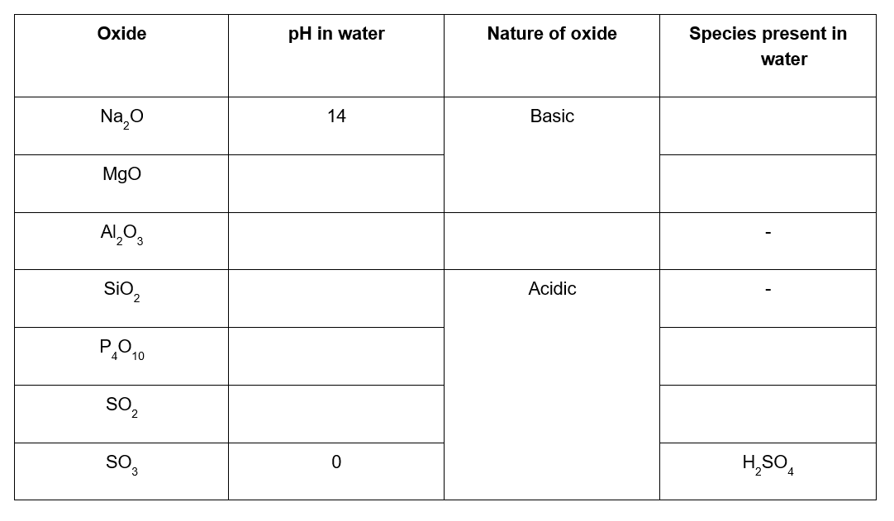

Reactions of Period 3 oxides

Write balanced equations for the following reactions illustrating the reactions of period 3 oxides with water, acids and bases.

- Phosphorus oxide with water
- Sulfur dioxide with water
- Sulfur trioxide with water
- Sodium oxide with hydrochloric acid
- Magnesium oxide with sulphuric acid
- Aluminium oxide with sulphuric acid
- Aluminium oxide with sodium hydroxide
- Silicon dioxide with sodium hydroxide
- Phosphorus oxide with sodium hydroxide
- Sulfur dioxide with sodium carbonate

Structure and bonding in Period 3 oxides

1. Complete the table to show the bonding present in the period 3 oxides.
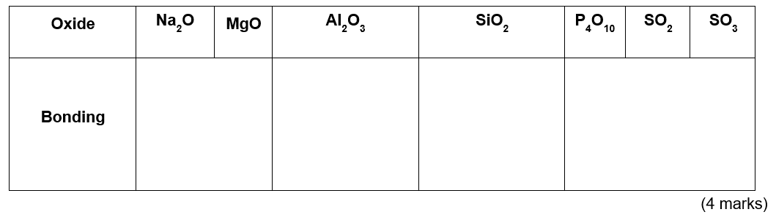
- Explain why Al₂O₃ displays amphoteric properties with reference to the ions present.
- marks)

- In water, SiO₂ maintains a pH of 7. With reference to the structure and bonding in SiO₂ explain this observation.
(1 mark)

- Na₂O reacts with water to give a solution with a pH of 14 whereas MgO reacts with water to give a solution with a pH of 10. Write equations for both reactions and explain the observed differences in pH.
- marks)

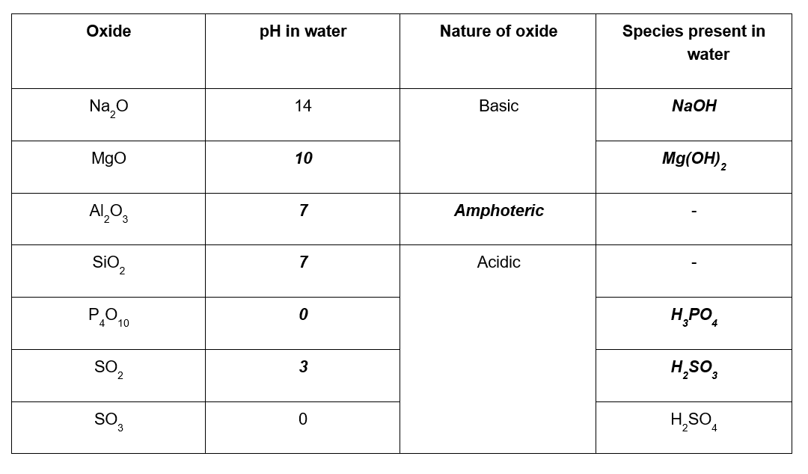
Periodicity – Answers

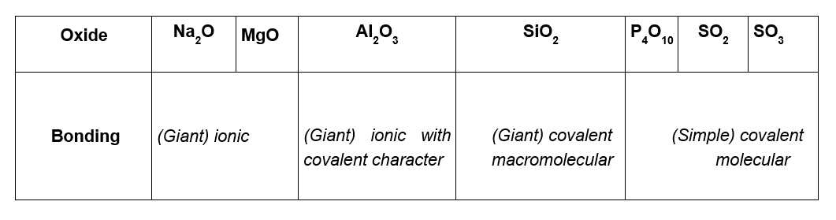
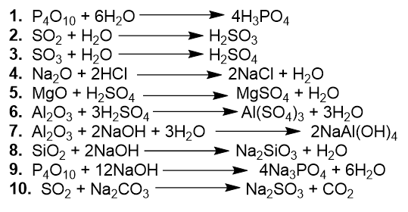
(a) Al³⁺ ion is small and highly charged (1 mark) and polarises the oxide ion (1 mark)
(b) SiO₂ has a covalent macromolecular structure so is insoluble in water (1 mark)
(c) Na₂O + H₂O → 2NaOH (1 mark) MgO + H₂O → Mg(OH)₂ (1 mark) MgO is only sparingly soluble/is less soluble (1 mark)

