Separating caffeine
Education in Chemistry
May 2021
https://rsc.li/2QLDAXU
An excellent way to improve your understanding when reading an extended piece of text is to convert the key processes into a series of labelled diagrams or a graphic.
In this activity you will develop this skill by looking at each of the three options for decaffeination in turn and completing graphics of the steps involved in each process.

1. Extracting caffeine with organic solvents
a. Add labels to each of the diagrams used to illustrate the step described.
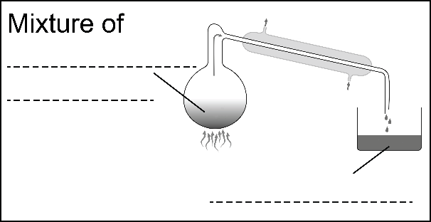
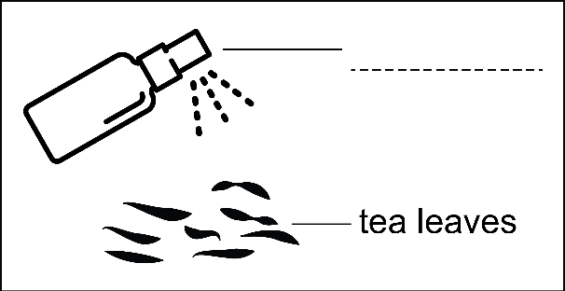
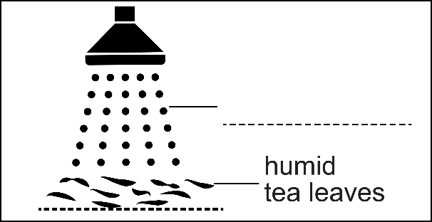
b. Add in an explanation of why that step is needed. The explanation has been added to Step 1 for you as an example.
Step 1
Spray the tea leaves with water.
Explanation
To swell the leaves and open their pores to enable the organic solvent to penetrate them.
Step 4
Caffeine is removed from the solvent by distillation.
Explanation
_______________________________________________
_______________________________________________

Step 3
The caffeine-laden dichloromethane is driven off the leaves using steam before they are dried to reinstate their original humidity levels.
Explanation
_______________________________________________
_______________________________________________

Step 2
Shower the humid tea leaves for 1.5–2.5 hours with dichloromethane.
Explanation
_______________________________________________
_______________________________________________
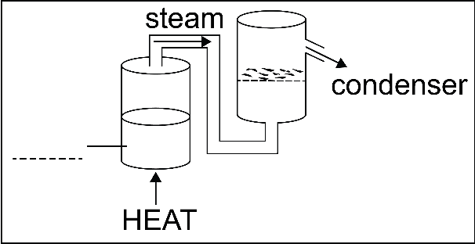

Step 4
Caffeine is removed from the solvent by distillation
Explanation

2. Extracting caffeine with supercritical carbon dioxide, CO₂
For this extraction option, describe the step illustrated by the diagram and add an explanation of why that step is required.

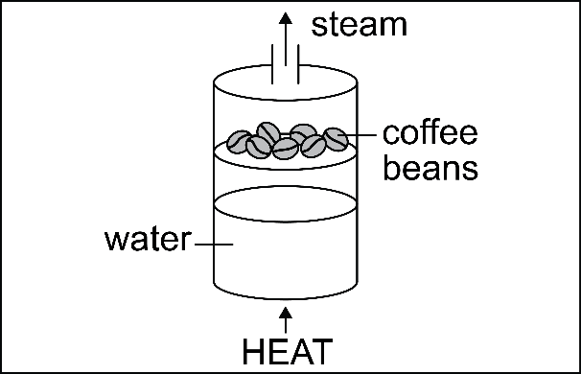
Step 1
_______________________________________________
Explanation
_______________________________________________
_______________________________________________
_______________________________________________

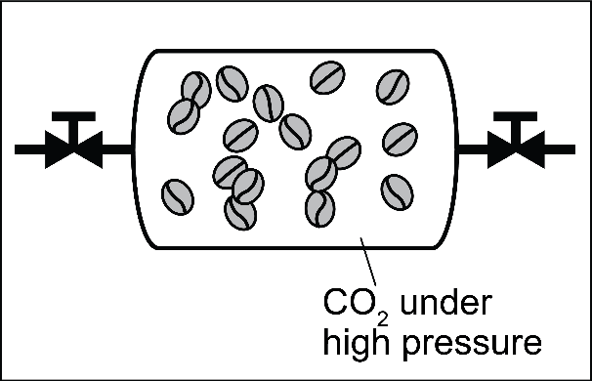
Step 2
_______________________________________________
Explanation
_______________________________________________
_______________________________________________
_______________________________________________

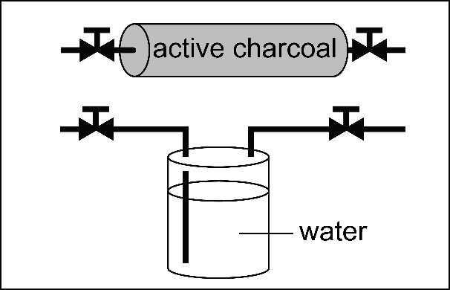
Step 3
_______________________________________________
_______________________________________________
Explanation
_______________________________________________
_______________________________________________

3. Extracting caffeine with water
Using the graphics given above as examples, draw your own graphic to illustrate the steps involved in extracting caffeine from coffee using water.

Answers

1. Extracting caffeine with organic solvents

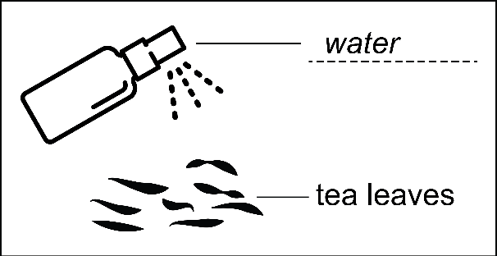
Step 1
Spray the tea leaves with water.
Explanation
To swell the leaves and open their pores to enable the organic solvent to penetrate them.
Step 2
Shower the humid tea leaves for 1.5–2.5 hours with dichloromethane.
Explanation
To extract the caffeine.
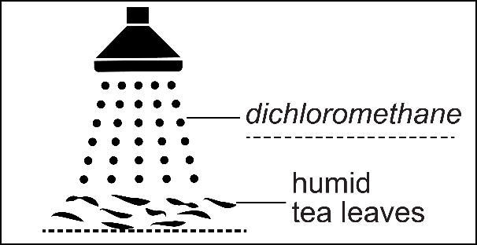

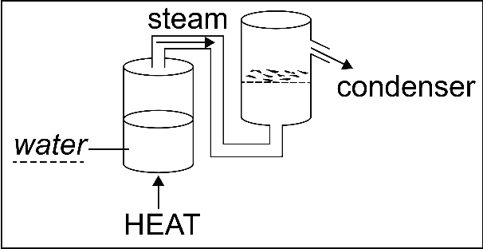
Step 3
The caffeine-laden dichloromethane is driven off the leaves using steam before they are dried to reinstate their original humidity levels.
Explanation
To ensure the tea is free of solvent and caffeine and ready to drink.

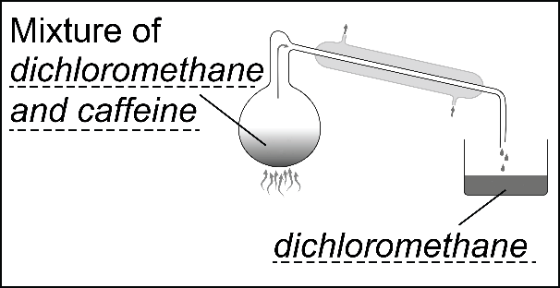
Step 4
Caffeine is removed from the solvent by distillation.
Explanation
Separating the caffeine from the dichloromethane means that the dichloromethane can be reused and the caffeine can be purified for use as natural food-grade caffeine.

2. Extracting caffeine with supercritical carbon dioxide, CO₂

Step 1
Swell the coffee beans or tea leaves with steam.
Reason
To enable the solvent to penetrate the beans or leaves.

Step 2
Place the coffee beans or tea leaves in a high-pressure vessel with CO₂ and pressurise for a few hours.
Reason
To selectively extract the caffeine.
Step 3
Pass the carbon dioxide through active charcoal or into distilled water.
Reason
To remove the caffeine from the CO₂ to allow both to be reused.

3. Extracting caffeine with water
Possible steps that could be illustrated include:
Step 1 Soak the green coffee beans for 8–10 hours in water that has been pre-saturated with all the soluble solids found in coffee beans apart from caffeine.
Step 2 Dry the beans.
Step 3 Pass the water through a carbon filter to recover both the caffeine and the aqueous extract for reuse.

