Microscale synthesis of aspirin – student sheet

In this experiment you will be preparing 2-ethanoyloxybenzenecarboxylic acid (aspirin) from the reaction between 2-hydroxybenzoic acid (salicylic acid) and ethanoic anhydride. The use of chemical splash goggles is recommended.

The reaction is:

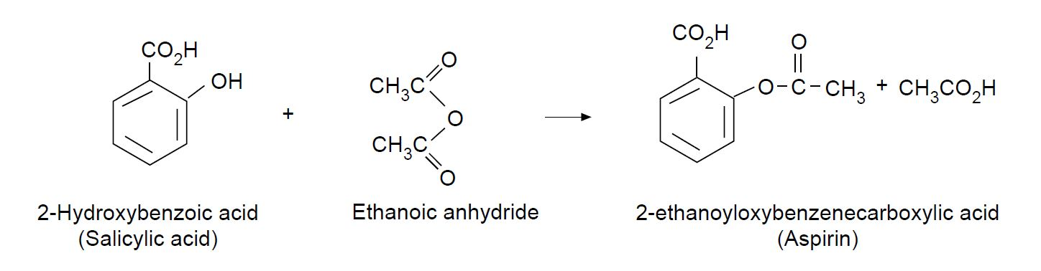

Instructions

- Half-fill a 50 cm³ beaker with deionised water, and heat to 70–80 °C.
- Weigh 0.23 g of 2-hydroxybenzoic acid (salicylic acid) into a test tube.
- Add 25 drops of ethanoic anhydride followed by one drop of 85% phosphoric acid.
- Place in the water bath and leave for 15 minutes.
- While still warm add 1.5 cm³ of deionised water (use the measuring cylinder) and cool to room temperature until crystallisation begins, then cool in an ice bath.
- Filter through a small filter funnel and recrystallise in a test tube using a mixture of 0.7 cm³ ethanol and 2 cm³ of deionised water.

Health, safety and technical notes

- Wear eye protection throughout (splash-resistant goggles to BS EN166 3).
- This experiment should be done in a fume cupboard.
- 2-Hydroxybenzoic acid is HARMFUL if swallowed or in contact with the skin and can cause eye damage.
- Ethanoic anhydride is CORROSIVE, HARMFUL if swallowed or inhaled and FLAMMABLE.
- Phosphoric acid (85%) is CORROSIVE.

