Swimming pool chemistry

Learning objectives
- Describe how the water in swimming pools is disinfected.
- Calculate concentration of various ions present in the water.
- Interpret data obtained from a mass spectrometer.
- Determine the structure of organic molecules.

Introduction

Chlorine (${Cl}_{2}$) is now rarely added directly to pools in the UK because of the hazards associated with its storage and use. Other chlorinating agents are used instead.

In a typical swimming pool, sodium chlorate(I) is added to disinfect the water. The chlorate(I) ion is the conjugate base of the weak acid $HOCl$. The equilibrium constant $K_{a}$ for $HOCl = 2.9 × {10}^{-8} mol {dm}^{-3}$ at $298 K$. Both the chlorate(I) ion and the acid $HOCl$ are involved in the disinfecting.

Some data were obtained from a swimming pool in Taunton, on a particular day in September. The combined concentration of $HOCl(aq)$ was measured as 0.50 parts per million (ppm). The $pH$was 7.3.

Questions

Part one
- Convert the combined concentration of $HOCl(aq)$ and $OCl^{-}(aq)$from parts per million into $mol {dm}^{-3}$. Give your answer to two significant figures.

Hint: 1 ppm = 1 mg dm⁻³ or ppm = mols x 1,000,000
- Calculate the concentration of $HOCl(aq).$ Give your answer to two significant figures.

Hint: Use the Henderson–Hasselbalch equation.
pH = pKa + log10([conjugate base]/[weak acid])

Sodium hydrogen carbonate and $CO_{2}$ gas are also added to buffer the swimming pool water. The $K_{a}$ value for carbonic acid (the weak acid formed when $CO_{2}$ dissolves in water) is $4.2 × {10}^{-7} mol {dm}^{-3}$. The ‘total alkalinity’ (combined concentration of all the bases present) was measured as $1.08 × {10}^{-3} mol {dm}^{-3}$.

- Assuming the only bases detected in the total alkalinity test are $O{Cl}^{-}$ and $HCO^{-3}$, calculate the concetration of carbonic acid in the swimming pool. Give your answer to two significant figures.

Hint: Start by writing down the equilibrium expression for carbonic acid.
Use your answers from questions 1 and 2 to calculate the concentration of OCl⁻.
Use the raw data rather than rounded data as this will build error into your answers.
- Explain the effect on the concentration of $HOCl$ of adding extra $CO_{2}$ gas.

Hint: Start by describing the reaction between carbon dioxide and water.
Then consider the effect it will have on the HOCl(aq) OCl⁻(aq) + H⁺(aq)

Calcium chloride is also added to swimming pool water. Another calcium compound, calcium sulfate, is a slightly soluble component of the grout used in between the tiles inside the swimming pool. The solubility product ($K_{sp}$) of a salt is the equilibrium constant for an ionic substance in saturated solution, such that $K_{sp}$ for a salt $M_{a}X_{b} = {\left[M\right]}^{a}{\left[X\right]}^{b}$ with the units that depend on $a$ and $b$.

- Give a general expression for the units of a solubility product of salt $M_{a}X_{b}$ in terms of $a$ and $b$.
- $K_{sp}$ for calcium sulfate has a value of $2.4 × {10}^{-5} {mol}^{2} {dm}^{-6}$ at $298 K$. If the concentration of chloride ions from the $Ca{Cl}_{2}$added is $0.1 mol {dm}^{-3}$, what is the concentration of the sulfate ions in the swimming pool?

Hint: K_{sp} = [Ca²⁺][SO₄²⁻]
Start by working out the concentration of the calcium ions from the information provided.
- Explain how adding calcium chloride helps to prevent grout dissolving.

Hint: Look up the common ion effect and then consider the effect of the additionally added ions on the equilibria present.
- The enthalpy change of solution for $NaCl(s)$ is $+3.9 kJ {mol}^{-1}$ and for $CaSO_{4}(s)$ it is $-17.8 kJ {mol}^{-1}$. Why is $CaSO_{4}$only sparingly soluble and $NaCl$ very soluble?

Hint: To answer this question you will need to consider factors such as the size and charge of ions and entropy.

Part 2

Sometimes organic compounds are added to swimming pool water instead of, or in addition to $HOCl$and $O{Cl}^{-}$. One example is trichloroisocyanuric acid. This undergoes hydrolysis to form an equilibrium with $HOCl$ and isocyanuric acid.

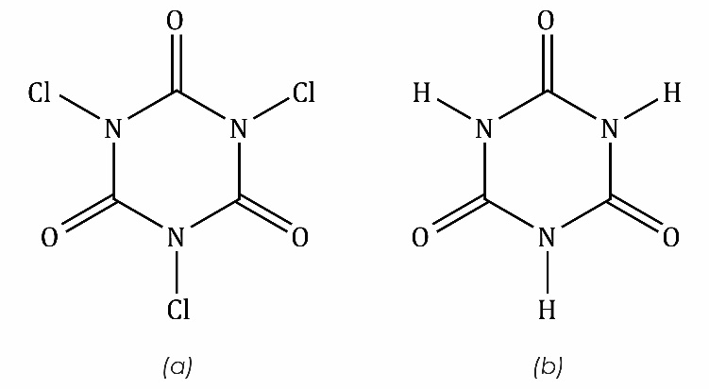

Figure 1: the structure of (a) trichloroisocyanuric acid and (b) isocyanuric acid
- Some data from the mass spectra of trichloroisocyanuric acid are shown below. The isotopes chlorine-35 and chlorine-37 occur in the ration 3 : 1.
- Identify the species detected at the peaks listed in the table. Note that molecules often fragment inside mass spectrometers and there can be rearrangement of the atoms in the fragments.
Mass/charge ratio | Relative height of peak as a percentage of the most abundant peak | Species giving rise to the peak
42 | 17.9 | $$NCO^{+}$$
70 | 100.0 | and
72 | 12.9
74 | 2.3
77 | 81.4
79 | 26.4
154 | 18.4
156 | 11.7
158 | 2.0
231 | 24.6
233 | 23.4
235 | 7.8
237 | 1.0
- Account for the relative heights of the peaks at mass/charge (m/c):
- 154, 156 and 158
- 231, 233, 235 and 237.

Hint: Use the number of chlorine atoms (and therefore isotopes) present in each species as your starting point.
- Use the relative heights of the peaks at m/c 231, 233, 235 and 237 to calculate the relative molecular mass of trichloroisocyanuric acid to two decimal places.
- It seems likely that the peak at m/c 70 is due to two species. A high resolution mass spectrometer would resolve the single peak at m/c into two separate peaks. Calculate what their relative heights would be.

Hint: Use the relative height of the peak at m/c 72 together with the fact that the isotopes chlorine-35 and chlorine-37 occur in the ratio 3 : 1 as your starting point.
- How many peaks would you expect to see in the proton NMR spectra of isocyanuric acid?

Hint: Look for the number of hydrogens in different environments.
- Discuss whether you think that isocyanuric acid will have a delocalised π system like benzene.
- Write a balanced equation for the reaction of trichloroisocyanuric acid and water.

Hint: Start by drawing out all the different resonance structures of isocyanuric acid.
- Discuss the oxidation state of the chlorine in trichloroisocyanuric acid. Electronegativity values are given below.

Hint: Start by comparing the different values of electronegativity and consider what this means for the bonds present. Alternatively, consider the products of hydrolysis and work backwards.
H  2.1 |  | Li  1.0 | Be  1.5 | B  2.0 | C  2.5 | N  3.0 | O  3.5 | F  4.0
 |  | Na  0.9 | Mg  1.2 | Al  1.5 | Si  1.8 | P  2.1 | S  2.5 | Cl  3.0

Pauling electronegativity values for some elements

Extension questions

Most ketones and aldehydes exist in solution as two tautomeric forms that are in dynamic equilibrium. The two tautomers (the ‘keto’ and ‘enol’ forms) interchange rapidly in the presence of $H^{+}$ions. An example of these forms for propanone is shown below:

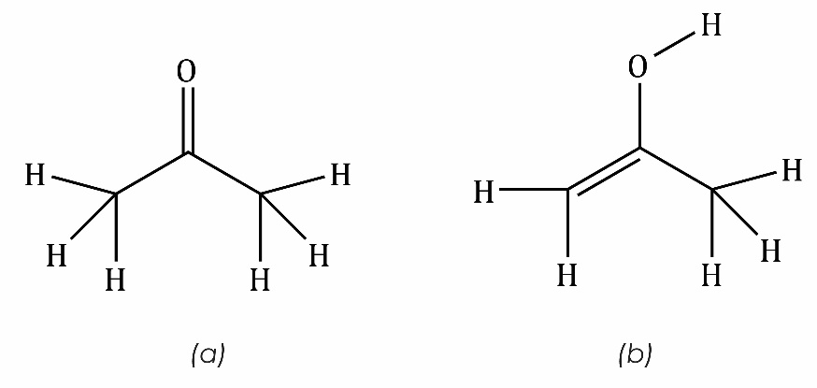

Figure 2: the structures of (a) the keto and (b) the enol – tautomers of propanone
- Suggest a mechanism for the conversion of the keto to the enol tautomer of propanone.

Hint: The H⁺ acts as an electrophile.
- Suggest a structure for cyanuric acid, the tautomeric form of isocyanuric acid.

