Fertilisers and sustainability – teacher notes
Education in Chemistry
Sustainability in chemistry 2021
Goal 2: End hunger, achieve food security and improved nutrition and promote sustainable agriculture
rsc.li/3sFPwsx
‘As the world population continues to grow, much more effort and innovation will be urgently needed in order to sustainably increase agricultural production.’
The ability to perform a chemistry practical safely is a key skill, assessed as part of 16–18 chemistry courses in the UK and Republic of Ireland. This activity gives learners an opportunity to practise these skills, in the context of fertilisers and the sustainability of their manufacture and use.
The practical itself, rates of hydrolysis of urea, and the calculation and conclusion questions are aimed at learners in their second year of a 16–18 chemistry course. Additional questions on fertiliser sustainability that accompany the practical add context. These could also be used with 14–16 learners. This practical experiment is an existing resource, part of our Challenging plants: fertilisers practicals.

Resources
- Student sheet containing instructions for completing a practical on the rate of hydrolysis of urea.
- Teacher and technician sheet with some information about the background chemistry and equipment list.
- Learner worksheet with additional questions based on the practical to help with assessment of practical skills and additional green chemistry questions, linking fertiliser to UN sustainable development goal 2.
- Grid for assessing the practical using CPACs (suitable for those following English curriculums).
Learning objectives
- Design an experiment to collect data to measure the rate of hydrolysis of urea.
- Carry out, analyse and conclude using gathered data, for an experiment to measure the rate of hydrolysis of urea.
- Use collected experimental data to identify the initial rate of hydrolysis of urea, find the order of reaction, write a rate equation and identify a rate determining step.
- Use a mathematical model for describing rates of reaction and use a graph to find half-life.
- Expand on the use of fertilisers linking to UN sustainable development goal 2.
This resource contains suggestions for assessing most of the practical skills for the write-up of a complete investigation. You could decide to just assess part of the practical, in which case the learning objectives and worksheets can be adjusted to give more or less information.

Differentiation
This activity is well suited to all learners, regardless of prior attainment. Some learners may require additional support in terms of further detail or prompts, to develop their practical skills.
Extension questions are available, encouraging learners to link their understanding of fertilisers and sustainability beyond the syllabus.

Self-assessment
Learners should be encouraged to self-evaluate their practical skills and/or peer-evaluate another learner’s write up. They should write down any targets for improving competency in the next practical.

Answers to questions based on the practical
1. Plan
List the variables that need to be controlled when measuring reaction rates. How would you control those variables in this practical, Rate of hydrolysis of urea?
Temperature: Do the reaction at room temperature. Measure the temperature before and after the experiment. If it is very different then the reaction can be completed in a water bath at a constant temperature.
Concentration of reactants: Use the same volume and concentration of urea solution. If repeating the experiment at different concentrations of urea, use the same volume. Use the same concentration of hydrochloric acid in the burette.
Pressure: Not relevant in this reaction.
Surface area: Use finely crushed soybean powder.
Catalyst: Use the same mass of finely crushed soybean powder from the same batch of soybeans. The catalyst in this experiment is urease.
pH: This reaction is designed to take the pH to 6.5 in each case.

In this practical, the independent variable is suggested to be the concentration of urea. The practical is designed to just be completed once with a set amount of urea in order to process it mathematically to gain practice in mathematical models surrounding rate equations. It can, however, be easily altered to be repeated with a different concentration of urea.
Measured variable is the volume of acid required to bring the pH to 6.5.
Control variables are listed above.

2. Method: apparatus
Justify your choice of apparatus for this practical.
See practical teacher and technician sheet for equipment list.
Learners could choose which equipment to use from a selection of apparatus on a bench. Equipment may be available to allow learners to choose between using a pH probe or a data logger to measure pH. If it would be difficult to have each learner using a different set of equipment, then they could justify their own equipment list before the practical and then add in adjustments for the equipment given.

3. Method: hazards
Using the CLEAPSS student safety sheets, or another appropriate source, assess the hazards associated with this practical and write a control measure used to lower the risk for each hazard identified.
Chemical | Reference | Hazard | Precaution
0.1 mol dm⁻³ NaOH (aq) | 31 | Low hazard but may cause harm in eyes | Wear goggles
0.1 mol dm⁻³ HCl (aq) | 20 | Low hazard but may cause harm in eyes | Wear goggles
Urease powder | 2 | Corrosive  Health hazard  Irritant | Use smallest amount possible  Wear eye protection  Use a fume cupboard to contain powder

Reference: CLEAPSS student safety sheets (2019)

4. Calculations and conclusions
The learner could plan to do a repeat and/or compare their values with a class set of results. This is not suggested in the student sheet for this practical.
You may prefer for the learner to devise their own results chart listing a title, units and appropriate SF when filling in their data. If so, do NOT provide the second page of the student sheet for the practical, which gives the following suggested titles for results chart:
Time after urea was added to urease extract/minutes | Volume of 0.1 mol dm⁻³ HCl(aq) required to give pH 6.5/cm³ | Total volume of 0.1 mol dm⁻³ HCl(aq) added/cm³
The rate at which you add the acid to neutralise the ammonia made, is a measure of the rate of hydrolysis of urea.
a) Plot a graph of the volume of 0.1 mol dm⁻³ HCl(aq) added/cm³ against time/minutes
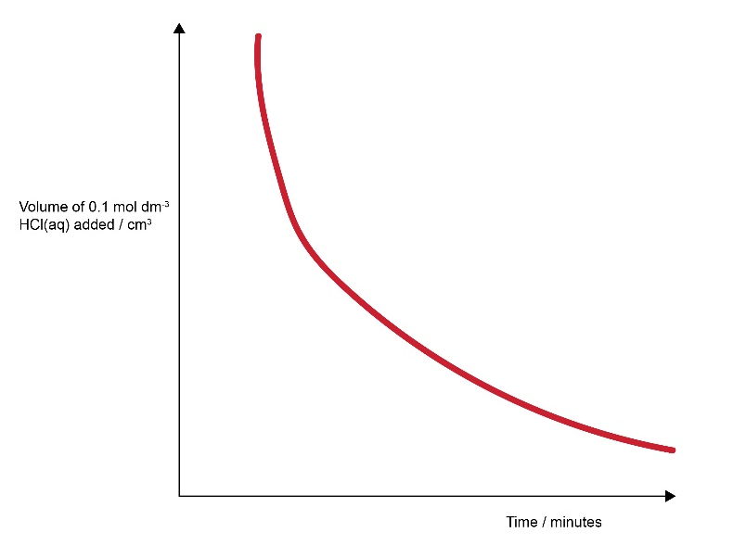
b) Using the graph, determine the initial rate of reaction. Add the correct units to your answer.
Use answer from learner’s graph. Expect to see evidence of working out a tangent. Units cm⁻³ min⁻¹.
c) Using the graph, find 3 half-lives. Using these half-life values, deduce the order of reaction with respect to urea.
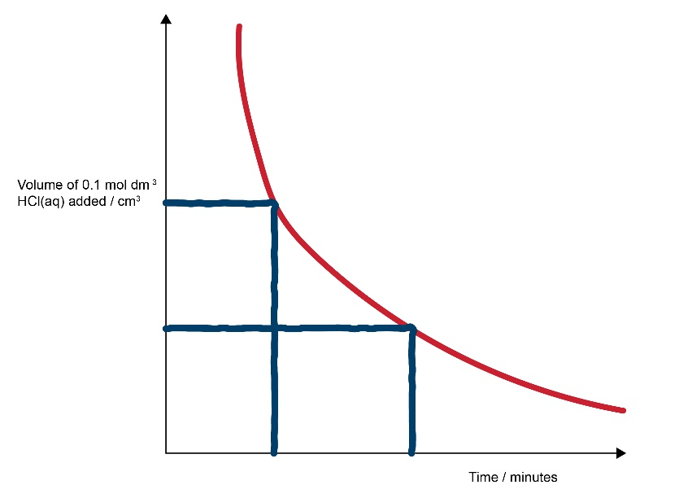
Expect the half-life to be constant (use reading correctly worked out from learner’s graph). First order with respect to urea.
d) The order with respect to urea needs be measured without any effect from the other reagents. Explain how the design of this reaction has helped.
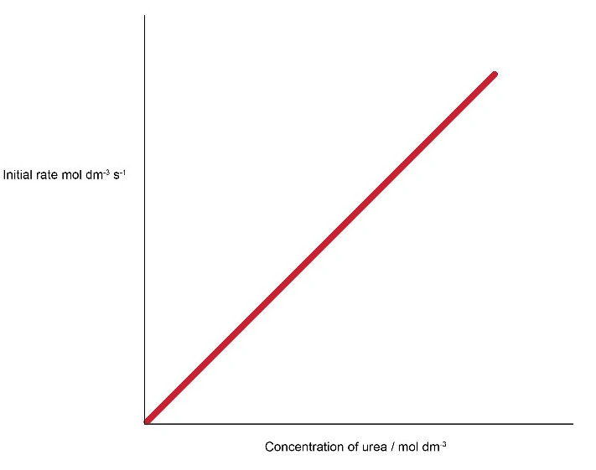
Large excess of other reagents so that the concentrations of these are effectively constant and thus those chemicals are zero order.
e) This experiment was repeated with different concentrations of urea solution and the initial rate was calculated for each concentration. Using your answer to c), sketch a graph of concentration of urea against initial rate of reaction.
f) Using the answer to c), identify the rate determining step in the mechanism below, and explain how you identified this step.
NH₂CONH₂ + H₂O H₂NCOOH + NH₃ RDS
H₂NCOOH + NH₃ 2NH₃ + CO₂
The urea is first order so the RDS should have 1 mole of urea in.
g) Using your answer to f), write an expression for the rate equation for the hydrolysis of urea.

Water is not a solvent but a reactant in this hydrolysis and one molecule appears in the rate determining step, so it is logical for the learner to add it into the rate equation like this:
Rate = k[NH₂CONH₂][H₂O].
However, as water is effectively a constant concentration then it doesn’t affect rate so also accept:
Rate = k[NH₂CONH₂].
Fertiliser sustainability questions
Industrially made, inorganic soluble ammonium salts are an alternative to spreading organic manure (or urine) on fields as a fertiliser for food crops. They are bought as soluble pellets or crystals and can be added to the soil for immediate use. Urea can also be made as pellets in industrial quantities or added naturally as urine to crops. In both cases it needs to be hydrolysed as shown in the Rate of hydrolysis of urea practical you have recently completed. Seaweed is another organic fertiliser which can be added directly to the soil. Organic fertilisers will also improve soil health.
- List one advantage and one disadvantage of using: a) organic materials such as manure and seaweed and b) inorganic ammonium salts, as fertiliser.
You may need to look up information. Include a list of your sources.

 | Organic | Inorganic | Both organic and inorganic
Advantage | Will improve the soil texture  Introduces useful microbes into the soil  Manure and seaweed are free  Helps increase water retention of soil | Can be nutrient specific so amounts of relevant nutrients can be controlled  Simple, easy and instant application to crops  Quick uptake | Increased plant crop yields
Disadvantage | Not nutrient specific  Raw manure needs time to start decomposing before the soil is ready to plant. Can't be added directly to growing plants.  Slow uptake | Can be harmful to human health if not applied safely and correctly  Does not improve soil structure  Need to buy in supplies | Excess nitrates from inorganic fertilisers leach from the soil and contaminate water supplies and cause eutrophication.  This will not happen with organic seaweed but can be a problem with slurry spreading.
- a) Compare the Haber process with hydrolysis of urea and work out the atom economy for each. Why is atom economy important?
Haber process N₂ + 3H₂ 2NH₃
Hydrolysis of urea NH₂CONH₂ + H₂O CO₂ + 2NH₃
b) Efficient processes have high atom economies. State one way that the atom economy in the hydrolysis of urea might be increased.
N₂ + 3H₂ 2NH₃ Atom economy = 100%
NH₂CONH₂ + H₂O CO₂ + 2NH₃ Atom economy = 34/78 = 44%
Atom economy tells you how much ‘waste’ the process gives by working out what percentage of the products is useful chemical/s. Efficient processes have high atom economies and are important for sustainable development, as they use fewer natural resources and create less waste. There is no waste with the Haber process as it only makes one useful product, so it has 100% atom economy. Atom economy can be increased by finding a different pathway for making a particular product and you could also find a use for any other products made.
- Apart from atom economy, what other factors would you need to take into consideration if you wanted to compare the sustainability of an industrial process for making nitrogen-based fertilisers from ammonia, such as the Haber process, with the hydrolysis of urea?

Rate of reaction, yield, conditions (including temperature, pressure, catalyst), toxicity and amount of any catalysts/reactants used, carbon footprint of the manufacturing process and factory, how the raw materials are obtained (hydrogen to make ammonia can be created from methane sourced from petroleum, manure can be from cows which themselves release huge amounts of methane).

Learners may come up with other ideas as well. There is no simple answer because everything has a carbon footprint and has advantages and disadvantages. Using search terms such as ‘why do we need fertilisers’ will pick up a variety of articles from companies and peer reviewed journals and an additional exercise would be to assess the validity of such information.

- Read the article about the smelly seaweed on the beaches of Jersey in the Channel Islands (https://www.itv.com/news/channel/2021-07-25/smelly-seaweed-affecting-trade-for-jerseys-beach-front-businesses). The neighbouring island of Guernsey has the same seaweed species but does not suffer from a smelly seaweed problem. You are a scientist in the Jersey Pollution laboratory. You have been asked to work out what the problem is and how to solve it.
Create a short half page report explaining what the problem is and suggesting how to solve it.
The problem is caused by the excessive run-off of soluble inorganic fertilisers into the sea. These added nitrates cause the seaweed to grow excessively and it gets washed up on the beach. The smell is due to the seaweed decaying. Guernsey is a much smaller island with less farming and thus less fertiliser usage. This problem is due to eutrophication and it is the environmental impact of over-use of synthetic fertilisers.
Learners might think that this is only a manufactured inorganic fertiliser problem. To a certain extent it is because the fertilisers added are instantly soluble, but this can occasionally happen with the use of organic fertilisers such as a spillage of slurry into local rivers.
In most countries there are strict laws about the use of fertilisers and slurry and when they can and can’t be applied to stop run-off into the water supply. Here is an example of the rules from Ireland.
Some learners may need extra help with a longer answer questions such as this. Here are some suggestions you could use:
Hint 1: seaweed photosynthesises and grows using the same nutrients as plants. What happens to plants when fertilisers are used?
Hint 2: the seaweed growth is in areas close to fields which are farmed. How might the farmers be accidently contributing to the seaweed problem?

UN Sustainable Development Goals Knowledge Platform https://sustainabledevelopment.un.org/topics

