Transition metal games
Education in Chemistry
July 2021
rsc.li/3pqFqKE
Games are fun! They are competitive and engaging and provide a safe environment to take a risk without the fear of getting an answer wrong.
These three transition metal games provide a great opportunity to develop understanding, vocabulary and thinking skills. Familiarise learners with keywords for the transition metals topic by exploring definitions in a variety of ways: writing questions, using key terminology in different sentences and avoiding ‘taboo words’.

Game 1: Jeopardy on transition metals
This game is inspired by the American television gameshow, Jeopardy!.

Game instructions
Print out or display the table of keywords on the second page of this document. For each keyword or phrase in the table, learners need to make up a question that will give that word or phrase as the answer.

Example
Neil Armstrong

Question ideas
Who is a famous American? This question is correct but not precise enough to give a single answer.
Who is an American astronaut? This question is better as it narrows down options but is still open to error.
Who was the first man on the moon? Spot on! This question will give the right answer.

Key starter words for questions
What….?
Who…?
Why….?
How….?
When…?

Jeopardy on transition metals
If this is the answer, what is the question?
Nº | Question | Answer
1 |  | Coloured compound
2 |  | H₂O ligand
3 |  | Variable oxidation state
4 |  | Coordination number 6
5 |  | Complex ion
6 |  | Reduce the activation energy
7 |  | Catalyst
8 |  | d Sub-shell
9 |  | Homogeneous
10 |  | Zinc

Game 2: Words in the bag
This game is inspired by the game Articulate!

You will need
- A set of keywords (print out page 4 of this document)
- A bag or envelope (one per team)
Cut out each of the words separately. The words could be printed on card or laminated to ensure that they can be used multiple times. Place the words in the bag or envelope.

Game instructions
This is a team game. It works best when teams have a minimum of three players. The aim of the game is to correctly describe as many words as possible in the shortest amount of time. Each team needs their own bag of words. The words are differentiated by colour with the easiest words in blue, the hardest in purple and the rest in orange. Remove the more difficult words to scaffold the task according to ability or progression through the course.
One player on each team is the ‘describer’, the other team members are the ‘guessers’. The describer pulls a keyword from the bag, ensuring that the guessers cannot see the printed word. The describer must use chemistry definitions to describe the word to their team. They must not use charades (actions) or ‘sounds like’ clues in their descriptions. The guessers can have as many tries at guessing as they need for each word. Once the correct word has been guessed the describer may pull another word from the bag.

Variations
The game can be played with one describer for the whole bag, or with the role of describer passing to another team member after each word.
Introduce a competitive element either against the clock or against other teams. The winners are the team who can guess the most words correctly in 45 seconds or the first team to complete the whole bag of words.

Follow-up activities

Extension 1
Challenge learners to create a transition metal related sentence using the words from the bag. Learners can either choose the word themselves, be given a word by the teacher or pick a word from the bag depending on the level of challenge or differentiation needed. Alternatively, see who can create a sentence that correctly includes as many of the words as possible.

Extension 2
Learners choose some of the words to create a ‘mind map’. Join the words with a linking sentence which shows how the terms are related. The more words that are chosen the more difficult the task. Learners should aim to link at least 5 words.
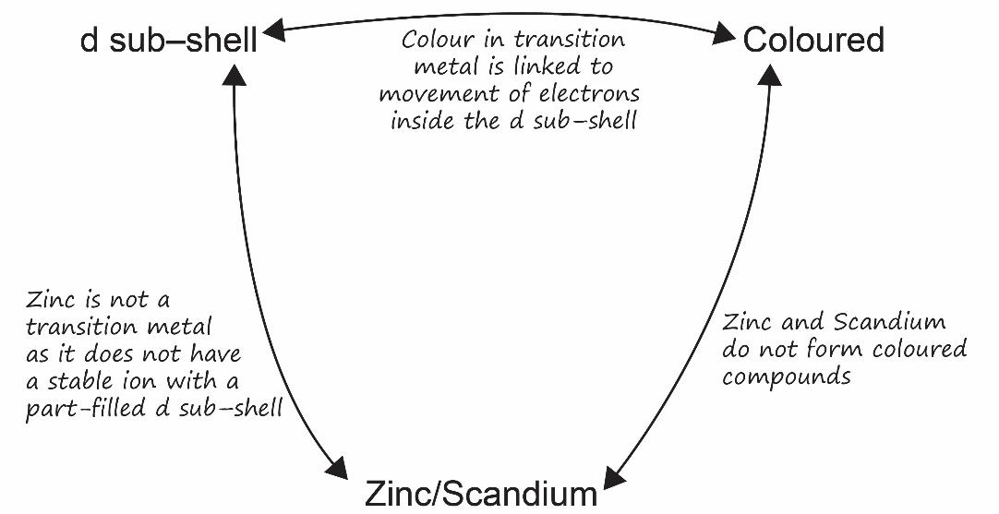
ligands | catalyst
precipitate | octahedral
tetrahedral | oxidation state
middle | metallic
d sub-shell | activation energy
coordination number | zinc/scandium
complex ions | (II) roman numeral
coloured | 5 orbitals
homogenous | heterogenous
stable | variable
monodentate | bidentate
partially filled d sub-shell | square planar

Game 3: Transition metal taboo
This game is inspired by the game Taboo.

You will need
- Transition metal taboo PowerPoint (available from: rsc.li/3pqFqKE)

Game instructions
This game is played in pairs.
Display the presentation ‘Transition metal taboo’. One player stands with their back to the presentation and the other faces it. The player facing the presentation describes the large word at the top of the slide without using any of the ‘taboo words’ below. The player with their back to the presentation, without looking, should guess the word at the top of the slide. They can guess as many times as they like.

Follow-up activities

Extension 1
Once you have completed all the words in the presentation, ask learners to come up with other words they could add to the game along with the ‘taboo words’ you are not allowed to say to describe it.

Extension 2
Rank the words in the presentation in order of difficulty. Explain why it is difficult to describe the word without using the taboo words.

Vocabulary
Keyword | Taboo words
Catalyst | Reaction, faster, energy, lower, not used up
Monodentate | One, single, ligand, attached, water, ammonia, chloride
Complex | Ion, atoms, charge, ligand, transition metal
Ligand | Water, bonded, transition metal, complex, ion
Zinc | Period 3, element, transition metal, ion, d sub-shell
d-Block | Electrons, structure, p-block, s-block, orbitals
Coloured | White, looks like, different, yellow, blue
(II) | Charge, Roman, number, +2, complex, ion
Homogenous | Catalyst, faster, reaction, same, state/phase, aqueous (aq)
Oxidation number | Different, varied, charge, ion, Roman numerals
Redox | Reduction, oxidation, charge, state, gain, loss, electrons

