Cool it

This resource accompanies the article Cooling in a warming climate in Education in Chemistry which can be viewed at: rsc.li/3YHZRTq.

The resource has been adapted from the book series In Search of Solutions, which aims to engage and motivate learners to develop key skills and encourage them to follow a scientific career through context-based problems. You can find more practical problem-solving activities from this series at: rsc.li/3ZUSPvu.

Learning objectives
- Describe and explain the changes that take place during an endothermic reaction.
- Devise a method to lower the temperature of water at room temperature to 6.5°C.
- Write an investigation report including what you did, your results and conclusion.

Learning objective 1 will be covered during the initial discussion, setting the context and via the introduction questions.

Learning objectives 2 and 3 are met during the student task.

Planning
Time | Total time = 1 hour.  15 minutes to set the scene, using the presentation and introduction questions.  15 minutes to plan the experiment in groups.  30 minutes to carry out the experiment.  Homework to complete the report.
Group size | 2–4
Curriculum links | Chemical reactions that involve temperature changes.  Endothermic reactions.  Practical skills – planning and carrying out an investigation.

Possible approaches

Start the lesson by setting the context before introducing the task. Use the following statements, images and notes provided in the presentation to stimulate discussion.
- Keeping people and things cool is an essential part of modern living.
- Keeping things cool contributes to global warming.
- As our climate warms, we will see more extreme weather.
- How do we keep things cool without contributing to global warming?

During the final part of the discussion, draw out ideas about endothermic reactions. Learners could then complete the introduction questions on the student worksheet to reinforce ideas before starting the task.

The student investigation is similar to the core practical ‘Temperature change’ (rsc.li/3T4G67d) and offers an opportunity for learners to apply their learning to a different context.

The reaction between citric acid and sodium hydrogencarbonate produces an effect similar to that of sherbet in the mouth. It is an endothermic reaction and the best results are obtained when a slurry is used. Learners need to ensure that their results are reproducible.

Some groups may need help in choosing the volume of water to be measured. Learners could be encouraged to carry out a trial experiment to help them decide the volume of water.

Before moving onto the practical work, learners should have their plans checked.

Alternative use of the resource

This resource could also be used with a STEM club as part of a series on climate change. In this situation you may wish to use further information from the accompanying article to highlight the problems surrounding the climate conundrum of how to keep cool without adding to the warming problems.

The investigation could also be set up as a competition to see who can get the temperature to drop to 6.5°C within a minute.

Technician notes

These technician notes are also available to download separately as a single page document from rsc.li/3JoTSyi.

Equipment

Please supply each group of learners with the following equipment and chemicals:
- Polystyrene cup and lid
- Thermometer (-10 to +100°C)
- Stirring rod
- Stop clock
- Spatula
- Two 50 cm³ measuring cylinders
- Safety glasses
- Deionised or distilled water
- 10 g citric acid
- 10 g sodium hydrogencarbonate
- Safety glasses

Preparation

No additional preparation is required for this experiment. However, depending on the group, you may wish to pre-measure the samples of citric acid and sodium hydrogencarbonate.

Safety and hazards
Read our standard health and safety guidance and carry out a risk assessment before running any live practical.
- Wear eye protection throughout the activity.
- Citric acid is an irritant. Eye protection must be worn.

WARNING: causes serious eye and skin irritation and may cause respiratory irritation.
- Sodium hydrogencarbonate is currently not classified as hazardous.

Answers
- 1. Most air conditioners, fans, fridges, freezers etc use electricity. Fossil fuels are still used to generate most of the world’s electricity, increasing the concentration of greenhouse gases in the atmosphere.

2. Chemical refrigerants contain potent greenhouse gases, hydrofluorocarbons, which sometimes leak out into the environment if the fridge is damaged or incorrectly disposed of.

- During an endothermic reaction, energy is taken in from the surroundings.

- Temperature will decrease/go down.

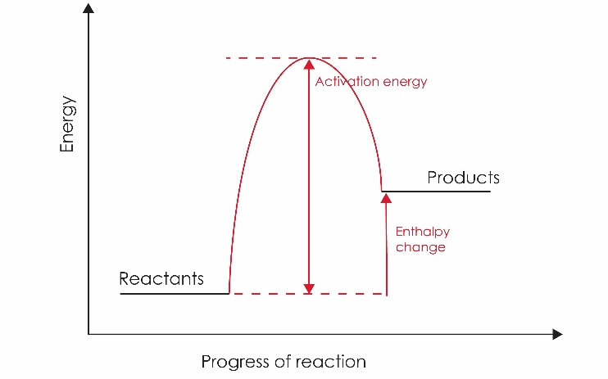

The products have more energy than the reactants. This is because energy has been taken in from the surroundings. The energy level has increased. The overall change in energy is represented by an upwards arrow (positive enthalpy change). The activation energy is the minimum energy required for a reaction to occur. This is shown by the ‘hump’ in the reaction profile.

Write-up and assessment

Suggested write-up

Learners need to produce a group report using the headings:
- Problem
- Method
- Results
- Conclusion

Members of the group could be responsible for a section. Encourage the use of diagrams and photographs.

