Station 1: screwdriver cast
Background
Criminals often use tools to force entry to premises and can leave behind evidence for the forensic scientist to find. Two tools of the same kind and made by the same manufacturer may look the same, but, through use, each tool can have differences. It is these differences that make them unique.
Forensic scientists can help the courts convict criminals by matching the marks on tools to those found at crime scenes.
You will compare the cast made of the screwdriver used at the crime scene to photographs of three screwdrivers found at the homes of the two suspects.
Equipment
- Photos of the screwdrivers found at the homes of Suspect 1 (EV2 flathead screwdriver and EV3 crosshead screwdriver) and Suspect 2 (EV4 flathead screwdriver)
- Blue mounting putty
- Screwdriver cast from crime scene (EV1) in evidence bag
Method
- Compare the photographs of the three screwdrivers found at the suspects’ homes with the screwdriver cast taken from the crime scene in evidence bag EV1.
- Record your observations and sketch what you see in your student workbook.
What should I look for?
- Does the size of the screwdriver in the photograph match that shown in the cast from the crime scene?
- What shape is the screwdriver from the crime scene – is it flathead or crosshead?
- Do any of the photographs show a screwdriver with a matching shape to the tool used?
- Are there any irregularities in the heads of the screwdrivers in the photographs or the cast from the crime scene?
- Do any of the reference screwdrivers match the cast taken from the door? How do you know?
Station 2: fingerprints
Background
Fingerprint analysis has been used to identify suspects and solve crimes for more than 100 years. It remains an extremely valuable tool for law enforcement.
One of the most important uses for fingerprints is to help investigators link one crime scene to another involving the same person.
No two people have exactly the same fingerprints. Even identical twins, with identical DNA, have different fingerprints. It is this uniqueness that makes fingerprinting an extremely useful forensic tool.
Equipment
- EV5 Aluminium powder fingerprint lift taken from the victim’s back door
- EV6 Aluminium powder fingerprint lift taken from the handle of the baseball bat found in the garden of a house in the street near to the victim’s house
- EV7 Ten-print fingerprint card from Suspect 1
- EV8 Ten-print fingerprint card from Suspect 2
- Fingerprint magnifier
Method
- Use the fingerprint magnifier to analyse the fingerprints lifted from the crime scene. Carry out the following:
- Identify ridge patterns (level 1 fingerprint detail) and ridge endings and bifurcations (level 2 fingerprint detail).
- Use fingerprint magnifiers to look at fingerprints taken from the suspects.
- Look for similar level 1 and level 2 fingerprint detail on the suspect’s prints.
- Record your observations and/or sketch what you see in your student workbook.
What should I look for?
- What ridge pattern can be seen in the fingerprint lift? Have any of the suspects got the same pattern?
- Look in more detail for ridge endings and bifurcations in comparable prints.

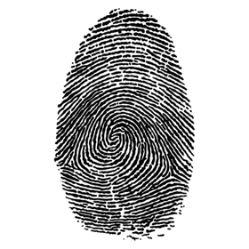
Level 1 fingerprint detail – pattern and ridge flow

© Olena Voronetska/Shutterstock
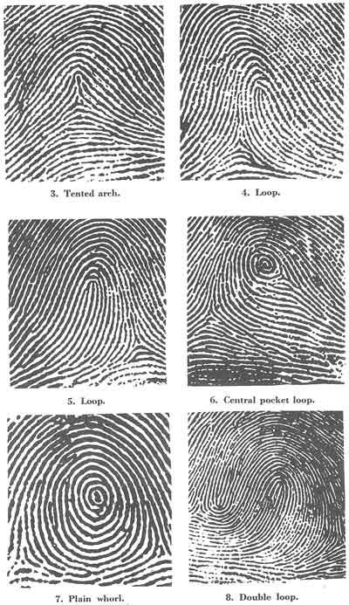
Level 2 fingerprint detail – ridge endings and bifurcations
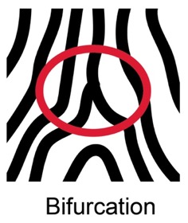
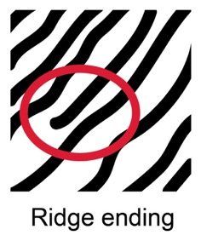
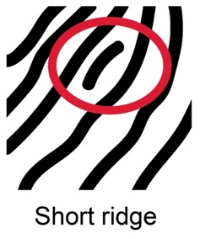
Adapted from © Federal Bureau of Investigation/Liverpool John Moores University
© Federal Bureau of Investigation
Station 3: white powder
Background
A flame test shows the characteristic colour of a metal salt. It is used to find the identity of an unknown metal or metal ion.
The heat of a flame excites the electrons of the metal ions. The ions emit visible light. Different metals give different colours to the flame.
During their investigation, the forensic scientists found a bag of unidentified white powder on one of the kitchen surfaces in the victim’s house (EV9), which they suspect may contain lithium.
The police found similar bags of white powder on Suspect 1 (EV10) and Suspect 2 (EV11).
Each of the metal powders has been dissolved in water to produce a solution. You will conduct flame tests on these solutions to identify the metal present in the white powder found in the victim’s house and on each of the two suspects.
Equipment
- Bunsen burner
- Heatproof mat
- Beaker of water (for the disposal of used splints)
- Boiling tube rack
- Three boiling tubes half-filled with the three solutions to be analysed:
- EV9 White powder from the victim’s house dissolved in water
- EV10 White powder from Suspect 1 dissolved in water
- EV11 White powder from Suspect 2 dissolved in water
- Matches and splint
Safety and hazards
Wear eye protection and a buttoned-up lab coat, if instructed, to protect your clothes.
Make sure that the Bunsen burner is on the yellow flame when it is not in use.

Method
- Light the Bunsen burner on the safety flame (yellow) and adjust it to give an invisible flame (air hole half-open).
- Collect a splint from one of the three labelled boiling tubes that are half-filled with the white powder solutions.
- Put the splint into the roaring blue flame of the Bunsen.
- Record the colour of the flame produced in the table in your student workbook and decide which metal is present using the table shown in the PowerPoint.
- Place the used splint into the beaker of water provided.
- Repeat this method using the other two solutions.
- Compare the flame colours from all three solutions to decide whether the white powder present at the victim’s house matches that found on either suspect.

Station 4: bloodstained clothing
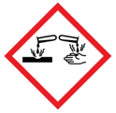
© Shutterstock

Background
One of the most common types of body fluid found at certain crime scenes, particularly the scenes of violent crime, is blood. Although the appearance of blood is often quite distinct, chemical tests are essential to confirm its identity. Luminol is frequently used to initially identify bloodstains, particularly if the perpetrator has attempted to clean up the blood, making it invisible to the naked eye. The Kastle–Meyer test can also be used to identify the presence of blood.
Equipment
- Kastle–Meyer test solutions
- 6% hydrogen peroxide solution
- Whatman filter paper
- Deionised water
- Fume hood
- Moveable light
- EV12 Victim’s clothing
- EV13 Swab taken from baseball bat on Whatman filter paper
- EV14 Suspect 1’s clothing
- EV15 Suspect 2’s clothing
Safety and hazards
Wear safety googles and take care not to spill the solutions, as both Kastle–Meyer test solution and hydrogen peroxide are irritating to the eyes. Kastle–Meyer test solution is also corrosive and can cause irritation to the skin.

Method
- In a fume hood, if available, or in a well-ventilated area, open the swab from the baseball bat and add a couple of drops of deionised water. Then undertake the Kastle–Meyer (KM) test (see overleaf for instructions).
- Complete the following steps for the victim’s clothing and the clothing from
Suspect 1 and Suspect 2.
- Lay out the clothing collected from the victim on a bench covered in brown paper.
- View the clothing under a moveable light source and search the clothing for any additional evidence such as stains, hairs or fibres.
- If any suspected blood is seen, collect it with a damp swab stick or filter paper.
- Take the swab stick to the fume hood and perform the KM test on the swab.
- Record your observations in your student workbook.

Note: all hazard symbol images are © Shutterstock.

The Kastle–Meyer test
Gently rub a small, clean, dry filter paper or swab stick onto the suspect stain. | 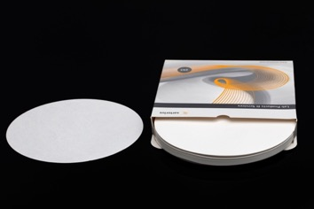  © Mehmet Cetin/Shutterstock
Add 1–2 drops of Kastle–Meyer solution to the paper. | 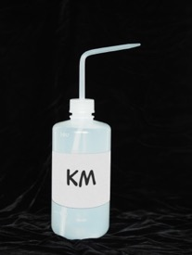  © James Jeong/Shutterstock
Wait for five seconds to ensure no colour develops.
Add 1–2 drops of the 6% hydrogen peroxide solution. | 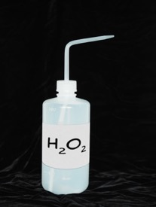  © James Jeong/Shutterstock
An immediate pink colouration indicates a positive reaction for blood. | 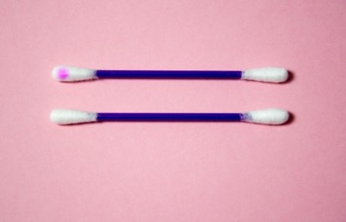  Negative  Positive  © Daniela Staerk/Shutterstock

Station 5: hair samples
Background
As an analyst, you can tell investigators whether individual hairs are human or animal, and, in the case of human hair, where on the body the sample originated from. Microscopic comparison identifies the shape, colour, texture and other visual aspects of the sample. The hair cuticle is a layer of hard, overlapping cells on the outside of the hair. If the hair still has a follicle (root) attached, DNA testing may be used to identify an individual; otherwise, hair comparison is typically used only to rule out a suspect. Collected samples are sent to the laboratory along with control samples from a suspected individual. Hair samples are primarily collected using tweezers.
Equipment
- Hair sample
- Pre-mounted hair samples:
- EV16 Hair taken from victim’s clothing
- EV17 Hair taken from Suspect 1’s clothing
- EV18 Hair taken from Suspect 2’s clothing
- Gloves
- Microscope
Method
- Collect the evidence bag and take out the hair sample that has been pre-mounted onto a slide.
- Place the slide on the microscope stage ready for examination.
- Repeat for all hair samples.
- Record your observations and sketch what you see in your student workbook.
What should I look for?
- Compare the hairs collected from the crime scene and the suspects using a microscope.
- Look at the colour and texture of the hair:
- Is the cuticle very rough or very smooth?
- Are there any patterns?
- How thick is the hair?
- Is there a follicle present?
Station 6: fibre samples
Background
When a crime is committed, the criminal can unknowingly leave fibres behind. A criminal can transfer fibres to the victim and vice versa. A criminal can also pick up fibres at the crime scene and unknowingly carry them away. Fibres can come from clothing, furniture, rope, blankets and so on.
Forensic scientists collect fibres and analyse them to try to determine what, where or from whom they came.
Equipment
- Fibre samples:
- EV19 Fibres taken from victim’s clothing
- EV20 Fibres taken from Suspect 1’s clothing
- EV21 Fibres taken from Suspect 2’s clothing
- Microscope
Method
- Collect the evidence bags and take out the first fibre sample.
- Place the slide on the microscope ready for examination.
- Repeat for all fibre samples.
- For all samples, record your observations and sketch what you see in your student workbook.
What should I look for?
- Look at the colour and texture of the fibre:
- Is it rough or smooth?
- Are there any patterns?
- How thick is the fibre?
- Compare the fibre with the reference standards on the next page:
- Can you identify the type of material the fibre came from?
Fibre reference examples
Fibre sample | Key features
Nylon  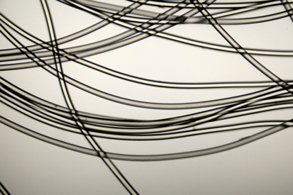  © Nnehring/Getty Images | Artificial fibres appear smooth and have very even features.  The fibres can also be shaped rather than round and have a variety of cross-sections.
Cotton  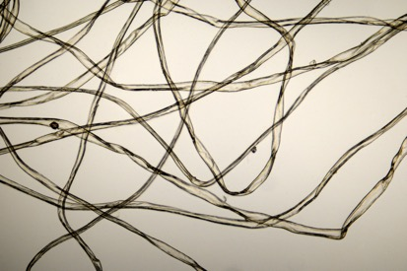  © Nnehring/Getty Images | Cotton is a plant fibre which can become twisted during drying.  Looks slightly rough in places compared with nylon.  Dyeing the fibres can make them more even.
Wool  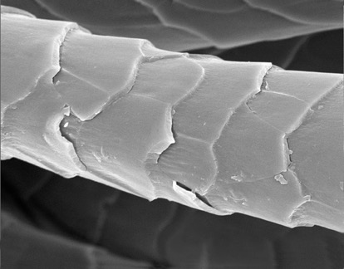  © ERRC | Wool is animal fibre from sheep or breeds of goat.  It has a central cortex of spindle-shaped cells surrounded by overlapping scales making it look rough under the microscope. The scales erode over time, so the fibre looks smoother.  The cortex can have a hollow core (medulla) which can be broken or uninterrupted.

