Quantitative chemistry: knowledge check
- This diagram represents a chemical equation. Label the diagram using the words below.

compound element molecule

product reactants
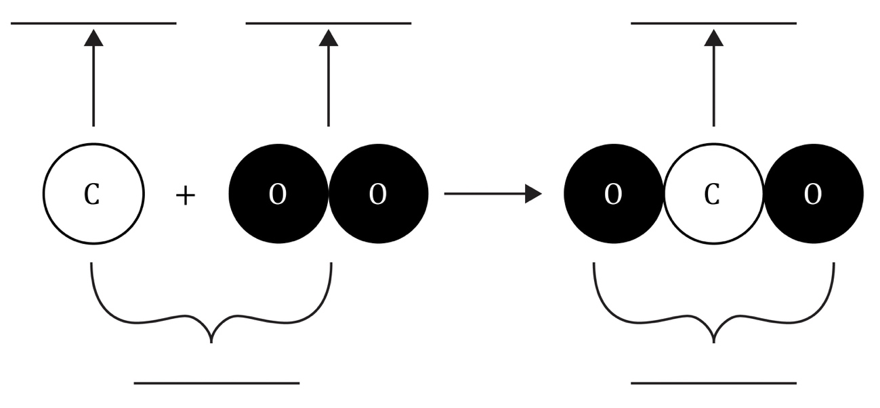
- Use the words to complete the sentences:

hydrogen reaction oxygen

products reactants

The diagram in question 1.1 shows an equation summarising a ___________________________. The ___________________________ can be found on the right-hand side of the arrow. The ___________________________ can be found on the left-hand side of the arrow. The reactants are ___________________________ and ___________________________.

- Use the words and symbols to complete the sentences:

compound elements H₂ H₂O O₂

The formula of the hydrogen molecule is ___________________________.
The formula of the oxygen molecule is ___________________________. The formula of the water molecule is ___________________________. Both the reactants are ___________________________ that contain one type of atom only. The product is a ___________________________, which is a substance made up of two (or more) different atoms bonded together.
- Use the words to complete the sentences:

atoms conservation hydrogen mass

oxygen products reactants rearranged

During a chemical reaction, ___________________________ are neither created nor destroyed. Instead, the atoms are just ___________________________ to form a new substance. This means that the total mass of the ___________________________ will be the same as the total mass of the ___________________________. In this example, there are four atoms of ___________________________ and two atoms of ___________________________ on both sides of the arrow. The equation is balanced and shows that the mass is conserved. The total ___________________________ stays the same during a chemical reaction. This is the law of ___________________________ of mass.

Quantitative chemistry: test myself

Use the words to complete the sentences. You do not have to use all the words.
You can use the words more than once.
- What does the formula H₂O mean in terms of the number and type of atoms?

one two hydrogen oxygen water

There are ___________________________ atoms of ___________________________ and ___________________________ atom of ___________________________ in one molecule of water.
- Write a word equation for the chemical reaction shown in the diagram.

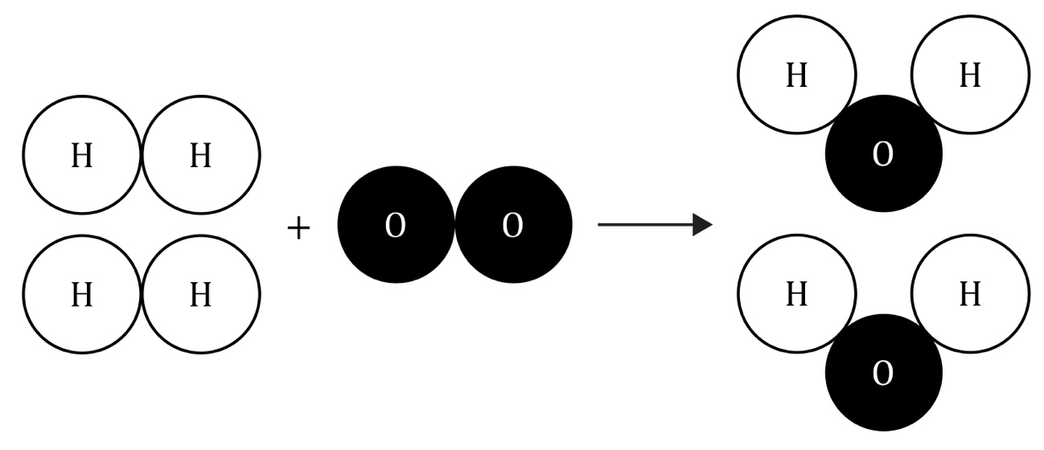

hydrogen oxide oxygen water

________________________ + ________________________ $→$ ________________________

- What is the formula for one molecule of hydrogen? For, example, the formula for water is H₂O.

Circle the correct answer.
H2 H h₂ H₂ h2
- What is the formula for one molecule of oxygen? For example, the formula for water is H₂O.

Circle the correct answer.
O₂ O o2 o o₂
- Using your answers from questions 2.3 and 2.4, write a balanced symbol equation for the reaction shown in the diagram in question 2.2.

________________________ + ________________________ $→$ ________________________
- Why does the number of hydrogen and oxygen atoms on the left-hand side of the arrow have to be equal to those on the right-hand side? Give your answer in terms of conservation of mass.

Use the words to complete the sentences. You do not have to use all the words.

atoms destroyed elements

produced rearranged

During a chemical reaction, ___________________________ are only ___________________________; they cannot be ___________________________, and new ones are not made.

- How much water would you expect to make from 4 g of hydrogen and 32 g of oxygen?

Circle the correct answer.
4 g 32 g 36 g 28 g

Show your working.

- How much water would expect to make from 20 kg of oxygen and 160 kg of hydrogen?

Circle the correct answer.
20 kg 160 kg 180 g 180 kg

Show your working.

- How much hydrogen would you need to react with 48 g of oxygen to make 54 g of water?

Circle the correct answer.
6 g 48 g 54 g 102 g

Show your working.

- This is the word equation for heating calcium carbonate:

calcium carbonate $→$ calcium oxide + carbon dioxide

Calcium carbonate decomposes to form calcium oxide and carbon dioxide. How much calcium carbonate would you need to start with to produce 28 g of calcium oxide and 22 g carbon dioxide when it completely decomposes?

Circle the correct answer. Show your working.
22 g 28 g 6 g 50 g

Quantitative chemistry: feeling confident?
- Use the Periodic table and the values below to complete the relative atomic mass column.

1 12 14 16 23 24

32 35.5 56 63.5
Element | Symbol | Relative atomic mass
hydrogen | H
oxygen | O
chlorine | Cl
carbon | C
nitrogen | N
iron | Fe
sodium | Na
magnesium | Mg
copper | Cu
sulfur | S

- Use the relative atomic masses from question 3.1 to complete the calculations and relative formula masses of the compounds in the table.
Compound name | Chemical formula | Calculation | Relative formula mass
water | H₂O | (2 × H) + (1 × O)  = (2 × 1) + (1 × 16) | 18
sodium chloride (salt) | NaCl | (1 × Na) + (1 × Cl)  = (1 × 23) + (1 × 35.5)
carbon dioxide | CO₂ |  | 44
methane | CH₄ |  | 16
ammonia | NH₃
copper sulfate | CuSO₄
glucose | C₆H₁₂O₆ | (6 × C) + (12 × H) + (6 × O)  = (6 × 12) + (12 × 1) + (6 × 16)
sodium carbonate | Na₂CO₃ |  | 106
magnesium hydroxide | Mg(OH)₂ | (1 × Mg) + (2 × O) + (2 × H)  = (1 × 24) + (2 × 16) + (2 × 1)
ammonium sulfate | (NH₄)₂SO₄ |  | 132

Quantitative chemistry: what do I understand?

Think about your answers and confidence level for each mini-topic. Decide whether you understand it well, are unsure or need more help. Tick the appropriate column.
Mini-topic | I understand  this well | I think I understand this | I need more  help
I understand that all substances are made up of atoms and molecules.
I can identity elements and compounds.
I can identify reactants and products in a chemical equation.
I can write simple chemical formulas.
I can understand and use the law of conservation of mass.
I can write simple word equations.
I can write simple balanced symbol equations.
I can calculate the mass of a reactant or product in a chemical reaction given all other reacting masses.
Feeling confident? topics | I understand  this well | I think I understand this | I need more  help
I can use the Periodic table to find the relative atomic masses of named elements.
I can calculate relative formula mass.

