Infection
Contents
- Guidance notes
- Learning objectives
- Introduction: what is infection?
- Career link
- Activity 1: spreading the infection
- Career link
- Activity 2: chemicals against infection
- Activity 2: chemicals against infection – card sort

Acknowledgements
This resource was originally developed by the University of Reading to support outreach work delivered as part of the Chemistry for All project.
To find out more about the project, and get more resources to help widen participation, visit our Outreach resources hub: rsc.li/3CJX7M3.

Guidance notes
This activity should take approximately one hour to complete in full. It was initially created for 11–14 year-old learners but can be adapted when teaching infectious diseases to other age groups.
Download the PowerPoint presentation, technician notes and student workbook that accompany this resource at rsc.li/3uUoCiQ.
Read our health & safety guidance, available from rsc.li/3IAmFA0, and carry out a risk assessment before running any live practical.
The safety equipment suggested is in line with CLEAPSS requirements. For non-hazardous substances, wearing lab coats can help to protect clothes. The safety rules might be different where you live so it is worth checking local and school guidance.
Learning objectives
- Explain how infections spread between humans.
- Describe some methods of preventing and fighting infections.
Introduction: what is infection?
Use slide 3 of the PowerPoint to introduce infection and find out what the learners already know. The slide notes provide additional information.
University laboratory technician apprentice
Highlight different routes into chemistry careers with Tyler’s job profile, available on slide 4 and from rsc.li/3ZpW6mE. She is a university laboratory technician apprentice, who supports students with their research into infectious diseases such as Covid-19 and long-term conditions such as lung diseases.

Activity 1: spreading the infection
If only a small number of learners are present, involve teachers and assistants so that as many cups as possible are circulating.
- Before learners arrive, set up 30 plastic cups. Number the cups by writing the numbers 1–30 on the underside of the base of each cup. Add 50 ml 1.0 M hydrochloric acid to one cup and 50 ml water to the other cups. Record the number of the cup you add the acid to without showing the learners.
- At the start of the activity, hand out a cup and a pipette to every participant. Make sure that one learner has the cup containing the hydrochloric acid.
- Ask the learners to mingle as described in the method in their student workbooks and on slide 6 of the PowerPoint.
- After five minutes ask the learners to stop and return to their seats.
- Each learner should then add 2–3 drops of universal indicator to their cup and observe the colour.
- The facilitator should also add 2–3 drops of universal indicator to 50 ml of water in a beaker – this can be used as a reference.
- Get learners to discuss the answers to the questions in the student workbook and then bring them all together for a class discussion. Show the answers on slide 7.
- Ask learners how infectious diseases are transmitted before moving on to slide 8.
Answers
- An orange, pink or red colour shows that the solution in the cup contains the acid.
- The learners should look at the underside of their cups to see the number written there. The learner with the number recorded by the teacher should have the most intense red colour in their cup and can be identified as the source of the ‘infection’. Their solution should be the most acidic as they started off with just the acid being present in their cup.
- This is dependent upon the learners’ results and techniques. It may be possible to identify the level of infection based on the shade of the universal indicator.
(Again the pattern of infection will determine how easy this is to see.)

Medicinal chemist
Use the video profile on slide 9 and available from rsc.li/3IUNNbf to introduce John, a medicinal chemist. He works on the discovery and development of drugs to treat infectious diseases such as malaria and tuberculosis. The
Activity 2: chemicals against infection
- Depending on the number of learners present, they could work in groups, pairs or individually.
- Without the learners knowing, put the powder into the ball from the Germaglo kit. (This will make sure that learners unknowingly have the powder applied to their hands.) Although this demonstration is not essential, it is a nice activity to use to highlight how easily germs can be transferred. You will have to purchase this kit from: bit.ly/3ZH7eep. Any object could be used to replace the ball if the UV powder can be applied to it. You may wish to use a garlic bulb, for example, so that you can link it to the card sort.
- Use slide 11 to introduce the Activity 2: chemicals against infection card sort. The card sort will need to be printed out and cut into cards prior to the lesson.
- Ask learners to use the information provided on pages 5–6 of their student workbooks to help them to sort the cards by matching the treatment used with the correct use of that treatment.
- As the class are carrying out the card activity, approach each group with the ball covered in UV powder. Ask each learner to handle the object, examine the object and ask if they can think what the object is for. (It will probably be necessary to keep applying powder to the ball, which should be done out of the learners’ sight.)
- Once all the learners have been ‘contaminated’ by the UV powder and completed the card sort, ask them to share their answers and explain which treatment should be paired with which purpose. Show the class answers using slide 12 of the PowerPoint.

- Explain that the purpose of the ball was to show how easy it is to spread infection. This will be done by turning off the lights and passing the torch between groups, so that they can examine how they have spread the infection while playing the game. Encourage learners to make the link between this game and the spread of bacteria and viruses between people.
- Before moving on to the next slide, give learners two minutes to work in pairs to list as many ways as they can of reducing the transmission of infectious diseases. Use slide 13 to lead a class discussion of the answers.
- Ask learners to list ways in which chemistry/chemists have an important role to play in the fight against microorganisms and the diseases they cause.
Answers
Treatment | Use of treatment
Gold nanoparticles | Killing E. coli bacteria
Titanium oxide nanoparticles | Killing bacteria
Iron oxide nanoparticles | Drug delivery
Zinc oxide nanoparticles | Killing staphylococcus (MRSA)
Honey | Antibacterial wound dressings
Tea tree oil | Killing staphylococcus (MRSA)
Carbon nanotubes | Bacteria-detecting bandages
Ajoene (from garlic) | Treating bacterial lung infections in cystic fibrosis

Associate scientist
Use slide 14 to introduce learners to Holly, an associate scientist specialising in pharmaceuticals, who works on the development of new medicines to treat diseases. Her video job profile is also available at rsc.li/3SVe4Lu.

Activity 2: chemicals against infection – card sort
Gold nanoparticles  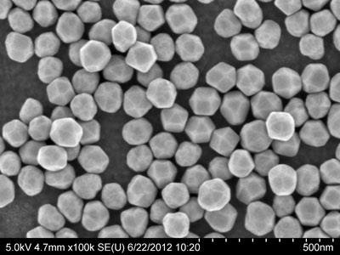  © Cytodiagnostic | Drug delivery  © kubais/Shutterstock
Zinc oxide nanoparticles  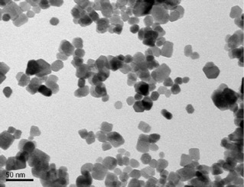  © Jose Alberto Alvarado | Treating bacterial lung  infections in cystic fibrosis  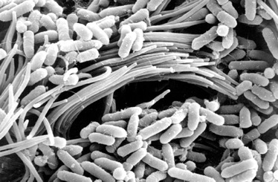  © Viral Shah
Tea tree oil  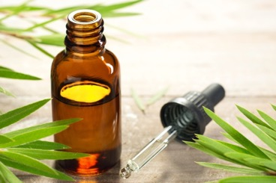  © AmyLv/Shutterstock | Killing staphylococcus (MRSA)  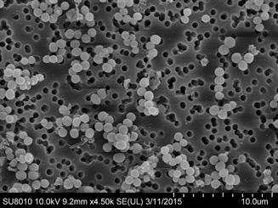  © Microspectacular/Shutterstock
Bacteria-detecting bandages  © photolinc/Shutterstock | Killing bacteria  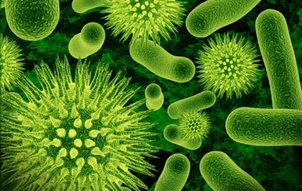  © Lotus_studio/Shutterstock
Killing E.coli bacteria  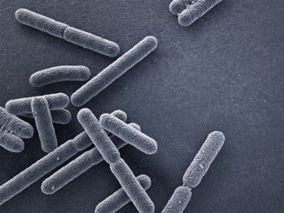  © MP Art/Shutterstock | Antibacterial wound dressings  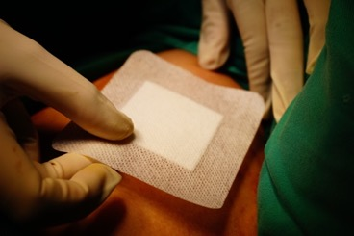  © Alan Nissa/Shutterstock
Ajoene (from garlic)  © Marian Weyo/Shutterstock | Carbon nanotubes  © Shutterstock
Honey  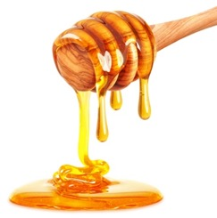  © Slawomir Zelasko/Shutterstock | Iron oxide nanoparticles  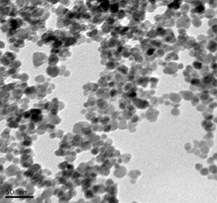  © Sri Vidawati
Killing staphylococcus (MRSA)  © Microspectacular/Shutterstock | Titanium oxide nanoparticles  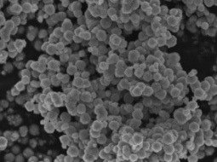  © S Sarala

