Metallic bonding and alloys

Learning objectives
- Describe the structure and bonding in pure metals and alloys.
- Explain the properties of pure metals and alloys using your understanding of their structure and bonding.

Introduction

Metallic bonding is a type of strong chemical bond which occurs in pure metals and alloys only. Alloys are mixtures of two or more elements where at least one is a metal. Metals are three-dimensional giant structures where positive metal ions are arranged in layers surrounded by a sea of delocalised electrons. Metallic bonds are the strong electrostatic interactions between the positively charged metals ions and the sea of delocalised electrons. Metals and alloys have high melting points as a large amount of energy is required to overcome these forces.

Metals are good electrical conductors due to the sea of delocalised electrons which are free to move through the structure and carry electrical charge.

Task 1 – True or false?

Determine whether the following statements are true or false:
- Metal ions are always positively charged.
- The metal ions are close packed in the structure.
- In metallic bonding, the outer shell electrons are delocalised.
- The delocalised electrons are in a fixed position and are unable to move.
- Metals cannot conduct electricity.
- Metals have high melting points.
- Metals are malleable and ductile.
- An alloy is a mixture of two or more elements , where at least one element is a metal.
- Pure metals are stronger than alloys.
- Alloys have a layered structure.
- In alloys, the atoms are all the same size.

Task 2 – Description of metallic bonding
- A student produced the diagram below to represent the structure and bonding in magnesium. There are some errors in this diagram.

Identify three errors. Use your knowledge and understanding of metallic bonding.

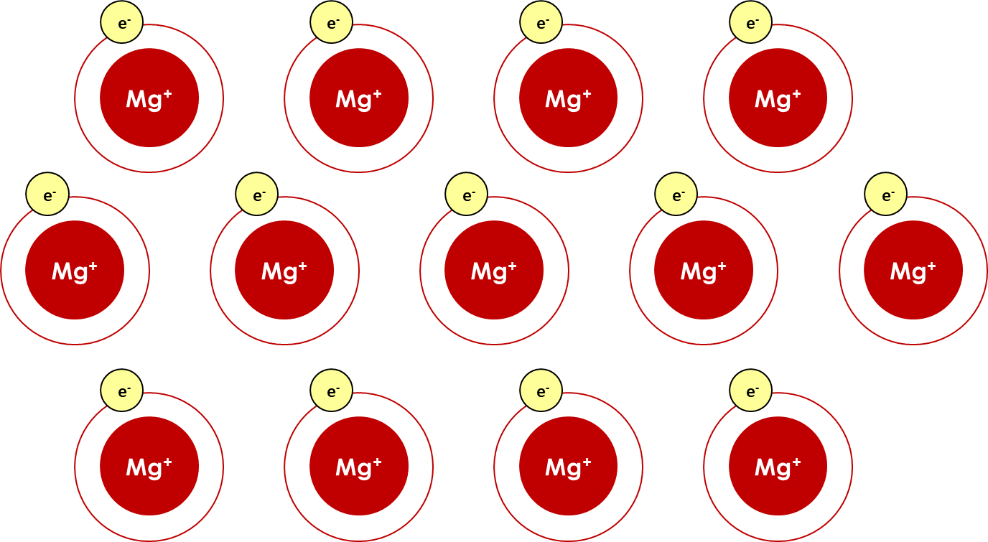

Description of error | Explanation of why this is incorrect

- Draw a labelled diagram to represent metallic bonding in magnesium. Use your annotations from question 1 and your own knowledge.

Task 3 – Properties of pure metals

The table below contains several important properties of metals.

Explain each property. Use your answers from Task 2 to explain each property.
Property of metals | Explanation using knowledge of metallic bonding
High melting point

High density

Good conductor of electricity

Malleable and ductile

Task 4 - Alloys

The diagram below shows the structure of an alloy. Alloys containing aluminium are used in the manufacture of aircraft due to their increased strength compared to pure metals. Compare the structure of an alloy to the structure of a pure metal and explain why alloys are used rather than pure aluminium.

__________________________________________________________________________________

__________________________________________________________________________________

__________________________________________________________________________________

__________________________________________________________________________________

__________________________________________________________________________________

__________________________________________________________________________________

__________________________________________________________________________________

__________________________________________________________________________________

__________________________________________________________________________________

__________________________________________________________________________________

__________________________________________________________________________________

__________________________________________________________________________________

__________________________________________________________________________________

__________________________________________________________________________________

__________________________________________________________________________________

__________________________________________________________________________________

__________________________________________________________________________________

__________________________________________________________________________________

__________________________________________________________________________________

__________________________________________________________________________________

