Bonding: knowledge check
- Complete the sentences.
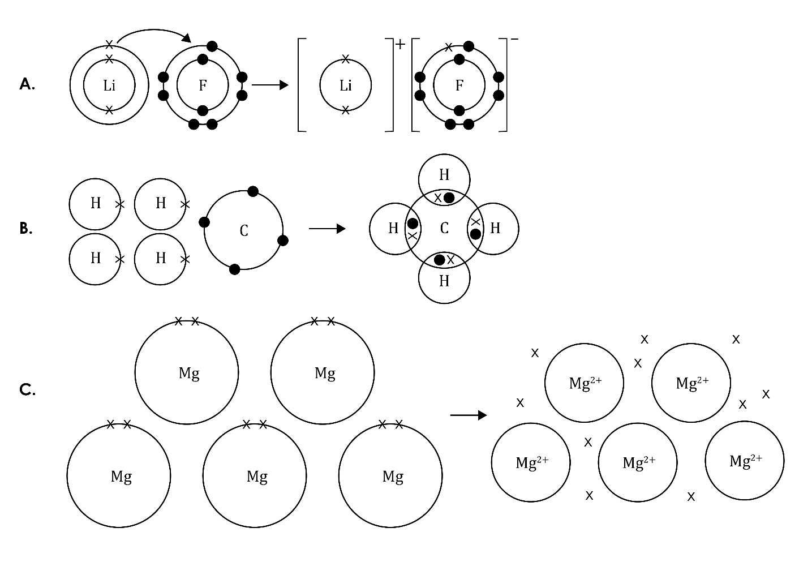
  - The type of bonding in figure A is _______________________________________.
  - The type of bonding in figure B is _______________________________________.
  - The type of bonding in figure C is _______________________________________.

- (a) What type of elements form ionic bonds?

  - What happens to electrons when an ionic bond forms?

  - What type of particles are present in an ionic compound?

  - What type of forces attract the oppositely charged ions to each other?

- (a) What type of elements form covalent bonds?

  - How are the electrons rearranged in a single covalent bond?

- (a) What two types of particles form a metallic bond?

  - Why do metal ions have a positive charge?

  - What forces attract the charged particles to each other?

Bonding: test myself
- What types of elements are involved in:
  - ionic bonding? _________________________________________________________
  - covalent bonding? _____________________________________________________
  - metallic bonding? ______________________________________________________

- In which type of bonding are electrons shared?

- What does the curved arrow represent in the diagram?

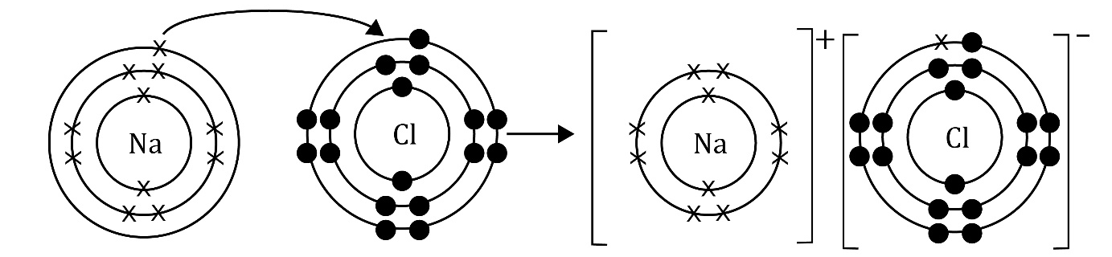

- What type of forces hold the particles together in an ionic bond?

- What does ‘delocalised’ mean?

- What are the charged particles in an ionic compound called?

- What type of bonds do you find in a compound?

- Why are metals good conductors of electricity?

- How do ionic compounds conduct electricity when solid, liquid and in solution? Explain your answer.

- Why are most covalent substances non-conductors of electricity?

Bonding: feeling confident?

Draw bonding diagrams for the following reactions.
- The reaction between magnesium and fluorine.

- The reaction between hydrogen and chlorine.

- The metallic bonding in zinc.

Bonding: what do I understand?

Think about your answers and confidence level for each mini-topic. Decide whether you understand it well, are unsure or need more help. Tick the appropriate column.
Mini-topic | I understand  this well | I think I understand this | I need more  help
I can identify ionic, covalent and metallic bonds from diagrams.
I know that there are ions in ionic bonds.
I know about electrostatic forces in ionic bonds.
I know that electrons are shared in covalent bonds.
I know that there are positive metal ions and negative delocalised electrons in metallic bonds.
I know the types of elements involved in:
- ionic bonds
- covalent bonds
- metallic bonds.
I can explain why metals conduct electricity.
I can explain the conditions required for ionic compounds to conduct electricity.
I can explain why covalent substances do not conduct electricity.
Feeling confident? topics | I understand  this well | I think I understand this | I need more  help
I can draw diagrams to represent ionic and covalent bonds.

