Chromatography: knowledge check
- Learners are completing an experiment to separate the coloured soluble substances in two different food dyes.

The diagram shows the apparatus used and the chromatogram produced.

Label the diagram using the words provided.
chromatography paper origin line solvent
solvent front food colouring
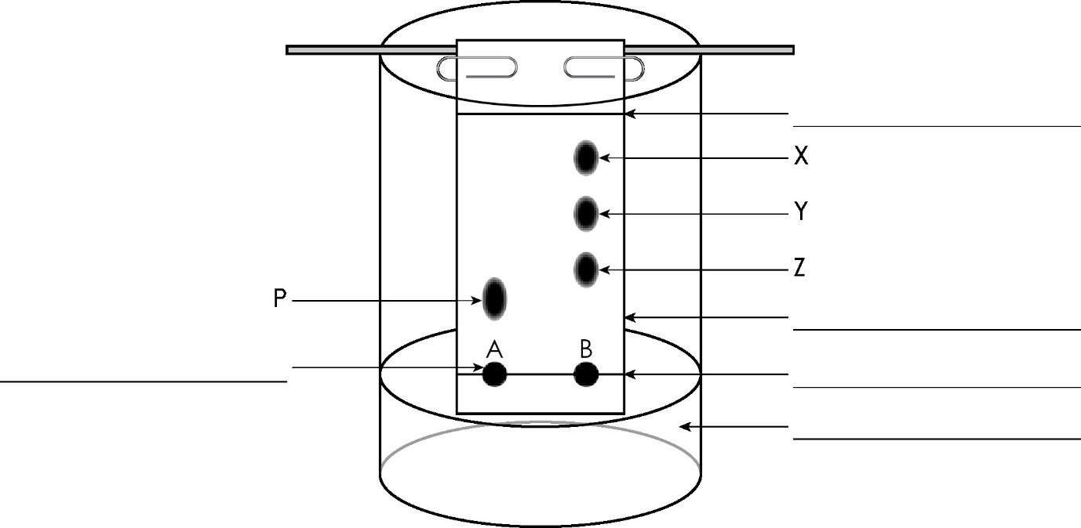

Questions 1.2 to 1.4 are about the experiment in question 1.1.

- The table shows the steps in the chromatography process used to separate the coloured substances, but they are given in the wrong order.

Add numbers to show the correct order for the steps. The first and last have been filled in for you.
1 | Draw an origin line in pencil about 1.5 cm from one end of the chromatography paper.
 | Place the paper inside the beaker. Make sure it just touches the water and it is vertical.
 | Check the paper is the right length by lining it up on the outside of the beaker so that the water is below the origin line.
 | Use a pipette to add small drops of food colourings A and B on the chromatography paper.
5 | Allow the solvent to move through the paper, removing it before the solvent reaches the top.
- Use the words to complete the gaps in the following sentences.
rates stationary phase solvent
chromatography paper mobile phase
The chromatography paper is the __________________ __________________ .
The solvent is the __________________ __________________ .
The different dissolved substances in a mixture are attracted to the __________________ and the chromatography paper in different proportions.
This causes them to move at different __________________ up the __________________ __________________ .

- Decide whether each of the statements is describing a pure substance or an impure substance and write your answer in the table.
Pure or impure?
A substance that contains only one element or compound.
A substance that contains two or more different elements or compounds.

Chromatography: test myself
Answer questions 2.1 to 2.4 by circling the correct answer(s). There may be more than one correct answer in each question.
- Which of the following can paper chromatography be used to separate?
mixtures of insoluble substances mixtures of soluble substances
a mixture of an insoluble a mixture of solvents
substance and solvent
- This is a chromatogram of four different inks.
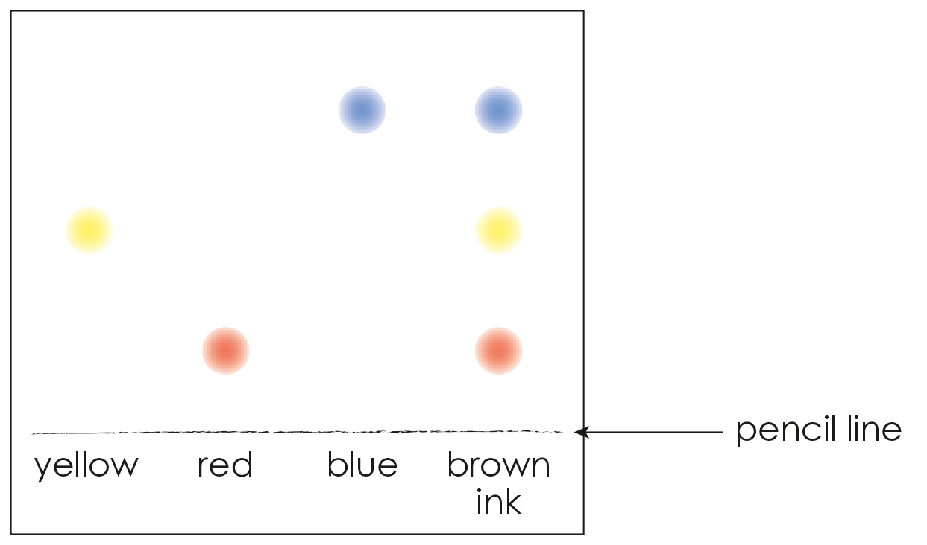

Which inks on the chromatogram are pure substances?
brown red blue yellow
2.3 How is chromatography used to identify unknown substances?
comparing the sizes of the spots comparing the shapes of the spots
comparing the R_{f} values comparing the time taken for the
substance to move

2.4 Thin layer chromatography uses a glass plate coated with alumina or silica gel.

What does this glass plate replace in the experiment in question 1.1?
solvent chromatography paper
beaker food colourings
2.5 This is a chromatogram of dark blue ink.
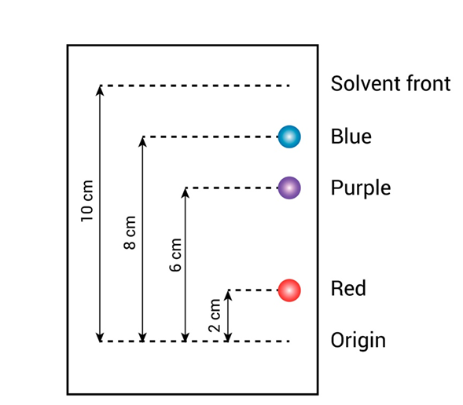

The equation used to calculate the R_{f} value is:
R_{f} = $\frac{distance travelled by substance}{distance travelled by solvent}$

Use the data shown in the chromatogram, along with the equation, to match up the correct R_{f} values for the red, purple and blue substances from those values listed.
0.8 0.2 0.6
Substance | R_{f} values
Red
Purple
Blue
2.6 A compound has a R_{f} value of 0.6. If the solvent travels 16.0 cm up the chromatography paper, what is the distance travelled by the compound?

Use the equation to calculate the answer.
$distance travelled by substance$ = R_{f} $×$ $distance travelled by solvent$
$distance travelled by substance$ = __________________ $×$ __________________
$distance travelled by substance$ = __________________ cm

Chromatography: feeling confident?
- This is a chromatogram of different coloured inks. What can you conclude about the black ink from the chromatogram shown?
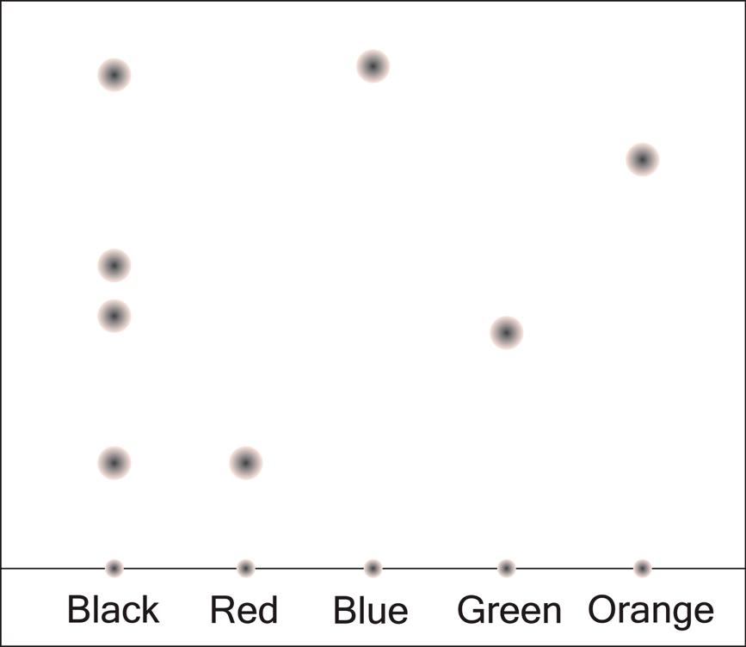

The first sentence has been started to help you.
My conclusion is that the black ink contains

- Substances A, B and C are found in chlorophyll. The R_{f} values of these three substances can be determined using thin layer chromatography and an organic solvent.

Choose the values from the list to complete the table. You do not have to use all the values.
4.2 4.0 0.59 2.3
The equation has been included in the first row to help you.
Substance | Distance travelled by the substance when the solvent travels 10 cm (cm) | R_{f} value
A | $$9.8$$ | R_{f} = $\frac{distance travelled by substance}{distance travelled by solvent}$ = $\frac{9.8}{10} =$
B | $$5.9$$
C |  | $$0.42$$

Chromatography: what do I understand?
Think about your answers and confidence level for each mini-topic. Decide whether you understand it well, are unsure or need more help. Tick the appropriate column.
Mini-topic | I understand  this well | I think I understand this | I need more  help
I can describe the process of paper chromatography.
I can describe how to prepare a chromatogram.
I can define a pure substance and an impure substance
I can interpret a chromatogram.
I can calculate R_{f} values.
I can use R_{f} values.
Feeling confident? topics | I understand  this well | I think I understand this | I need more  help
I can interpret chromatograms of coloured inks.
I can interpret and use information from chromatograms of chlorophyll.

