Transition metals and anticancer drugs
Education in Chemistry
Sustainability in chemistry 2021
Goal 3: ensure healthy lives and promote well-being for all at all ages
rsc.li/2X3vSv4
This activity will check your knowledge on shapes of complexes, your understanding of anticancer drugs and provide you with some history behind cisplatin.

Task 1: knowledge retrieval
1. List four characteristic properties of transition metals.
……………………………………………………………………………………………………………
……………………………………………………………………………………………………………
……………………………………………………………………………………………………………
……………………………………………………………………………………………………………
2. Complete the table.
Name of shape | Number of coordinate bonds | Bond angle
 |  | 180°
Tetrahedral
 | 4 | 90°
 | 6

3. Which shape of complex ion can show both optical isomerism and cis-trans isomerism?
……………………………………………………………………………………………………………
4. Define the term ligand.
……………………………………………………………………………………………………………
……………………………………………………………………………………………………………
……………………………………………………………………………………………………………
5. State the name of the effect which favours multidentate ligands replacing monodentate ligands.
……………………………………………………………………………………………………………

Task 2: cisplatin and other platinum anticancer drugs
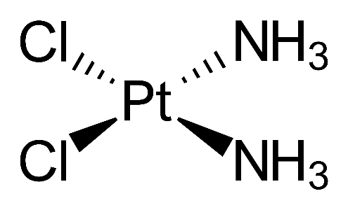

Figure 1: structure of cisplatin.
1. Using Figure 1 and words from the box below, complete the following paragraph. The same word may be used more than once.
platinum, 90, four, anticancer, two, chloride, isomer, ammonia, zero, square planar

Cisplatin is a _____-coordinate, ____________ complex of ____________(II). It has bond angles of ______°. Cisplatin has two _____________ ions and two ___________ molecules as ligands. The overall charge on cisplatin is _____, this is because the charge on the ________________ ion is 2+ which is cancelled out by the two __________ ions. Cisplatin is used as an _______________ drug. However, its ____________ transplatin is inactive against cancer.
2. Draw the structure of transplatin.

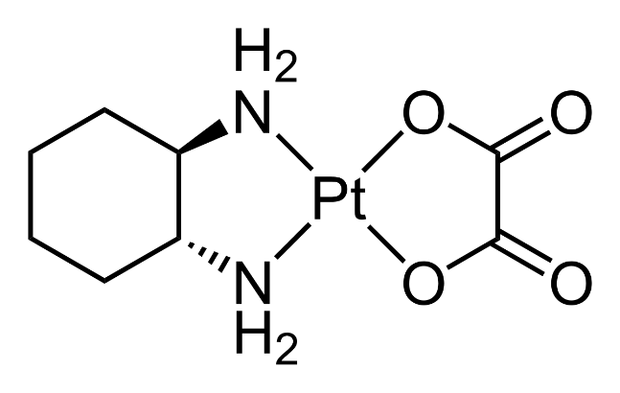
Figure 2: structure of oxaliplatin.
3. Cisplatin prevents DNA replication in cancer cells by a ligand replacement reaction with DNA. A chloride ion in cisplatin is exchanged for a nitrogen atom on a guanine base, which forms a bond with the platinum ion in cisplatin.
Figure 2 shows the structure of oxaliplatin. Oxaliplatin is another platinum based anticancer drug. Using your knowledge of cisplatin, suggest and explain how oxaliplatin may prevent cancer cells from replicating.
……………………………………………………………………………………………………………
……………………………………………………………………………………………………………
……………………………………………………………………………………………………………
……………………………………………………………………………………………………………
……………………………………………………………………………………………………………
……………………………………………………………………………………………………………
……………………………………………………………………………………………………………
……………………………………………………………………………………………………………
……………………………………………………………………………………………………………
……………………………………………………………………………………………………………
……………………………………………………………………………………………………………

4. Suggest why using oxaliplatin as a treatment for cancer often has adverse side-effects.
……………………………………………………………………………………………………………
……………………………………………………………………………………………………………
……………………………………………………………………………………………………………
……………………………………………………………………………………………………………
……………………………………………………………………………………………………………
……………………………………………………………………………………………………………

Task 3: cisplatin comprehension/quiz
In 1845, cisplatin was first synthesised. Alfred Werner deduced the structure of cisplatin in 1893. However, cisplatin’s anticancer properties were not known at the time. It was only in the 1960s that cisplatin’s anticancer properties would be discovered.
Barnett Rosenberg, an American chemist, was carrying out a series of experiments which involved looking at the effects of electric currents on the growth of E. coli. In the experiments, an ammonium chloride solution containing E. coli was electrolysed using platinum electrodes.
Rosenberg found that unusually long E. coli cells were being produced and cell division was being interfered with. However, this was not directly due to the electric current but due to cisplatin forming at the platinum electrodes, which in turn was interfering with cell division.
Rosenberg and his group of scientists found that cisplatin was successful against cancer in mice and this was reported in 1965. In 1971, clinical trials in humans took place and cisplatin was licensed for use in 1979 in the UK. Cisplatin is a chemotherapy drug; patients are given a solution of cisplatin as an intravenous drip. Cisplatin is used against testicular, ovarian, lung, bladder, colorectal and other cancers.

Quick quiz
- When was cisplatin first synthesised?
- When was the structure of cisplatin known by?
- Who deduced the structure?
- In which decade were cisplatin’s anticancer properties discovered?
- Who discovered cisplatin’s anticancer properties?
- What caused the growth of the unusually long E. coli?
- When was cisplatin licensed for use in the UK?
- How many years did it take for cisplatin to be licensed in the UK from the first clinical trials in humans?
- How are patients normally given cisplatin?
- Name three types of cancer cisplatin is used on.

