The oxidation of cyclohexanol by nitric acid – student sheet

In this experiment you will be oxidising cyclohexanol using nitric acid. In this reaction the nitric acid breaks open the six-carbon ring to form the dicarboxylic acid, 1,6-hexanedioic acid (adipic acid). Whereas cyclohexanol is a liquid, 1,6-hexanedioic acid (adipic acid) is a solid and you can measure its melting point.
The reaction is:

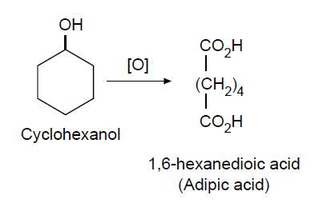

Procedure

- Half-fill a 100 cm³ beaker with deionised water, and heat to 80–90 °C.
- Add 1 cm³ of nitric acid to a test-tube and place in the water bath.
- Carefully add six drops of cyclohexanol to the test-tube. You will notice some bubbling and the nitric acid turns brown.
- Leave for 10 min.
- Remove the test-tube from the water bath and allow to cool to room temperature.
- Cool further in an ice bath – crystals should form.
- Filter off the crystals, wash with 2 cm³ of deionised water and dry them.
- Measure the melting point of your product.

Questions

- What is the melting point of your product?
- How does it compare with the value from data books?
- Can you explain any variations?

Health, safety and technical notes

- Read our standard health and safety guidance
- Students must wear suitable eye protection (splash proof goggles to BS EN166 3). The reaction should be done in a fume cupboard.
- Cyclohexanol is a skin and respiratory irritant and is harmful if swallowed or inhaled (see CLEAPSS HazCard HC084c).
- Nitric acid, 5 mol dm^{–3} HNO₃ (aq), is CORROSIVE (see CLEAPSS HazCard HC067).

