Organic synthesis

Organic transformations 1

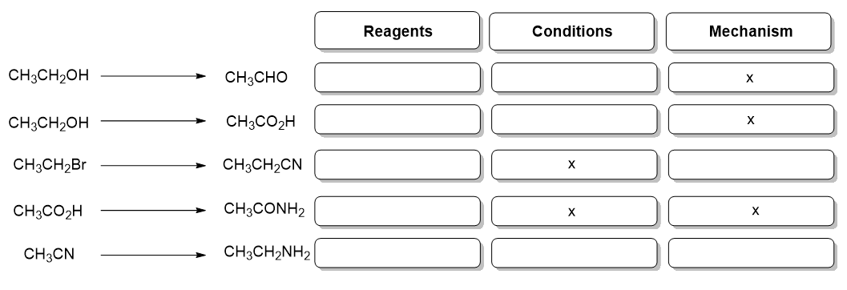
Complete the diagram showing the reagents, conditions and mechanisms that accompany the following transformations.

Organic transformations 2

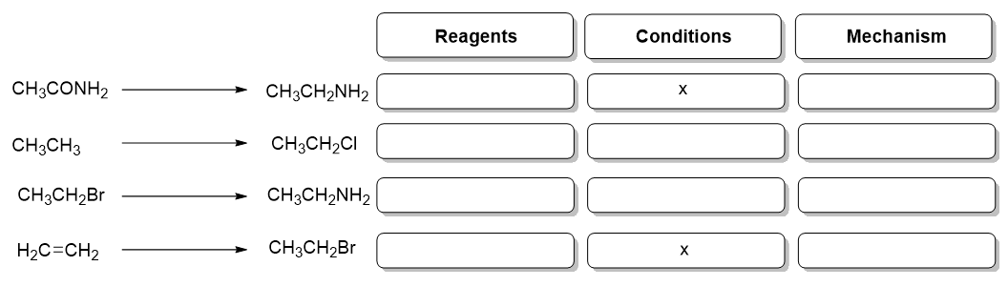
Complete the diagram showing the reagents, conditions and mechanisms that accompany the following transformations.

Organic transformations 3

Complete the diagram below to show the reagents and species formed.

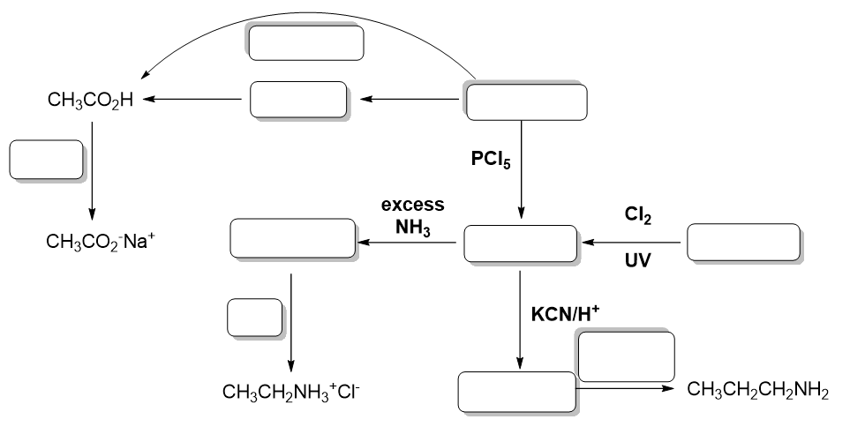

Organic synthesis – Answers

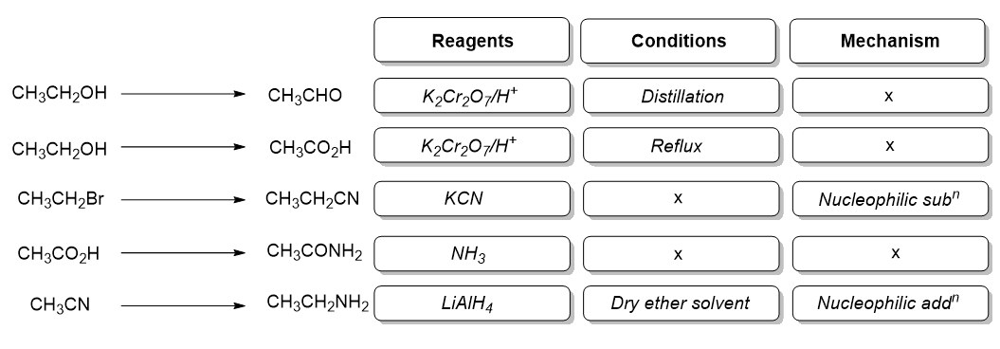
Organic transformations 1

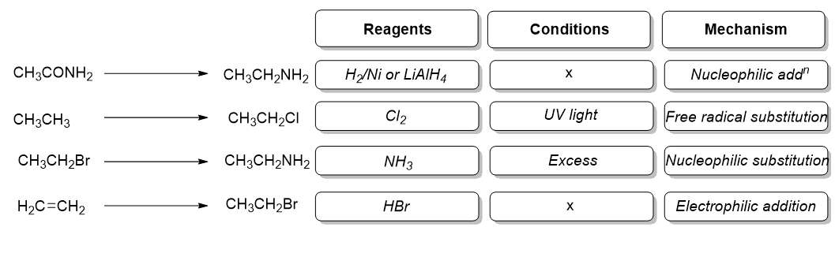
Organic transformations 2

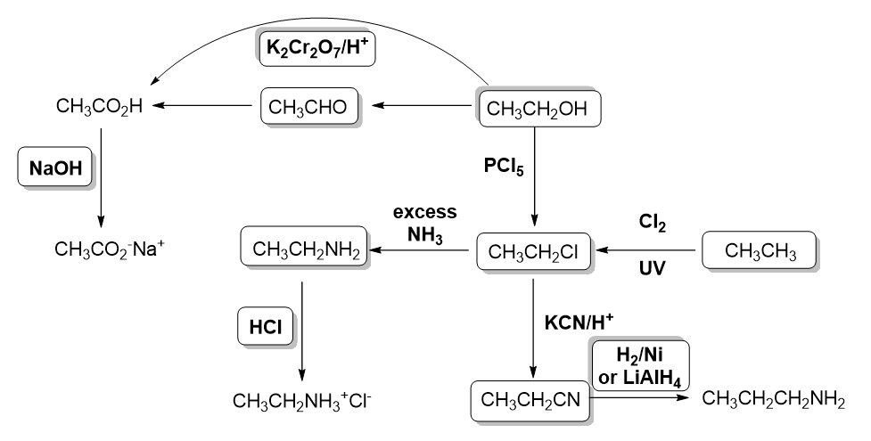
Organic transformations 3

