Investigating the properties of poly(caprolactone)
Education in Chemistry
July 2017
rsc.li/EiC417-medical-plastics
This experiment accompanies the above article ‘Body, heal thyself’.
Aim  The aim of this experiment is to test how bouncy the polymer used by Julian’s group, poly(caprolactone), is at different temperatures.  Apparatus  - Poly(caprolactone)  - Kitchen roll tube  - A4 paper  - Ruler  - Scissors  - Glue stick  - Clamp and stand  - Thermometer  - Beaker of hot water / water bath  - Beaker of ice | 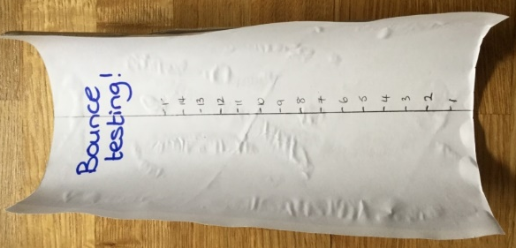

Method
- Cut a 1 cm wide strip down the length of a kitchen roll tube. Glue a strip of white paper up the middle of the inside of the tube. Draw a scale with centimetre divisions up the middle of the paper strip. Stand the tube up in a widely opened clamp and stand.
- Measure the mass of your sample of poly(caprolactone) and then place it into a beaker of hot water to soften it. Wait 3–5 minutes.
- Take the poly(caprolactone) out of the water and roll it into a ball. Measure its temperature.
- Drop the ball from the top of the tube and record the greatest height it bounces to.
- Repeat twice. You may need to rewarm the polymer in hot water.
- Let the ball cool and repeat the experiment for the new temperature. Use ice/cold water to reach lower temperatures.

Results
Mass of polycaprolactone =
Temperature (⁰C) | Bounce height (cm)

Analysis and evaluation
- Describe what happens to the bounce height as the temperature changes.
- With reference to human body temperature, discuss why poly(caprolactone) would be a good polymer for Julian to use for replacement spinal discs.

