Producing ‘gold’ coins on a microscale

This resource is part of a collection of ideas and activities for chemistry lessons in the festive season. Find more at: rsc.li/3h40uXc.

Use this microscale practical experiment to teach your class about the important industrial process of electroplating. You can use it to revisit some of the key concepts of electrolysis and provide an engaging, hands-on practical activity with a seasonal hook.

Differentiation

The practical experiment is suitable for all learners within the 14–16 age group; some of the questions may be more suitable for learners taking higher tier exams. Question 10 requires learners to produce a longer answer. A structure strip is given, providing scaffolded prompts to help overcome ‘fear of the blank page’. Use this long-answer question to consolidate learning. (Read more about how to use structure strips at rsc.li/2P0JDlW.) Removing the structure strip would increase the challenge of this question. Copies of the structure strip are provided on the final page of these teacher notes.

Learning objectives
- Understand that electroplating is an important industrial application of electrolysis.
- Electroplate a coin.
- Describe how to electroplate a metal.
- Explain what happens at each electrode during electroplating.

The introduction and experiment relate to learning objectives 1 and 2. The questions relate to all learning objectives.

Setting up the experiment

Refer to the technician notes for the equipment list, safety notes and preparation and disposal advice.
Read our standard health and safety guidance and carry out a risk assessment before running any live practical.

Note: the coins cannot be used as legal tender after the experiment but can be displayed or stuck into students’ notes.

Expected results

See the image below as a guide.

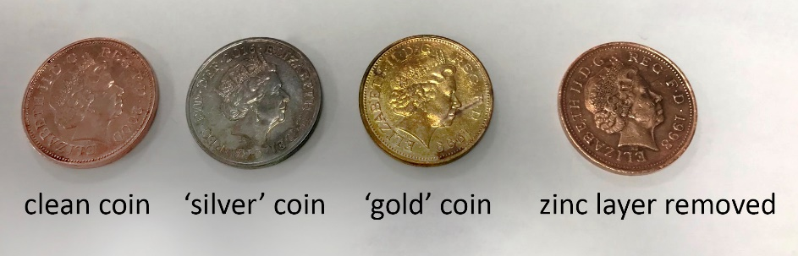

Supporting chemistry
The electrolyte must contain the metal ions used for the plating. The best conditions for electroplating require a low concentration of the hydrated metal ion used for plating and a good conductivity in the solution (ie a high total concentration of ions). In this case, the zinc is in equilibrium but the position of the equilibrium lies well to the right, so the concentration of hydrated zinc ion, Zn²⁺(aq), is extremely
low:
$${Zn}^{2+}\left(aq\right)+{4OH}^{-}\left(aq\right)⇌{Zn\left(OH\right)}_{4}^{ 2-}(aq)$$

Curriculum links

Electrolysis is covered in most 14–16 specifications. Electroplating is specified less often but provides a useful real-life context. This activity includes many of the key learning points related to electrolysis.

Answers
- Jewellery making; cans to store food (accept other relevant examples).
- Any two from: improve appearance; improve durability; resistance to corrosion.
- When the power supply was turned on the brown coin turned silver.
- The object is being plated with a thin layer of metal. Metal always forms positive ions, which are attracted to the negative electrode. Therefore, the object being plated should always be the negative electrode/cathode.
- (a) A liquid or solution of an ionic compound.

(b) Because it contains ions that are free to move.

(c) Positive zinc ions are attracted to the negative electrode where they will discharge and gain two electrons to form zinc metal.
- ${Zn}^{2+}\left(aq\right)+{2e}^{-}→Zn(s)$
- Zinc atoms are oxidised and the zinc ions dissolve in the electrolyte. Equation is:

$$Zn\left(s\right)→{Zn}^{2+}\left(aq\right)+{2e}^{-}$$
- When heated, the copper in the coin mixed with the zinc on the coin produces the alloy brass, which is a golden colour.
- C is correct because the object to be coated (ie the fork) must be at the negative electrode; the positive electrode is the source of the coating metal (ie silver) and the electrolyte must contain the coating ions (ie silver) that are free to move.
- See table below.
Electroplating an iron screw | Model answer
Define electroplating. | Electroplating is the process of covering a metal object with a thin layer of another metal.
State the meaning of electrolyte and name the ion that must be present for nickel plating. | Liquids and solutions that are able to conduct electricity are called electrolytes. They contain positive and negative ions. The nickel plus ion must be present. (Accept Ni⁺ or Ni²⁺.)
What is the negative electrode made from? | The iron screw is the negative electrode.
What will you observe at the negative electrode? Write an equation. | The grey iron screw will slowly change to a silvery-white colour.  ${Ni}^{+}\left(aq\right)+e^{-}→Ni(s)$ or ${Ni}^{2+}\left(aq\right)+{2e}^{-}→Ni(s)$  (Accept both as students may not be familiar with which ion nickel forms.)
Explain why the positive electrode is made from nickel foil. | The positive electrode is made from nickel foil to provide the source of nickel for the screw. Nickel ions will slowly dissolve into the electrolyte.
Write an equation for the reaction at the positive electrode. | $Ni(s)→{Ni}^{+}\left(aq\right)+e^{-}$ or $Ni(s)→{Ni}^{2+}\left(aq\right)+{2e}^{-}$  (Accept both as students may not be familiar with which ion nickel forms.)

Other useful resources

The animations in our video, Electrolysis of aqueous solutions (rsc.li/3a7LS37), help to illustrate the movement of ions in solution during the electrolysis of aqueous copper sulfate. It could be used to remind students that an electric circuit is only complete when charge can flow all the way around it. During electrolysis, the ions move to carry the charge between the electrodes. Having been reminded about how electrolysis works, students could then be challenged to explain how the charge is carried during electroplating.

The teacher demonstration, Turning copper coins into ‘silver’ or ‘gold’ (rsc.li/3h2Ea06), is a similar experiment and may be used to introduce the principles of electroplating before the students go on to electroplate their own coins on a microscale.

CLEAPSS recommend an alternative method for electroplating copper with zinc (bit.ly/3fvylaT) on a reduced scale. You may feel that this method is more appropriate for some of your learners. To keep the festive theme, just replace the copper foil strip with a copper coin.
Ancient coins (rsc.li/3WmUcC8), provides some background information about how coins have been part of our history for nearly 3000 years and the role chemistry plays in learning about the past! You may find some interesting snippets to drop into your lesson.

There are lots more microscale experiments available in our collection (rsc.li/3FDUP4i).

Structure strip for long-answer question

A student wants to electroplate a screw with nickel metal. Describe and explain the process of electroplating a screw with nickel. Include half-equations for the reaction at each electrode.
Electroplating an iron screw | Electroplating an iron screw | Electroplating an iron screw | Electroplating an iron screw
Define electroplating. | Define electroplating. | Define electroplating. | Define electroplating.
State the meaning of electrolyte and name the ion that must be present for nickel plating. | State the meaning of electrolyte and name the ion that must be present for nickel plating. | State the meaning of electrolyte and name the ion that must be present for nickel plating. | State the meaning of electrolyte and name the ion that must be present for nickel plating.
What is the negative electrode made from? | What is the negative electrode made from? | What is the negative electrode made from? | What is the negative electrode made from?
What will you observe at the negative electrode? Write an equation. | What will you observe at the negative electrode? Write an equation. | What will you observe at the negative electrode? Write an equation. | What will you observe at the negative electrode? Write an equation.
Explain why the positive electrode is made from nickel foil. | Explain why the positive electrode is made from nickel foil. | Explain why the positive electrode is made from nickel foil. | Explain why the positive electrode is made from nickel foil.
Write an equation for the reaction at the positive electrode. | Write an equation for the reaction at the positive electrode. | Write an equation for the reaction at the positive electrode. | Write an equation for the reaction at the positive electrode.

