Metallic bonding: knowledge check
- What type of bonding does this diagram represent? Circle the correct answer.

covalent bonding ionic bonding metallic bonding
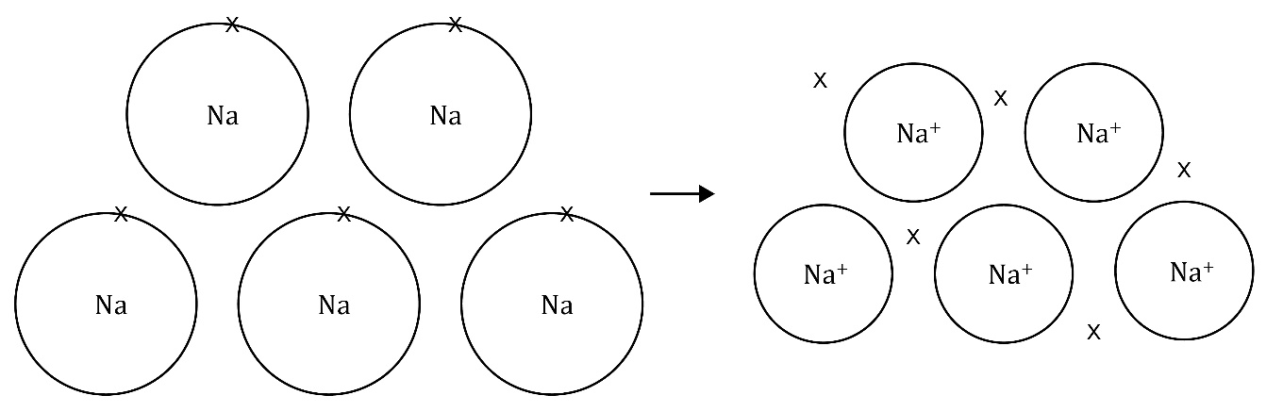
- Use the words to complete the sentences. You may use the words more than once.

electrons electrostatic forces ions metallic

_____________________________________ bonding – the electrons leave the outer shells of metal atoms, forming positive metal ions and a ‘sea’ of delocalised _____________________________________ that are free to move. This bonding is a result of the strong _____________________________________ of attraction between the positive metal _____________________________________ and the negative delocalised _____________________________________.

Metallic bonding: test myself

Use the words to complete the sentences.
- What types of elements are involved in metallic bonding?

metal and non-metal metals only non-metals only

Metallic bonds are found in _____________________________________.
- Are metallic bonds strong or weak?

strong weak

Metallic bonds are _____________________________________.

- What does ‘delocalised’ mean?

atoms electrons ions

The _____________________________________ are free to move.
- Why are metals good conductors of electricity?

atoms charge delocalised electrons

Metals are good conductors of electricity because they contain _____________________________________ _____________________________________ that are free to move and carry the _____________________________________.

Metallic bonding: feeling confident?
- Complete the diagram to represent the metallic bonding in copper.

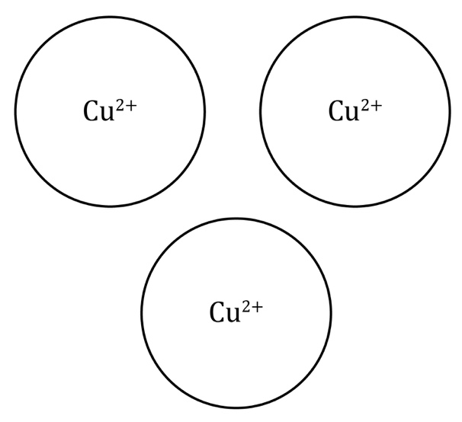
- Complete the diagram to represent the metallic bonding in iron.

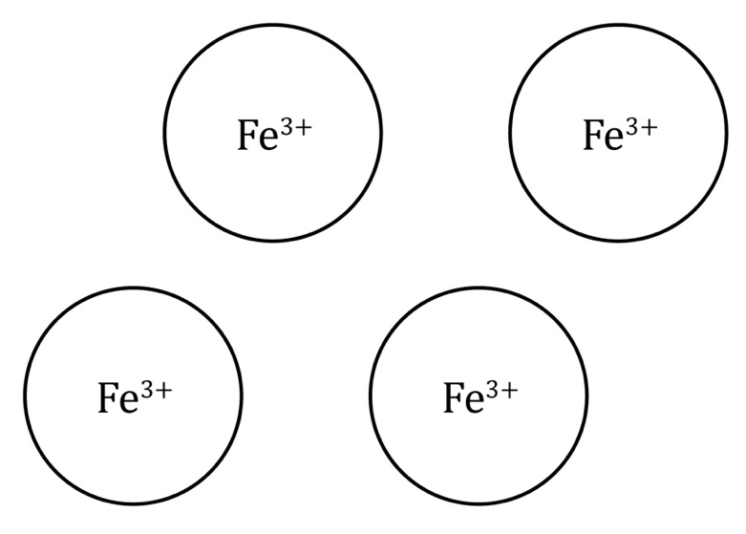

Metallic bonding: what do I understand?

Think about your answers and confidence level for each mini-topic. Decide whether you understand it well, are unsure or need more help. Tick the appropriate column.
Mini-topic | I understand  this well | I think I understand this | I need more  help
I can interpret diagrams representing metallic bonds.
I know that there are positive metal ions and negative delocalised electrons in metallic bonds.
I know about electrostatic forces in metallic bonds.
I can explain why metals conduct electricity.
Feeling confident? topics | I understand  this well | I think I understand this | I need more  help
I can complete diagrams to represent the formation of metallic bonds.

