The water cycle

Condensation: as the warm moist air rises through the cooler denser air above, the water vapour condenses forming tiny water droplets, eventually forming clouds.

Transpiration: water is absorbed by plants via their roots, and can be released as water vapour via their leaves, adding to the water vapour directly evaporating from the oceans.

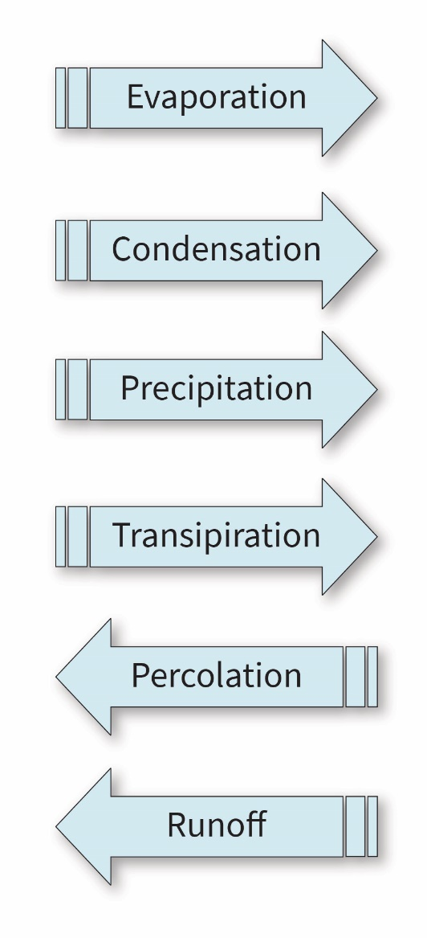
Learning objectives
- Identify processes in the water cycle.

Evaporation: the Earth’s surface absorbs energy from the Sun, causing an increase in the rate of evaporation of surface water forming water vapour.
- Construct a model of the water cycle.

Introduction

The water cycle is the continuous movement and transportation of water on Earth driven by the energy of the Sun.

Percolation: some water will percolate through the soil and rocks. It can remain as groundwater, transport back to the oceans, or be absorbed by plants.

Instructions

Cut out the boxes of text along the dotted lines. Match these to the appropriate blank boxes on the water cycle diagram.

Precipitation: when the water droplets are large enough, they fall back to the Earth’s surface as rain, sleet or snow.

If your diagram does not have arrows, cut out the blue arrows and arrange them to show the movement of water through the diagram.

Runoff: some of the water will run over the Earth’s surface, via streams and rivers back to the sea.

The water cycle

Condensation: as the warm moist air ________ through the cooler denser air above, the water vapour __________ forming tiny water droplets, eventually forming _________.

Transpiration: water is _________ by plants via their roots, and can be released as water vapour via their leaves, adding to the water vapour directly ___________ from the oceans.

Learning objectives
- Describe processes in the water cycle.

Evaporation: the Earth’s surface absorbs _________ from the Sun, causing an increase in the rate of evaporation of surface water forming water _________.
- Construct a model of the water cycle.

Introduction

Word bank
☐ absorbed ☐ clouds
☐ condenses ☐ energy
☐ evaporating ☐ groundwater
☐ oceans ☐ plants
☐ rises ☐ rivers
☐ sleet ☐ snow
☐ soil ☐ streams
☐ vapour ☐ water droplets

The water cycle is the continuous movement and transportation of water on Earth driven by the energy of the Sun.

Precipitation: when the __________ _____________ are large enough, they fall back to the Earth’s surface as rain, _______ or ________.

Percolation: some water will percolate through the ________ and rocks. It can remain as ______________, transport back to the __________, or be absorbed by _________.

Instructions

Cut out the boxes of text along the dotted lines. Match these to the appropriate blank boxes on the water cycle diagram.

Fill in the blanks using the words in the word bank provided. You only need to use each word once.

Runoff: some of the water will run over the Earth’s surface, via ________ and ________ back to the sea.

If your diagram does not have arrows, cut out the blue arrows and arrange them to show the movement of water through the diagram.

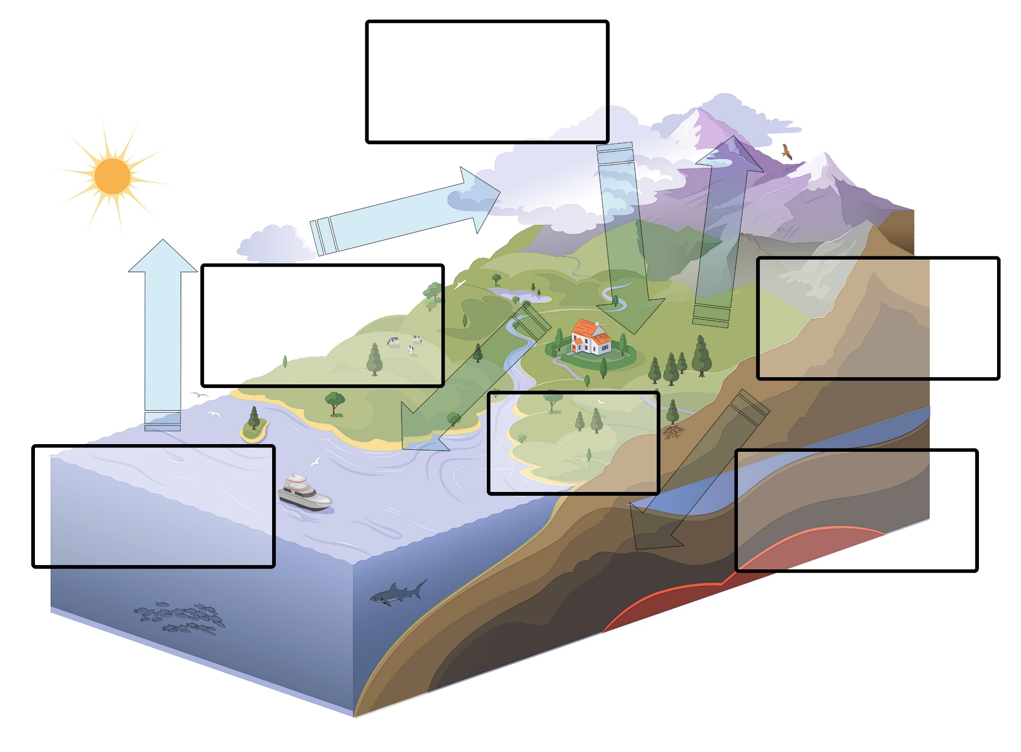
The water cycle

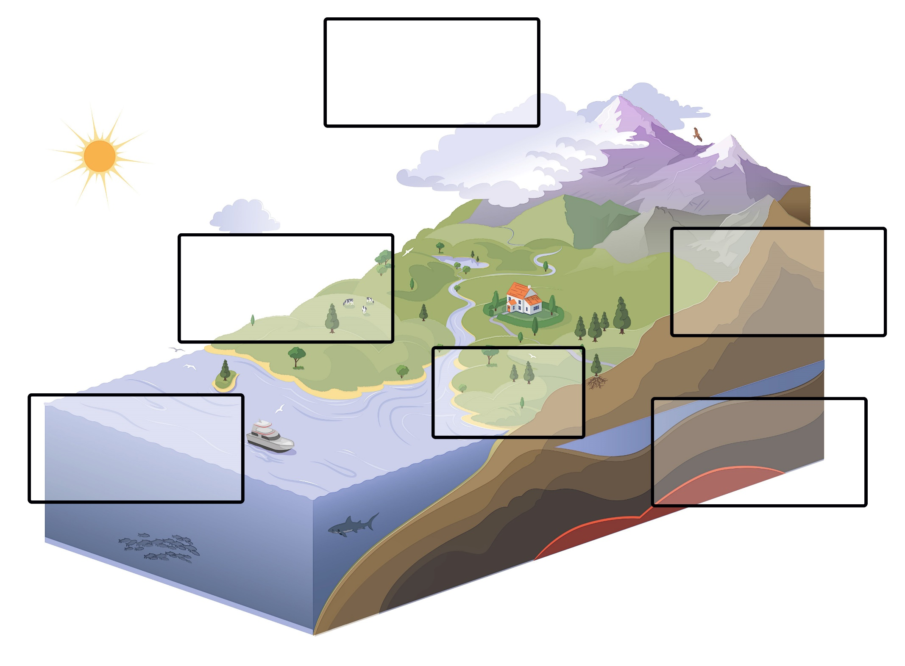
The water cycle

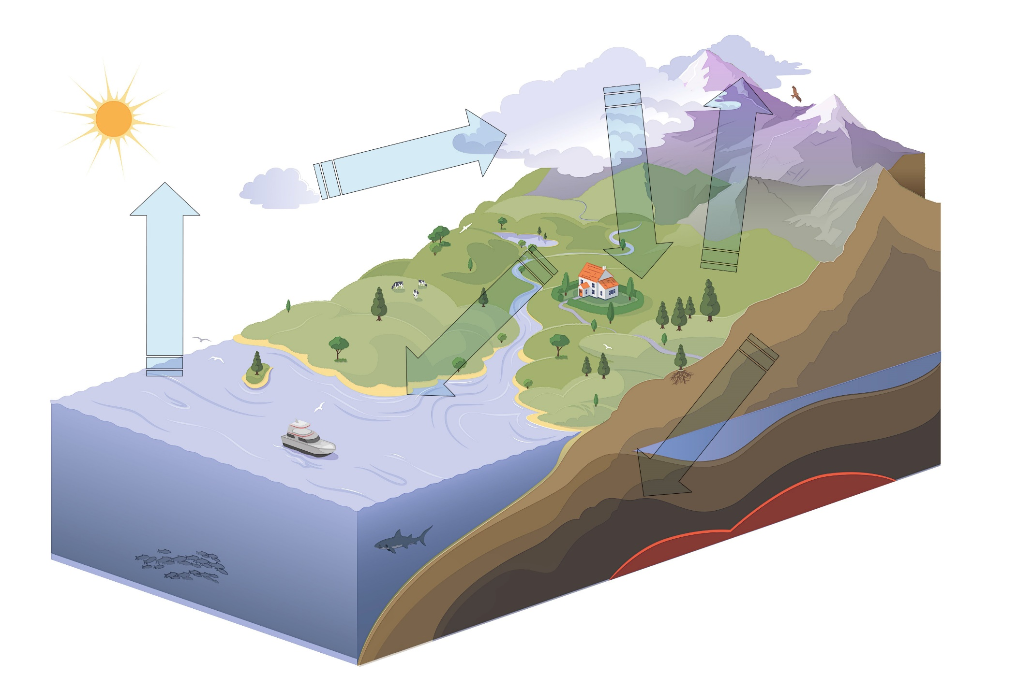
The water cycle

