Oxygen and methylene blue – student sheet

In this experiment you will be generating oxygen gas by reacting hydrogen peroxide and potassium manganate(VII) and testing for it using methylene blue solution.
You will be familiar with testing for oxygen using a glowing splint which re-lights in the gas. This microscale experiment provides an alternative test. Students must wear eye protection.

Procedure
- Construct the gas generating apparatus by cutting the top off a plastic pipette so that a piece of rubber tubing can be attached to the pipette as shown:
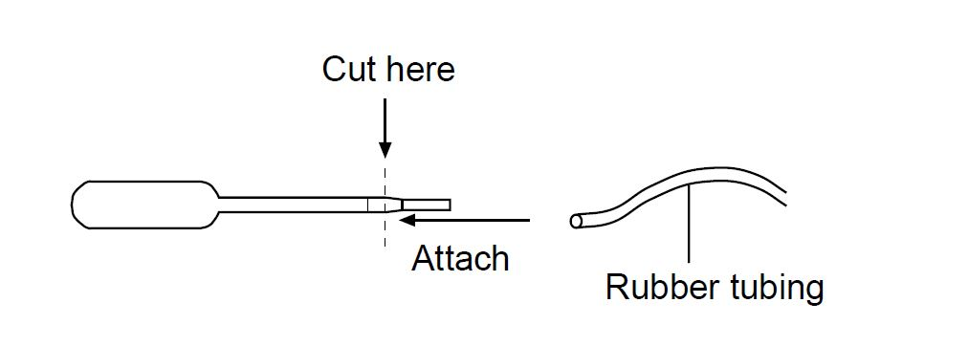
- Add methylene blue solution to a 10 cm³ beaker until it is about half-full.
- Add 10 drops of hydrogen peroxide to the shortened pipette.
- Turn the pipette almost to the horizontal position and carefully put five drops of potassium manganate(VII) solution in the stem as shown:
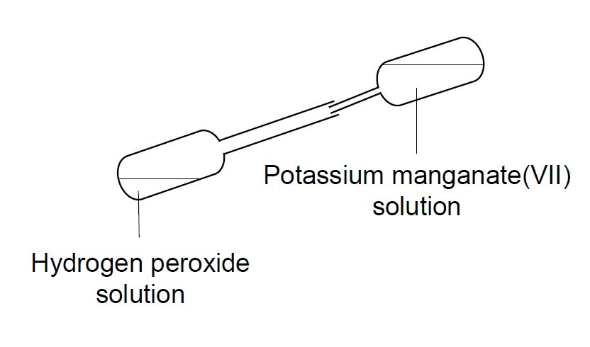
- Attach the rubber tubing to the pipette, place the other end in the methylene blue solution, and gently turn the pipette upright. The potassium manganate(VII) solution, held in the stem, should fall down into the hydrogen peroxide, causing vigorous evolution of oxygen gas.
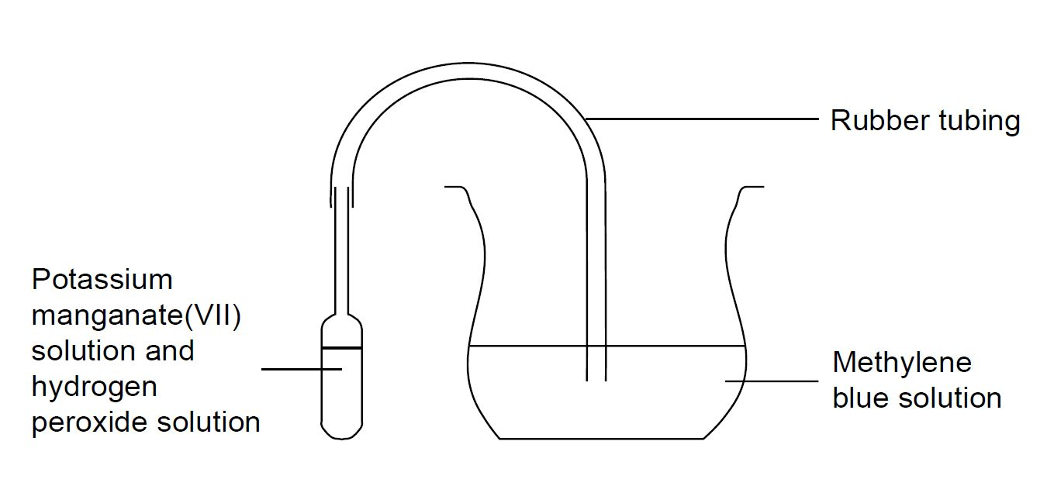
- Describe your observations.

Questions
The reaction (above) shows the structures of methylene blue in the reduced (colourless) and blue (oxidised) forms.
- Which structure is which?
- Can you give reasons for your answer?
- Can you write an equation for the reaction between potassium manganate(VII) and hydrogen peroxide?
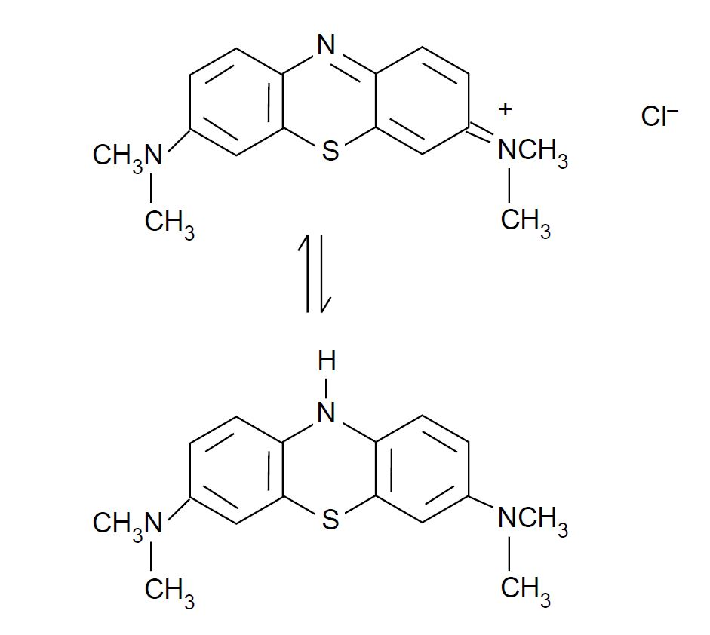

Health, safety and technical notes
- Wear eye protection throughout (splash-resistant goggles to BS EN166 3).
- Glucose / methylene blue / sodium hydroxide solution is corrosive, goggles (to BS EN166 3) should be worn. Reducing the concentration to below 0.5 mol dm⁻³ will mean it is merely an irritant and will still work (see CLEAPSS Hazcard HC040c, HC032).
- Sodium hydroxide itself is highly corrosive, if students are making up their own solutions (see CLEAPSS Hazcard HC091a).
- Hydrogen peroxide, 5% solution H₂O₂(aq) and potassium manganate(VII), KMnO₄(aq), 0.1 mol dm^{–3} are of low hazard (see CLEAPSS Hazcard HC050, HC081).
- Using less (2.4g) of potassium hydroxide will mean the solution is irritant rather than corrosive, and pupils can just use safety glasses (see CLEAPSS Hazcard HC091b).

