Electrolysis of brine in an improvised cell
Education in Chemistry
January 2018
rsc.li/EiC118-preciouswater
In this experiment you will work in a pair to construct a cell to carry out electrolysis is discussed in the above article, ‘Precious water’.
Materials needed
- Butter/margarine tub
- 2 corks with pre-drilled holes
- 2 carbon rods
- Plasticine or a glue gun
- Circuit apparatus: power pack or battery (6V is usually sufficient); wires; crocodile clips
- Brine
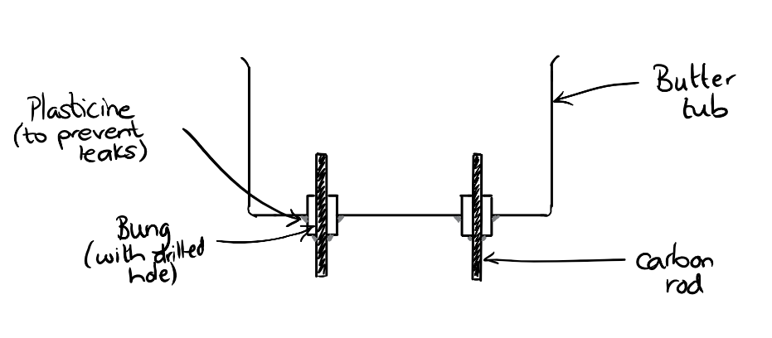
The diagram above shows a cross section of the electrolysis cell. You will need to cut holes in your tub. Draw around your corks first so you can make your holes the right size.
When your cell is complete, add your brine solution and connect the circuit up to the carbon rods. You can use ignition tubes filled with the brine solution placed over the carbon rods to collect any gases that might be produced at the electrodes. You can add a few drops of universal indicator to find out more about the chemistry happening in the cell.
Write down your observations for the positive and negative electrode.

Now look at the eight debate cards below. Discuss the statements with your lab partner. Do you agree? In what ways are the statements correct? Can you spot any that are wrong? Are any partly correct?

There are bubbles forming on top of the carbon rods. That must be a physical change like evaporation. | There is a smell like swimming pools so chlorine must be being produced.
The sodium ions are making sodium which is reacting with the water and producing hydrogen. | The ions in the brine are attracted to the electrode with the opposite charge – a bit like magnets.
The bubbles coming from each electrode are different sizes. Different gases must be being produced. | The brine is mostly water so the gases produced could be hydrogen and oxygen from splitting up water.
Sodium can’t be being produced at one of the electrodes as sodium sets on fire when it reacts with water. | When universal indicator is added the water turns purple which means there is an alkali. Alkalis have OH⁻ ions so something must be happening to the water.

