Escape the classroom again
Education in Chemistry
November 2019
rsc.li/34maTCe
Modelled on Escape rooms, these Escape the classroom activities challenge students to solve chemistry-based puzzles to open a locked folder containing a reward. On the following pages are the puzzles and the solutions.

Puzzle 1 – Hydrophobic revelation
The code to find
Is set in stone
Dihydrogen oxide
Will make it known …

Puzzle 2 – Word grid
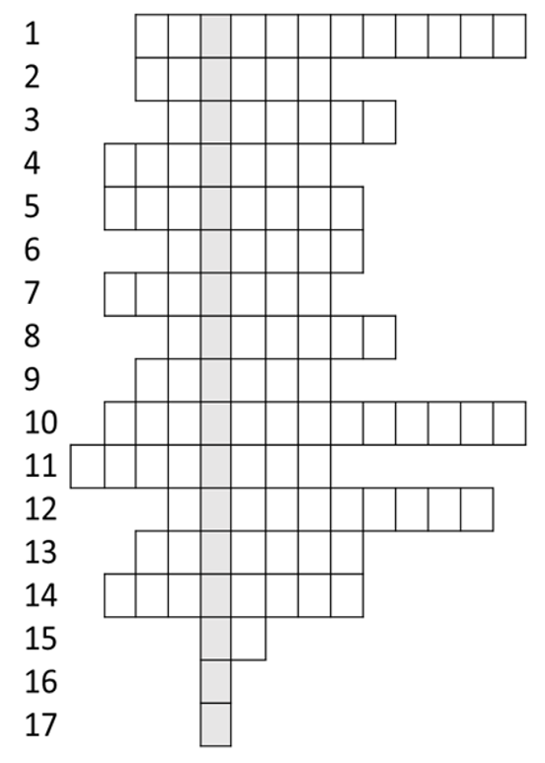

- Family of saturated hydrocarbons, general formula C_{n}H_{2n}.
- Unsaturated hydrocarbon with formula C₂H₄.
- An example of this type of formula is C_{n}H_{2n}.
- This solution will rapidly decolourise in the presence of unsaturated hydrocarbons.
- Alkenes will react with bromine in this type of reaction.
- Compounds with same molecular formula but different structural formula.
- Hydrocarbon with formula C₅H₁₂.
- Hydrocarbon with formula C₃H₈.
- This element is required for combustion.
- Gas produced during combustion of hydrocarbons.
- Name given to –OH functional group in ethanol.
- Series with similar chemical properties and same general formula.
- Family of saturated hydrocarbons, general formula C_{n}H_{2n+2}.
- Alcohol with three carbon atoms.
- Number of hydrogens in hexane.
- Number of carbons in methanol.
- Number of hydrogens in ethane.

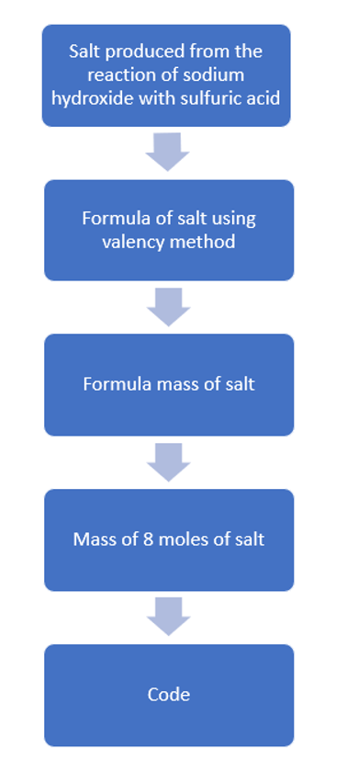
Puzzle 3 – Interweaved enigma

Puzzle 4 – A question of balance
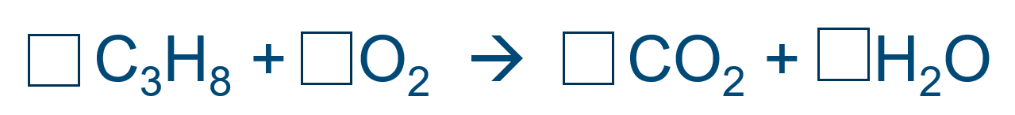
This equation needs balance
This is conservation of mass
Get the right numbers
The next stage you will pass …

Puzzle 5 – Particle poser
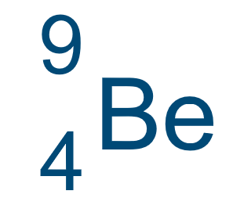
The first number is atomic
the second is mass
The third is number of neutrons
Next is ion charge and you will pass …

Puzzle 6 – Riddle
I’m a molecular solid element
When burning I look grand
I was isolated from urine
By the German Henning Brand
I’m in DNA, fertilisers
Matches and much more
My molecules aren’t diatomic
I group my atoms in four
The temperature I boil at
Will give you the clue
To open lock 1
How will you do?

Solutions

Puzzle 1
346

Puzzle 2
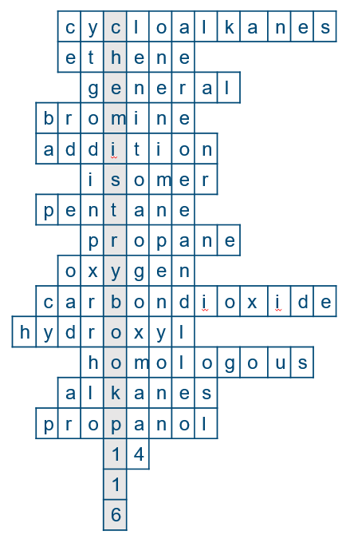

Puzzle 3
Sodium sulfate
Na₂SO₄
(2 x 23) + 32 + (4 x 16) = 142
142 x 8 = 1136
Code = 1136

Puzzle 4
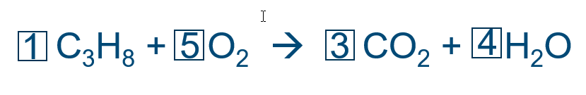

Puzzle 5
Atomic number is 4
Mass number is 9
Neutrons = 5
Charge is 2+
So code is 4952

Puzzle 6
Boiling point = 280

