Amino acids, peptides and proteins

This resource accompanies the article A meaty problem in Education in Chemistry which can be viewed at: https://rsc.li/3lRKgA7

Learning objectives
- Review the naming and structures of common amino acids.
- Draw the structural formulas for dipeptides and tripeptides formed during protein synthesis and the component amino acids formed during hydrolysis.
- Investigate how thin layer chromatography (TLC) can be used to separate amino acids in a mixture.
- Calculate Rf values to identify individual amino acids.

Introduction

Students successfully completing the questions will show understanding of the learning objectives.

‘Review the naming and structure of common amino acids’ is assessed using questions 1(a), 3 and 5 (b).

‘Draw the structural formulas for dipeptides and tripeptides formed during protein synthesis’ is assessed using question 2. ‘Draw the structural formulas for… the component amino acids formed during hydrolysis’ is assessed using questions 3 and 5.

‘Investigate how thin layer chromatography (TLC) can be used to separate amino acids in a mixture’ is assessed using questions 4 and 5.

‘Calculate Rf values to identify individual amino acids’ is assessed using questions 4 and 5 (f).

Answers
- (a) Glycine: 2-amino ethanoic acid

Alanine: 2-amino propanoic acid
Common properties | Reason
They are solids of high melting temperatures | Owing to strong electrostatic attraction between ions
Soluble in water | Strong electrostatic attraction between ions and polar water molecules

(b)

- (a) Gly-Ala:
Ala-Gly:

(b) Gly-Ser-Ser:

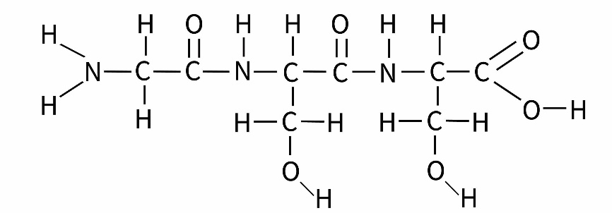

Ser-Gly-Ser:

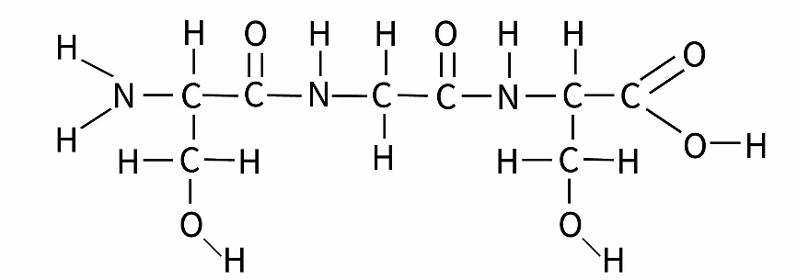
Ser-Ser-Gly:

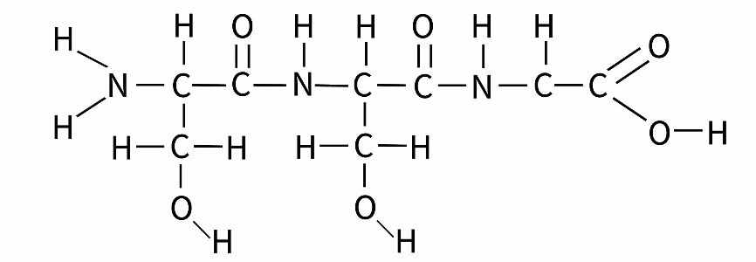

(c) 2 moles of H₂O are formed

- Equation should show:
- Addition of 2 moles of water to 1 mole of glutathione as reactants and
- Formulae of constituent amino acids glutamic acid, cysteine and glycine as products.

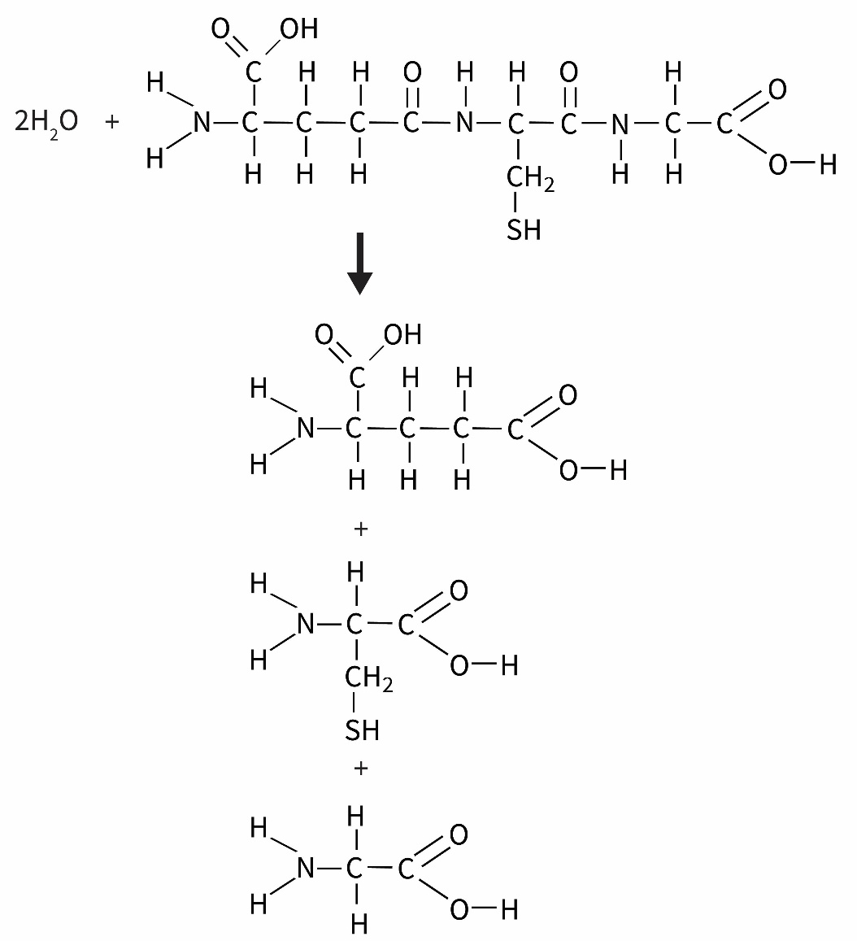

Amino acid | Estimated Rf value | Corrected Rf value
Alanine (ala) | 0.74 | 2.8/3.5 = 0.80*
Glutamic acid (glu) | 0.60 | 2.2/3.5 = 0.63*
Glycine (gly) | 0.46 | 1.6/3.5 = 0.46*
Serine (ser) | 0.22 | 0.8/3.5 = 0.23*

*Due to printer scaling these values may be different. Please check and amend your mark scheme accordingly.

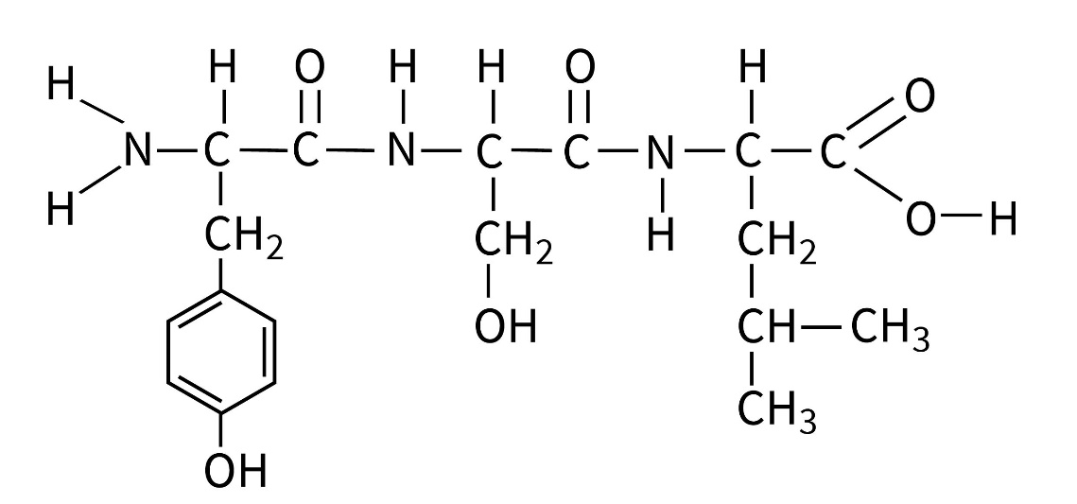
- (a)

(b)

Tyrosine:

Serine:

Glycine:

(c) Serine = most soluble

Both tyrosine and serine contain an O-H bond within the R group which can H-bond with water

In the serine the polar O-H bond is a larger proportion of the R group than in tyrosine

Amino acid | Side chain polarity | Rf value
Tyrosine | polar | 0.59
Serine | polar | 0.65
Leucine | non-polar | 0.43

(d)

(e) Cross contamination using same pipette,

Spot too concentrated causing streaking

(f) i. Rf values are 0.8/3.8 = 0.21* and 1.75/3.8 = 0.46*

ii. Tripeptide is made up of only two different amino acids

*Due to printer scaling these values may be different. Please check and amend your mark scheme accordingly.

