Conservation of mass
Education in Chemistry
July 2020
rsc.li/2XcHadN
Explore how mass is conserved when a substance is dissolved or heated.

Dissolving sugar
A beaker of water and a beaker of sugar are put on both sides of some scales.
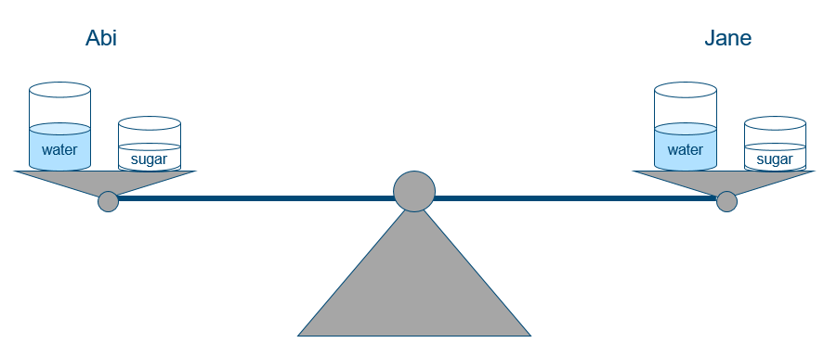
Jane takes her beaker of water off the scales and pours her sugar into it. She stirs it until she cannot see the sugar granules. Abi leaves her water and sugar alone.
- Sketch what you think the scales will look like if Jane puts her two beakers back on the scales. Explain your answer.

Heating copper(II) carbonate
A sample of copper(II) carbonate is added to a test tube and heated.
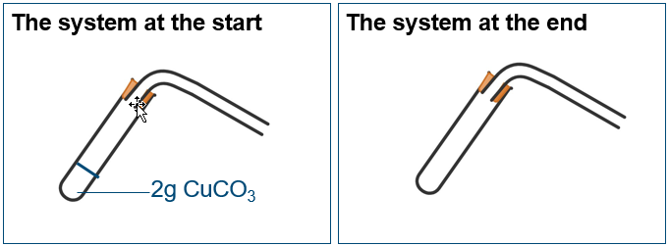
2 g CuCO₃
- Draw on and label all the substances that you think would be present in the same system at the end of the reaction.
- Use the diagram to explain what happens to atoms in copper carbonate when it decomposes.
- Suggest why some people incorrectly think this reaction disproves the law of conservation of mass.
- Imagine a test tube containing calcium hydroxide (lime water) was added to the end of the delivery tube at the start of the reaction. What effect would this test tube of lime water have on:
  - the mass of the system?
  - the mass of carbon dioxide produced by the reaction?
  - the overall mass change of the system?
  - the carbon atoms from the copper carbonate?

