The hunt for vitamin C

Learning objectives
- Apply the practical techniques of preparing a solution and carrying out a titration to analyse the mass of vitamin C in cooked cabbage.
- Plan a practical method for your analysis from partial instructions, taking into account health and safety considerations and the required accuracy and precision.
- Record, analyse and present data to reach a conclusion from your results.
- Apply concepts of redox, solubility, enzyme and numerical chemistry to the analysis of vitamin C in cabbage.

Introduction

Vitamin C is the compound ascorbic acid. Its molecular formula is C₆H₈O₆. The important functions of ascorbic acid are to make collagen (the protein in skin, cartilage, blood vessels and bones), heal wounds and help the body to absorb iron. The recommended daily intake of vitamin C is 90 mg. Vitamin C is not stored well so must be consumed as part of our diet.

Cooking can reduce the content of vitamin C in food so the choice of cooking method is important to preserve the maximum amount of this critical vitamin. The amount of vitamin C in food can be determined by a redox titration with a standard solution of dichlorophenolindophenol (DCPIP), an indicator dye.

In Task 1 you will study the structure and bonding in vitamin C to predict the effect of different cooking methods on its content in food.

In Task 2 you will use half-equations to deduce the roles of vitamin C and DCPIP in the redox titration and the stoichiometry between these reagents.

In Task 3 you will plan a method to analyse and compare the vitamin C content of cabbage cooked by two different methods from a partial set of instructions.

In Task 4 you will carry out your method, record you results and use your data to calculate the vitamin C content of cabbage from two different cooking methods.

Task 1 – Structure and bonding in vitamin C

Below are models of displayed and skeletal formulas for ascorbic acid (vitamin C).

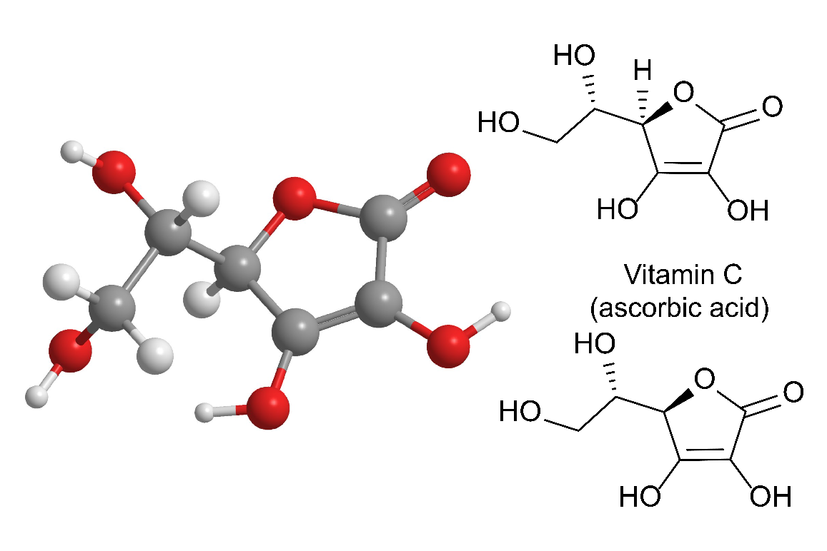

Questions

- Suggest, according to its name, a functional group you would expect this molecule to contain.
- State the functional group(s) actually present in ascorbic acid.

- Vitamin C is a water-soluble vitamin so washing and boiling the fruit and vegetables that contain it will reduce its content.

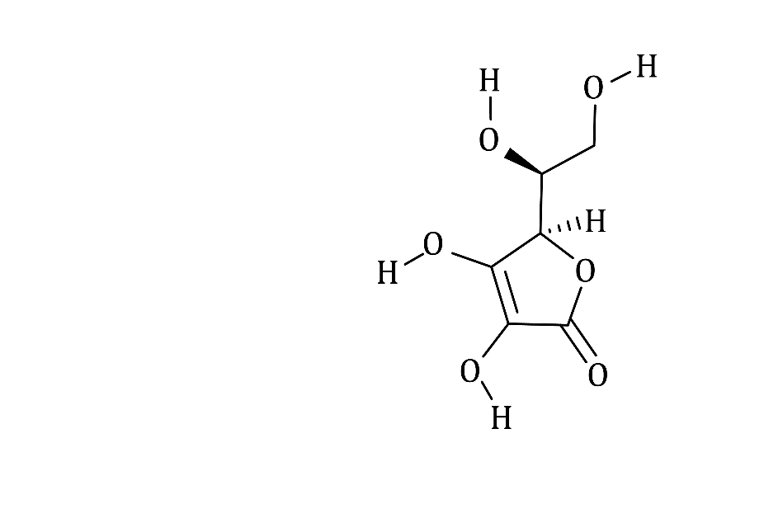

Use the above diagram to show how a hydrogen bond is formed between the vitamin C molecule and a water molecule. Draw and label the hydrogen bond.

- Cabbage is shredded or finely chopped before cooking. Explain why the vitamin C content of cabbage is reduced during cooking to a greater extent than the same mass of a whole vegetable such as a potato.

- Cabbage cells also contain the enzyme ascorbic oxidase, which oxidises vitamin C. Ascorbic oxidase has its highest activity at pH 5. Using your knowledge of enzyme chemistry, suggest two ways in which this enzyme can be in activated to preserve the vitamin C content of cabbage.

Task 2 – The redox reaction between ascorbic acid (vitamin C) and DCPIP (dichlorophenolindophenol)

The half-equations for the reactions occurring in the redox reaction between ascorbic acid and DCPIP are shown below:

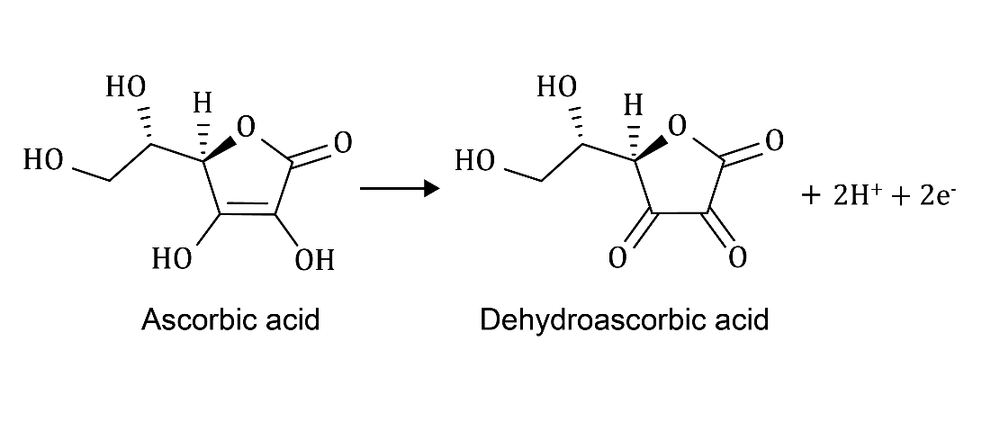

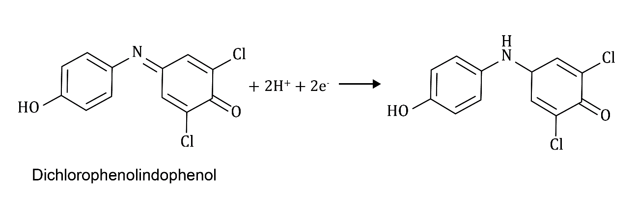
- State the role of the following in the above equations:
- ascorbic acid
- DCPIP

- Combine the two half-equations to draw the full redox equation for this reaction.

- Use your redox equation to state the stoichiometry between DCPIP and ascorbic acid.

Task 3 – Plan the analysis of the vitamin C content of cooked cabbage

Hypothesis:

More than 50% of vitamin C is lost from cabbage when it is cooked in boiling water. Less vitamin C is lost during cooking when the cabbage is plunged directly into boiling water because this should immediately inactivate the enzyme ascorbic acid oxidase. If cabbage is placed in cold water which is then brought to the boil, the vitamin C content will be lower.

Fact:

There are 36.6 mg of vitamin C in 100.0 g of raw cabbage.

You can find the mass of vitamin C in cooked cabbage by titration with standardised DCPIP. The list of available reagents and apparatus are below.

Reagents and materials
- 100 g of green cabbage (you should aim to use all of this)
- 1 dm³ of 5% phosphoric acid (H₃PO₄)
- 100 cm³ of aq DCPIP (0.4 g dm⁻³)
- 75 cm³ of standard vitamin C (0.2 g dm⁻³) in 5% phosphoric acid (H₃PO₄)
- Deionised water (to ensure no dissolved oxygen interferes with the vitamin C content)

Available equipment
- Filter funnel
- Muslin or glass wool
- 25 cm³ pipette and safety filler
- 50 cm³ burette
- 250 cm³ conical flask
- 25 cm³ measuring cylinder
- 100 cm³ measuring cylinder
- 500 cm³ measuring cylinder
- 250 cm³ beaker
- Bunsen burner, tripod and gauze
- Safety glasses
- Liquidiser

The three stages of the method are:
- Stage 1 – standardisation of the DCPIP indicator dye.
- Stage 2 – analysis of the vitamin C content of cabbage cooked by adding it directly to boiling water.
- Stage 3 – analysis of the vitamin C content of cabbage cooked by adding it to cold water which is then heated to boiling point.

Stage 1: standardisation of DCPIP dye

Before you use the DCPIP indicator to determine the vitamin C content of cabbage you must first standardise the DCPIP to find the mass (mg) of vitamin C equivalent to 1 cm³ of DCPIP solution. This amount is called the dye factor, F.
- Safely transfer 25 cm³ of the standard vitamin C solution provided to a suitable vessel and titrate against the DCPIP solution.
- As the DCPIP is run in, the colour change is from blue to colourless and the end point is when a pink colour is seen which persists for 10 seconds.
- Repeat step i. using 25 cm³ of 5% phosphoric acid (H₃PO₄) to reach the same end point. This is referred to as a ‘blank’ titration as only the solvent (and no vitamin C) is present.

Questions
- Write down the specific measuring apparatus and safety measures needed in step i.
- The dye factor, F, is the mass, in mg, of vitamin C equivalent to 1 cm³ of DCPIP solution. F can be calculated using the following formula:

$$F= \frac{volume of standard vitamin C solution ×concentration of vitamin C (mg {dm}^{-3})}{\left(standardisation titre-blank titre\right)×1000}$$

Calculate the value of F where the standardisation titre = 27.50 cm³ and the blank titre = 0.50 cm³.

- Use the method for Stage 1 and the list of available equipment, reagents and materials provided to plan a method for Stages 2 and 3. Your plan should include details of the apparatus you will use and consideration of independent variables, such as time and temperature, to ensure fair sampling to compare the vitamin C content of cabbage cooked by each method.

Task 4 – Analysis of vitamin C in cabbage

When you have checked your plan from Task 3 with your teacher, carry out the analysis of the vitamin C content of cabbage cooked by the two different methods.
- Before starting your practical work, prepare tables to record the results for your mass and titration reading in an appropriate format. Record the mass of the liquidised sample of cabbage mixed with 250 cm³ of 5% phosphoric acid as M_{c} and the mass of the 20 cm³ portion of this mixture as m_{c}.

- Calculate the vitamin C content of each sample of cabbage using the formula:

$$Mass treated = 50.0 g$$

$$Mass sampled for titration = \frac{m_{c}}{M_{c}} ×50.0 g$$

$$Volume of dye titre = V {cm}^{3}$$

$$Dye factor = F mg {cm}^{-3}$$

$$50.0 g of sample contains = V ×F × \frac{M_{c}}{m_{c}} mg vitamin C$$

$$100.0 g of sample contains = V ×F × \frac{M_{c}}{m_{c}} ×2 mg vitamin C$$
- Compare the mass of vitamin C per 100.0 g of cabbage for each of your two samples. Comment on whether these values are consistent with the hypothesis stated at the start of Task 3 and below. You should use the fact that there is 36.6 mg of vitamin C in 100.0 g of raw cabbage.

Hypothesis:

More than 50% of vitamin C is lost from cabbage when it is cooked in boiling water. Less vitamin C is lost during cooking when the cabbage is plunged directly into boiling water because this should immediately inactivate the enzyme ascorbic oxidase. If cabbage is placed in cold water which is then brought to the boil the vitamin C content will be lower.

