Electrochemical cells misconception buster

This resource accompanies the article Teaching electrochemical cells at post-16 in Education in Chemistry which can be viewed at: rsc.li/46nHSXn. The article provides classroom tips, activities and ideas to combat electrochemistry misconceptions.

Learning objectives
- Describe how to set up an electrochemical cell, including:
  - The function and use of a salt bridge.
  - The relative positions of half cells according to their E⊖ values.
  - The use of a platinum electrode where necessary.
  - The components and use of the standard hydrogen electrode.
- Write and apply the conventional representation of an electrochemical cell.
- Use E⊖ values to predict the direction of simple redox reactions.
- Calculate the EMF (E_{cell}) and use this value to predict the feasibility of the cell.

Identify and target misconceptions in the three main pinch points of electrochemistry: setting up cells, redox equations and calculations.

How to use the resource

Activity 1 consists of 20 multiple choice questions. Instruct learners to read each question carefully, using the diagrams and data provided to tick an answer. There is one correct answer per question.

After learners mark the multiple choice questions either by peer or self-assessing, they will complete the relevant follow-up tasks to target areas for improvement and increase their understanding of certain topics.

If appropriate, guide learners to follow-up tasks based on misconceptions you have already identified throughout the course or for further practice if they get 20/20 on the quiz. Activity 2 is fully differentiated for learners to target their own misconceptions identified from the multiple choice quiz.

Extension opportunities

Non-rechargeable and rechargeable cells are not explicitly covered in this task. Encourage learners to read the EiC Batteries and electrochemical cells article (available from rsc.li/3Xoy23g) as an introduction. As a follow-up activity, use the lead–acid accumulator cell practical (rsc.li/3NtKAC0) to either introduce or revise these concepts.

Answers

Activity 1: multiple choice questions
Qu | Answer | Explanation | Activity 2 follow-up task
1 | A – A half-cell | An electrochemical cell is made up of two half-cells joined together by a connecting wire and a salt-bridge. A battery is made of multiple cells joined together in series. | Complete task a
2 | C – 0.5 mol dm⁻³ | The concentration of hydrogen ions in the standard hydrogen electrode must be 1.00 mol dm⁻³. Since sulfuric acid is a diprotic acid with the formula H₂SO₄, every mole of acid releases two moles of hydrogen ions, therefore the concentration of acid must be 0.5 mol dm⁻³ to release 1.00 mol dm⁻³ of hydrogen ions. | Complete task b
3 | D - Fe²⁺(aq), Fe³⁺(aq)|Pt(s) | According to IUPAC convention, reduced forms go on the outermost edge of cell representations. You separate species in the same phase by a comma (,), while separating species in a different phase by a single line (|). Since Fe²⁺ and Fe³⁺ are both aqueous, you use an inert platinum electrode. | Complete task c
4 | A - Reduced form at edges, more negative cell on the left-hand side. | According to IUPAC convention, reduced forms go on the outermost edge of the cell representation. The more negative half-cell goes on the left. | Complete task c
5 | C - 298 K, 100 kPa, 1 mol dm⁻³ H⁺ solution, platinum electrode. | The concentration of hydrogen ions in the standard hydrogen electrode (SHE) must be 1.00 mol dm⁻³, not simply the ‘acid’ concentration (as some acids, such as sulfuric acid, release more than one hydrogen ion per acid molecule). You use standard conditions for the SHE. A graphite electrode is unsuitable, as it may react with the solutions; you must use an inert platinum electrode. | Complete task b
6 | B - It allows inert ions to transfer between half-cells to maintain electrical neutrality. | The salt bridge completes the electrical circuit as described. Note that only the inert ions used in the salt bridge can transfer between solutions; not the ions from the electrochemical cell. Neither current nor electrons can ‘flow’ through a salt bridge. | Complete task a
7 | C – KNO₃ | Use salts which do not easily form precipitates for salt bridges. Sodium ions and chloride ions are inappropriate, as they are too large to allow effective diffusion across the salt bridge. Chloride forms many insoluble salts with metals, so cannot be used for salt bridges. | Complete task a
8 | A - || | You must represent a salt bridge with a double vertical line, ||. | Complete task a
9 | C – Pt(s) | To construct the SHE, pump hydrogen gas through a porous tube containing an inert platinum electrode dipped in a 1 mol dm⁻³ H⁺ solution at 298 K and 100 kPa. | Complete task b
10 | D – Copper electrode | To construct a half-cell, dip a metal into a solution of its ions. Since the solution is copper sulfate, you must use a copper electrode. Only use a platinum electrode if there are no solid electrodes in the half-cell. | Complete task a
11 | D – The cell with the more negative E⊖ value. | Half-cells can have positive or negative E⊖ values, depending on the tendency of the species to be oxidised or reduced. The more negative cell is always placed on the left-hand side; it is the anode. | Complete task a
12 | A – Electrons flow from the zinc half-cell to the iron half-cell; Zn is oxidised and Fe³⁺ is reduced. | The zinc loses electrons to form Zn²⁺. The electrons flow through the conducting wire to the iron half-cell. Fe³⁺ ions gain an electron to form Fe²⁺. | Complete task d
13 | A –  Zn(s)|Zn²⁺(aq)||Fe³⁺, Fe²⁺(aq)|Pt(s) | According to IUPAC convention, reduced forms go on the outermost edge of the cell representation, so Fe²⁺ must go on the far right, and Zn on the far left. The more negative half-cell goes on the left. Since there are no solid electrodes in the Fe²⁺/Fe³⁺ half-cell, you require a platinum electrode. | Complete task a
14 | C – Cl₂ | Oxidising agents cause other species to become oxidised. They themselves are reduced. | Complete task f
15 | A - Cl₂ + 2Br⁻ ⇌ 2Cl⁻ + Br₂ | The chlorine/chloride half-cell has a more-positive E⊖ value, so reduction occurs.  Cl₂ + 2e⁻ ⇌ 2Cl⁻  This means that the bromine/bromide reaction occurs in the opposite direction.  2Br⁻ ⇌ Br₂ + 2e⁻  Combining the equations gives A. | Complete task e
16 | A - Cl₂/Cl⁻ as electrons flow towards it | Electrons flow towards the positive electrode. Since the E⊖ value for the chlorine/chloride half-cell is more-positive, we know that reduction occurs there – electrons are gained. So, electrons must flow towards this half-cell. | Complete task f
17 | B – +0.27 V | E_{cell} = E⊖_{red} - E⊖_{ox}  We know that the chlorine/chloride half-cell is where reduction occurs.  +1.36 – 1.09 = +0.27 V | Complete task g
18 | B – Br⁻ | The bromine/bromide half-cell has a more-negative (less positive) E⊖ value, so oxidation occurs, and bromide ions lose electrons to form bromine:  2Br⁻ ⇌ Br₂ + 2e⁻ | Complete task d
19 | D - Mg | Reducing agents cause other species to become reduced. They themselves are oxidised. Species with a higher tendency to become oxidised have a more-negative E⊖ value. Ensure you are selecting the species which loses electrons – the Mg loses two electrons to become Mg²⁺, so it is Mg which is the reducing agent. | Complete task f
20 | C – ii and iv only | E_{cell} = E⊖_{red} - E⊖_{ox}  Reactions are only feasible if they produce a positive EMF (E_{cell}).  The EMFs for the cells as shown are:  i. -0.25 – 0.34 = -0.59 V  ii. +0.77 – (-2.33) = 3.10 V  iii. -0.25 – (0.77) = -1.02 V  iv. +0.34 – (-0.25) = +0.59 V | Complete task h

Activity 2: follow-up tasks
Follow-up task | Answer
Credit labelled diagrams or written descriptions.

Zinc half-cell – 1.00 mol dm⁻³ of Zn²⁺ ions (allow any suitable solution such as ZnSO₄, Zn(NO₃)₂, ZnCl₂ etc). Zn(s) electrode submerged into the solution, connected to a conducting wire.
Silver half-cell – 1.00 mol dm⁻³ of Ag⁺ ions (allow any suitable solution such as AgNO₃, but NOT silver halide solutions as they form precipitates). Ag(s) electrode submerged into the solution, connected to a conducting wire.
Salt bridge connects the two cells to complete the circuit. Any suitable ions – eg KNO₃.
Zinc half-cell must be placed on the left-hand side.
Voltmeter used in the circuit to measure the EMF.

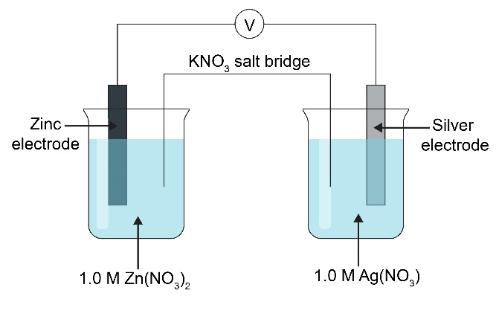
Credit labelled diagrams or written descriptions.

Standard hydrogen electrode (SHE):
1.00 mol dm⁻³ H⁺ solution (check the solution used – if H₂SO₄(aq), then the concentration of acid must be 0.5 mol dm⁻³).
Platinum electrode submerged in the acid solution, connected to a conducting wire.
H₂(g) pumped through a porous tube into the solution.
SHE placed on the left-hand side of the electrochemical cell, as shown in the diagram:
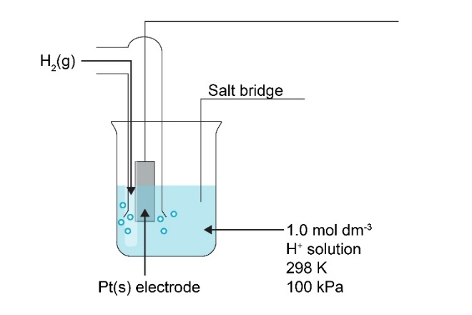
Fe²⁺/Fe³⁺ half-cell:
1.0 mol dm⁻³ both Fe²⁺ and Fe³⁺ solution.
Pt(s) electrode connected to a conducting wire.
As shown in the diagram:
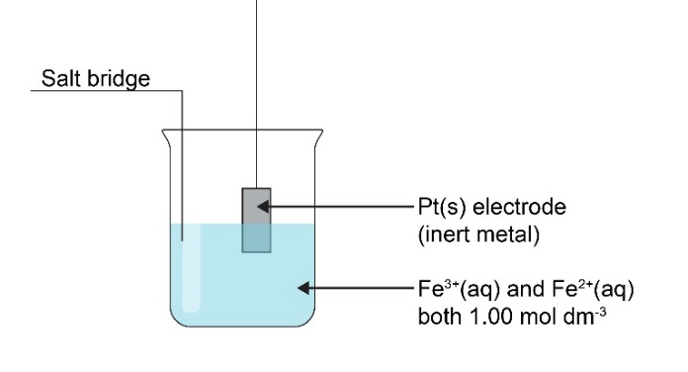

Salt bridge connects the two cells to complete the circuit. Any suitable ions – eg KNO₃.
SHE must be placed on the left-hand side.
Voltmeter used in the circuit to measure the EMF.
- The more negative cell, with the exception of the SHE, which is always placed on the left.
- Any cells with non-solid electrodes. Common examples include the Fe²⁺/Fe³⁺ half-cell, and non-metal half-cells such as Cl₂/Cl.
- Platinum is inert; graphite could react with the electrolyte solutions.
- SHE is always placed on the left-hand side of a cell.
- The right-hand side.
- From the anode (LHS) to the cathode (RHS), ie from the more-negative cell to the less-negative cell.
- Reduced forms go on the edges of the cell. Substances in a different phase are separated by a single vertical line, |. Substances in the same phase are separated by a comma. The salt bridge is represented by a double vertical line, ||.
Cl₂ + 2e⁻ ⇌ 2Cl⁻ E⊖ = + 1.36 V
Br₂ + 2e⁻ ⇌ 2Br⁻ E⊖ = +1.09 V
2Br⁻ + Cl₂ ⇌ 2Cl⁻ + Br₂
The Br₂/Br⁻ half-cell is more-negative: oxidation occurs.
Electrons flow from the Br₂/Br⁻ half-cell (anode) to the Cl₂/Cl⁻ half-cell (cathode).
The reaction is feasible in this direction since the EMF would be positive:
EMF = +1.36 – 1.09 = +0.27 V
Reaction ii:
Mg²⁺/Mg half-cell is more-negative – Mg must be oxidised to Mg²⁺: Mg ⇌ Mg²⁺ + 2e⁻

Fe²⁺/Fe³⁺ half-cell is more-positive – Fe³⁺ must be reduced to Fe²⁺: Fe³⁺ + e⁻ ⇌ Fe²⁺

Combining the two half-equations gives the ionic equation:
Mg + 2Fe³⁺ ⇌ Mg²⁺ + 2Fe²⁺

Reaction iv:
Ni²⁺/Ni half-cell is more-negative – Ni must be oxidised to Ni²⁺: Ni ⇌ Ni²⁺ + 2e-

Cu²⁺/Cu half-cell is more-positive – Cu²⁺ must be reduced to Cu: Cu²⁺ + 2e⁻ ⇌ Cu

Combining the two half-equations gives the ionic equation:
Cu²⁺ + Ni ⇌ Ni²⁺ + Cu (This is also the feasible direction of reaction i).

Feasible reaction iii:
Fe²⁺/Fe³⁺ half-cell is more-positive – Fe³⁺ must be reduced to Fe²⁺: Fe³⁺ + e⁻ ⇌ Fe²⁺

Ni²⁺/Ni half-cell is more-negative – Ni must be oxidised to Ni²⁺: Ni ⇌ Ni²⁺ + 2e-

Combining the two half-equations gives the ionic equation:

Ni + 2Fe³⁺ ⇌ Ni²⁺ + 2Fe²⁺
- Oxidation – loss of electrons.
- Reducing agent – a species which causes other species to be reduced by gaining electrons; it is oxidised (loses electrons) in the process.
- Cathode – the electrode where reduction occurs.

Mg + 2Fe³⁺ ⇌ Mg²⁺ + 2Fe²⁺

Mg is the reducing agent (since it is oxidised to Mg²⁺).
Fe³⁺ is the oxidising agent (since it is reduced to Fe²⁺).
Mg²⁺/Mg electrode is the anode (oxidation occurs).
Fe²⁺/Fe³⁺ electrode is the cathode (reduction occurs).

Cu²⁺ + Ni ⇌ Ni²⁺ + Cu

Ni is the reducing agent (since it is oxidised to Ni²⁺).
Cu²⁺ is the oxidising agent (since it is reduced to Cu).
Ni²⁺/Ni electrode is the anode (oxidation occurs).
Cu²⁺/Cu electrode is the cathode (reduction occurs).
 | EMF = +0.80 – (-2.38) = +3.18 V
Feasible direction is:
Cr²⁺ ⇌ Cr³⁺ + e⁻
Pb²⁺ + 2e⁻ ⇌ Pb
2Cr²⁺ + Pb²⁺ ⇌ 2Cr³⁺ + Pb

EMF = -0.13 – (-0.41) = +0.28 V

Extension

In Br₂, oxidation state = 0

In HBrO, oxidation state = +1

In Br⁻, oxidation state = -1

Oxidation:

Br₂ + 2H₂O → 2HBrO + 2e⁻ + 2H⁺

Reduction:

Br₂ + 2e⁻ → 2Br⁻
- Br₂ is the oxidising and reducing agent.
- Disproportionation – bromine is both oxidised and reduced within the same reaction.
- +1.36 V = +1.07 V – E⊖_{ox}

E⊖_{ox} = -0.29 V

- 3Br₂ + 6OH⁻ → BrO₃⁻ + 5Br⁻ + 3H₂O

