Measuring the amount of vitamin C in fruit drinks – teacher notes

Topic
Food, scientific methodology. Quantitative chemistry/mole calculations.

Timing
20 minutes

Description
In this experiment students use the microscale titration technique to measure the amount of vitamin C (ascorbic acid) in fruit drinks. The basis of the measurement is as follows.

A known excess amount of iodine is generated by the reaction between iodate, iodide and sulfuric acid:
IO_{3–}(aq) + 5I–(aq) + 6H⁺(aq) → 3I₂(aq) + 3H₂O(aq)

A measured amount of fruit drink is added. The ascorbic acid in the drink reacts quantitatively with some of the iodine:

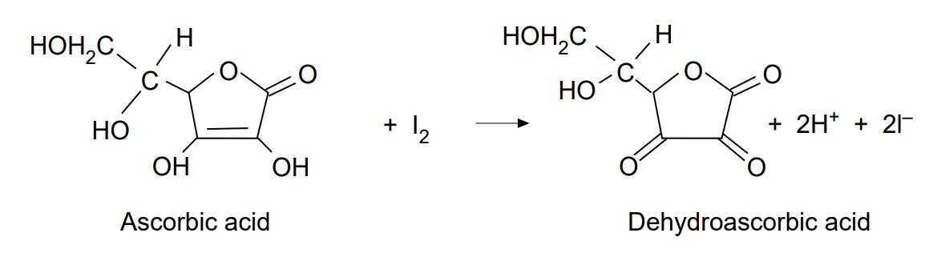

The excess iodine is then titrated against standard thiosulfate solution:
I₂ + 2S₂O₃^{2–} → S₄O₆^{2–} + 2I–

Apparatus
- Eye protection
- Student worksheet
- Microscale titration apparatus - see our apparatus and techniques for microscale chemistry guidance below
- Pipette (glass), 1 cm³
- Pipette (glass), 2 cm³
- Pipette filler
- Beaker, 25 cm³
- Measuring cylinder, 5 cm³
- Beaker (for filling titration apparatus), 10 cm³

Chemicals
Solutions should be contained in plastic pipettes. See the accompanying guidance on apparatus and techniques for microscale chemistry, which includes instructions for preparing a variety of solutions here https://rsc.li/3fUiMJY

- Sodium thiosulfate
- Potassium iodate
- Potassium iodide
- Starch solution (freshly made)
- Sulfuric acid, 1 mol dm³
- Sample(s) of fruit juice

Stock solutions
- Sodium thiosulfate solution 0.010 mol dm^{–3}
Weigh out, accurately, ca 0.620 g of Na₂S₂O₃.5H₂O, dissolve in deionised water and make up to 250 cm³ in a volumetric flask. Store this stock solution in a dark glass bottle.

- Potassium iodate solution 0.001 mol dm^{–3}
Weigh out, accurately, ca 0.054 g of KIO₃, dissolve in deionised water and make up to 250 cm³ in a volumetric flask.

- Potassium iodide solution 0.005 mol dm^{–3}
Weigh out 0.21 g of KI, dissolve in deionised water and make up to 250 cm³ with deionised water.

Observations
The titre volume should be in the range 0.5–1 cm³, the disappearance of the blue-black colour marking the end-point.

This experiment offers possibilities for assessing students’ abilities in following instructions and/or processing results.

A survey of a range of fruit drinks (and maybe other products containing vitamin C) could form the basis of a class project or as an activity for a school or college chemistry club.

Notes
The reaction to generate the iodine is based on using an accurately known volume of the potassium iodate solution (the concentration of which is accurately known).

The potassium iodide solution and the sulfuric acid are added in slight excess, and thus the concentrations of these solutions is not critical.

Instead of generating the iodine in situ, it is possible to use standard iodine solution in this procedure.

This would need to be diluted to give an aliquot containing 7.2 x 10–6 moles of iodine for each determination.

Specimen result and calculation
Volume of thiosulfate delivered during the titration = 0.74 cm³.
Concentration of thiosulfate = 0.010 mol dm^{–3}.
Therefore, number of moles thiosulfate =

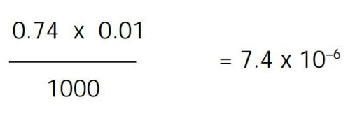

Therefore, the number of moles of iodine that this reacted with during the titration = 3.7 x 10^{–6}.

The total number of moles of iodine produced in the reaction between iodate, iodine and sulfuric acid based on using 2 cm³ of iodate with a concentration of 0.0012 mol dm^{–3} =

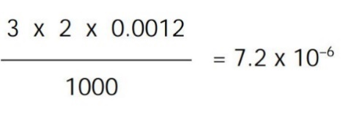

Therefore, the number of moles of iodine which reacted with the ascorbic acid = 7.2 x 10^{–6} – 3.7 x 10^{–6} = 3.5 x 10^{–6}

Since 1 mole of iodine reacts with 1 mole of ascorbic acid then the number of moles of ascorbic acid is also 3.5 x 10^{–6}.

The volume of the fruit juice used was 1 cm³.

Therefore, the number of moles of ascorbic acid in 1000 cm³ = 3.5 x 10^{–3}.

The relative molar mass of ascorbic acid = 174.12 g.

Therefore, mass of ascorbic acid (in 1000 cm³) = 174.12 g x 3.5 x 10^{–3} = 0.609 g.

The vitamin C content of the fruit drink = 61 mg per 100 cm³.

Health, safety and technical notes
- Read our standard health and safety guidance here https://rsc.li/3SRKCow
- Wear eye protection.
- Sulfuric acid, 1 mol dm³ is a skin/eye irritant (see CLEAPSS Hazcard HC098a).
- Sodium thiosulfate, 0.010 mol dm⁻³, potassium iodate, 0.001 mol dm⁻³ and potassium iodide, 0.005 mol dm⁻³ solutions are of low hazard, as are the starch solution and fruit juices (see CLEAPSS Hazcards HC095a, HC080, HC047b).

