Escape the classroom
Education in Chemistry
November 2018
rsc.li/2DUcogN

For this version of an Escape room, challenge students as a group to solve chemistry-based puzzles to open a locked box containing a reward, allowing them to develop problem-solving, knowledge and practical skills in a novel way.
On the following pages are teacher instructions, an example jigsaw and student worksheets.

Jigsaw
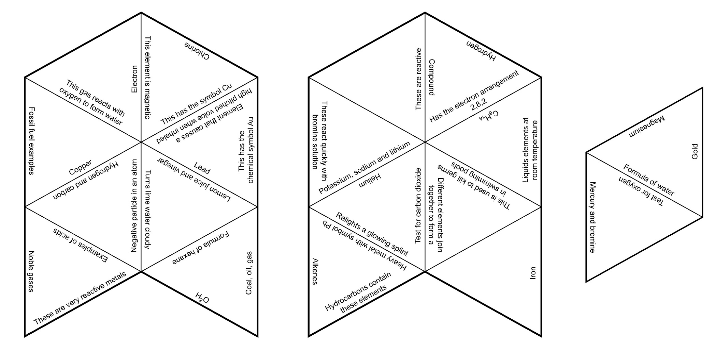

Periodic table guess who

Preparation
Label the guess who doors with: sulfur, sodium, germanium, oxygen, uranium, argon, francium, gold, carbon, copper, krypton, neon, silver, indium, chlorine, iodine, magnesium, hydrogen, nickel, europium, mercury, xenon, neptunium and aluminium

Clues
Close the door of …
… all elements named after planets.
… all elements named after countries.
… all elements that have full energy levels.
… all elements that are worn as jewellery.
… all elements that are used in coins.
… an element named after a continent.
… the element with an electron arrangement 2,8,3.
… the element required for combustion.
… the element which is a yellow solid at room temperature, found in matches.
… the element that burns with a bright white flame.
… the element used to kill germs in swimming pools.

Microscale chemical changes

Materials
- Dropper bottles with various chemicals
- Universal indicator
- Hydrochloric acid (0.1 M)
- Sodium hydroxide (0.1 M)
- Lead nitrate (0.01 M)
- Potassium iodide (0.0 1M)
- Phenolphthalein solution
- Copper sulphate (0.5 M)
- Ammonia (1 M)
- Laminated instruction sheet

Activity
Pupils should add a drop of each the chemicals to each other using the instructions and note the colour. The colour will correspond to a number. This will give the code required to unlock the box. This can be used to introduce pH, precipitation and complexes.

Microscale chemical changes worksheet

- Add 1 drop of lead nitrate to 1 drop of potassium iodide in the circle.

- Add 1 drop of universal indicator to 1 drop of hydrochloric acid in the circle.

- Add 1 drop of copper sulfate to 1 drop or ammonia in the circle.

- Add 1 drop of phenolphthalein to 1 drop of sodium hydroxide in the circle.

1 | 2 | 3 | 4 | 5 | 6 | 7 | 8 | 9

Conductivity code

Materials
- Carbon fibre
- Copper
- Electrolycra
- Perspex (cover slip)
- Rock
- Rubber band
- Sandpaper
- Wooden splint
- Zinc
- Microscale conductivity meter (see SSERC or CLEAPSS website for construction) or any set-up that can test for electrical conductivity.

Conductivity code worksheet
Rubber | Wood | Electrolycra | Rock | Perspex | Copper | Zinc | Sand | Carbon fibre
1 | 2 | 3 | 4 | 5 | 6 | 7 | 8 | 9

Which conducts electricity? Test to see. The conductors will reveal the key.

