Covalent bonding: teacher guidance

This resource forms part of the Review my learning series from the Royal Society of Chemistry. Additional support for addressing misconceptions identified using these worksheets can be found at rsc.li/3mm0IeW.

This worksheet assesses content from the 14–16 specifications. The content is a subset of the Bonding worksheet and can be used to provide extra support for learners on covalent bonding. It can identify learners’ knowledge gaps and misconceptions following the completion of that part of the curriculum.

The Covalent bonding worksheet covers the following topics:
- interpreting diagrams representing covalent bonds
- sharing electrons in covalent bonds
- types of elements involved in covalent bonds.

If learners successfully answer questions on these topics, they can attempt the extension question where they can complete a diagram representing the formation of a covalent bond.

There is only one level of this worksheet. Level 1 () is a scaffolded worksheet in which learners select words from a word list to complete sentences.

The worksheet can be used in a variety of ways:
- as an assessment of learners’ knowledge at the beginning or end of a period of teaching
- as an assessment of knowledge during a period of teaching and after learners have completed the relevant section of the specification
- as a revision tool prior to the relevant examination
- as a refresher exercise for teachers or non-subject specialists.

There is also scope to use this worksheet to support learners who struggle with this type of bonding particularly. These learners could then be encouraged to attempt the partially scaffolded Bonding worksheets to reinforce their understanding.

The ‘What do I understand?’ page can be used both to identify areas needing whole class attention and as an indicator for learners to help guide their revision.

The Teacher guidance provides model answers and guidance on learners’ misconceptions. Learners can use the model answers to self- or peer assess.

Answers

Covalent bonding: knowledge check
- covalent bonding

- Covalent bonding – this bonding occurs between non-metal atoms. In a single covalent bond, a pair of electrons is shared between two atoms. These shared electrons are found in the outer shells of the atoms. Each atom contributes one electron to the shared pair of electrons.
Guidance: Note that in a dative (or coordinate) covalent bond, one of the atoms donates both shared electrons.

Covalent bonding: test myself
- non-metals only

- Covalent bonds are strong.

- The covalent molecule is carbon dioxide.

- There are two electrons in a single covalent bond.
Guidance: It is a common misconception that covalent bonds are weak, but this is not the case. Diamond, the hardest known substance, has covalent bonds only. Another misconception is that atoms share one electron in a covalent bond. Learners need to understand that each atom contributes one electron to a single covalent bond, so there are two electrons altogether.

Covalent bonding: feeling confident?

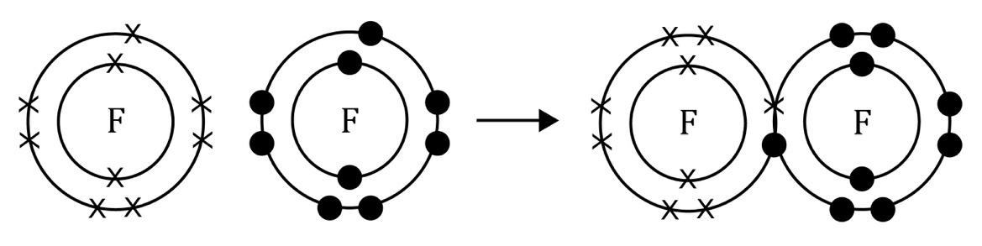
Guidance: The common misconceptions that learners have when drawing diagrams to represent covalent bonds are only showing one electron being shared and adding extra electrons for sharing. Encourage them to count the number of electrons in the outer shells to check they do not exceed the permitted number for that shell, ensuring that the shared electrons are counted for both atoms.

Covalent bonding: what do I understand?
Mini-topic | Assessed via:
I can interpret diagrams representing covalent bonds. | Q1.1
I know that electrons are shared in covalent bonds. | Q1.2, Q1.2, Q2,4, Q3.1
I know the types of elements involved in covalent bonds. | Q1.2, Q2.1, Q2.3
Feeling confident? topics | Assessed via:
I can complete a diagram to represent the formation of a covalent bond | Q3.1

