Reaching dynamic equilibrium: storyboard

Learning objectives
- State what a reversible reaction is.
- Describe how a reversible chemical reaction reaches dynamic equilibrium.

Introduction

Most chemical reactions you have studied so far are irreversible, where the reaction only takes place in one direction.

However, many chemical reactions are reversible: the products can react together to reform the original reactants. The forwards reaction and the reverse reaction are both occurring.

In dynamic equilibrium, the forwards reaction and reverse reaction occur at the same rate in a closed system. The concentrations of substances at equilibrium are constant, they are not changing.

True or false? Checking understanding
Q. | Statement | True or false?
 | Combustion is an example of an irreversible reaction.
 | The symbol for a reversible reaction is .
 | Products must be allowed to leave the flask in a reversible reaction.
 | A reversible reaction can only reach dynamic equilibrium in a closed system.
 | A reaction at equilibrium has stopped.
 | At equilibrium, the rate of the forwards reaction is equal to the rate of the reverse reaction.
 | If a reaction is at equilibrium, it means that all reactants have been fully converted into products.
 | A system at equilibrium will show measurable changes in the concentrations of reactants and products over time.
 | If the forwards reaction is exothermic, then the reverse reaction will be endothermic.

Instructions

Create a storyboard to describe how a chemical reaction reaches dynamic equilibrium. A storyboard contains an illustration and a short section of text underneath to describe what is happening in the picture. The storyboard shows a sequence of events.

What does a storyboard look like?

Use the table to show how the stages progress:
1 | 2 | 3 | 4
5 | 6 | 7 | 8

Complete the cloze activity on the storyboard sheet. Choose from the keywords in the box below:

Keywords
☐ carbon dioxide ☐ closed ☐ combustion
☐ concentrations ☐ decrease ☐ equal
☐ equilibrium ☐ forwards ☐ increase
☐ irreversible ☐ leave ☐ oxygen
☐ products ☐ rate ☐ reacting
☐ reversible ☐ product ☐ time

Complete the storyboard. Use the keywords to fill in the gaps below.
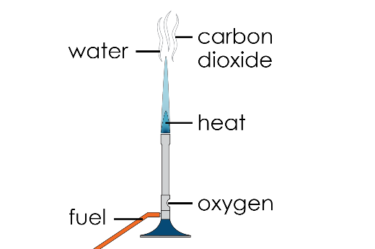 | 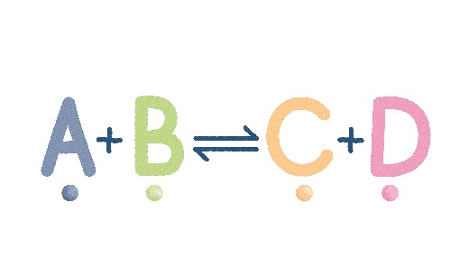 | Forwards reaction:  A + B $→$ C + D  Reverse reaction:  C + D $→$ A + B | 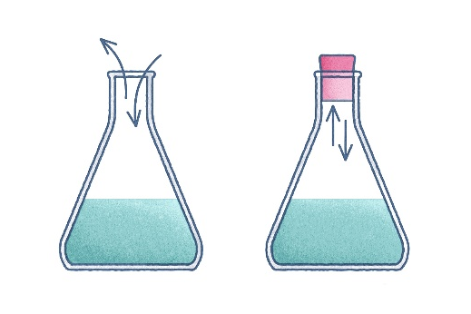
___________________ is an example of an __________________ reaction, where a fuel reacts with _____________ to form ___________ _____________ and water. | Many chemical reactions are ___________________, where the ___________________ can react together to reform the original reactants. | In a reversible reaction, the _______________ reaction and the reverse reaction are occurring at the same ________________. | For a reversible reaction to reach equilibrium, nothing must enter or _________________ the flask. This is called a _________________ system.
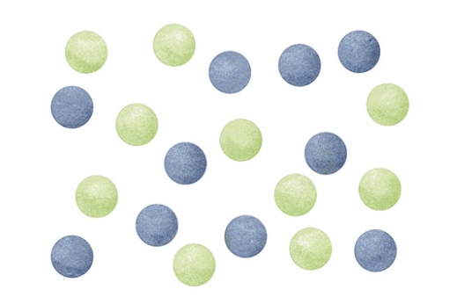 | 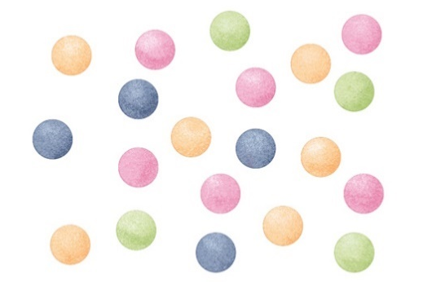 | 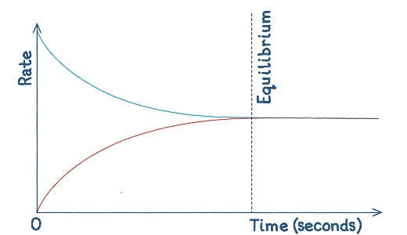 | 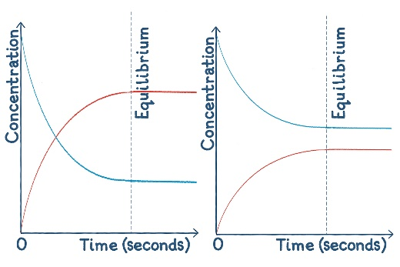
At the beginning of the reaction, the __________________ of A and B are at their highest, therefore the _________________ of the forwards reaction is the highest. | When A and B react, their concentrations ___________________ , decreasing the rate of the forwards reaction. The reaction produces C and D, so their concentrations ____________________, increasing the rate of the reverse reaction. | Eventually, the rates of the forwards and reverse reaction become __________________ and ___________________ is reached. | Particles are still ________________, but as A and B react to produce C and D, another C and D react to produce A and B, maintaining a constant ____________________.

Use the keywords to fill in the gaps below. Choose the illustration from the support sheet.
___________________ is an example of an __________________ reaction, where a fuel reacts with _____________ to form ___________ __________ and water. | Many chemical reactions are ___________________, where the ___________________ can react together to reform the original reactants. | In a reversible reaction, the _______________ reaction and the reverse reaction are occurring at the same ________________. | For a reversible reaction to reach equilibrium, nothing must be able to enter or _________________ the flask. This is called a _________________ system.
At the beginning of the reaction, the __________________ of A and B is at its highest, therefore the _________________ of the forwards reaction is the highest. | When A and B react, their concentrations ___________________ , decreasing the rate of the forwards reaction. The reaction produces C and D, so their concentrations ____________________, increasing the rate of the reverse reaction. | Eventually, the rates of the forwards and reverse reaction become __________________ and ___________________ is reached. | Particles are still ________________, but as A and B react to produce C and D, another C and D react to produce A and B, maintaining a constant ____________________.

Support sheet

Use these images to complete the storyboard. You will need to put them into the correct order in the sequence.
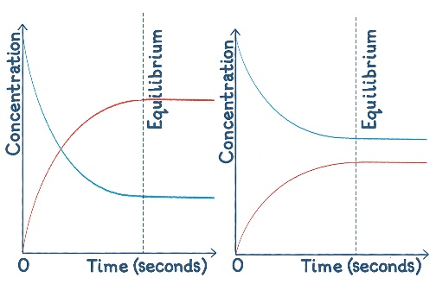

Forwards reaction:

A + B $→$ C + D

Reverse reaction:

C + D $→$ A + B

