Quantitative chemistry: teacher guidance

This resource forms part of the Review my learning series from the Royal Society of Chemistry. Additional support for addressing misconceptions identified using these worksheets can be found at rsc.li/3mm0IeW.

These worksheets assess content from the 11–14 and 14–16 specifications. They can be used to identify learners’ knowledge gaps and misconceptions following the completion of that part of the curriculum.

The Quantitative chemistry worksheets cover the following topics:
- atoms and molecules
- elements and compounds
- reactants and products in a chemical equation
- simple chemical formula
- law of conservation of mass
- writing simple word equations
- writing simple balanced symbol equations
- calculating the mass of a reactant or product in a chemical reaction given all other reacting masses.

If learners successfully answer questions on these topics, they can attempt the extension questions. These cover:
- using the Periodic table to find the relative atomic masses of named elements
- calculating relative formula mass.

Level 1 () is a scaffolded worksheet in which learners select words from a word list to complete sentences. Level 2 () is partially scaffolded worksheet in which learners complete sentences. Level 3 () is an unscaffolded worksheet in which most of the tasks involve answering questions with a minimum of prompts.

The worksheets can be used in a variety of ways:
- as an assessment of learners’ knowledge at the beginning or end of a period of teaching – the level of the worksheet used can be matched to the ability of the learners
- as an assessment of knowledge during a period of teaching and after learners have completed the relevant section of the specification
- as a revision tool prior to the relevant examination
- as a refresher exercise for teachers or non-subject specialists.

There is also scope to increase the level of the worksheets used as learners progress through the curriculum.

The ‘What do I understand?’ page is common to all levels of worksheet and can be used both to identify areas needing whole class attention and as an indicator for learners to help guide their revision.

The Teacher guidance provides model answers for each level and guidance on learners’ misconceptions. Learners can use the model answers to self- or peer assess.

Answers

Quantitative chemistry: knowledge check
- scaffolded/partially scaffolded/unscaffolded

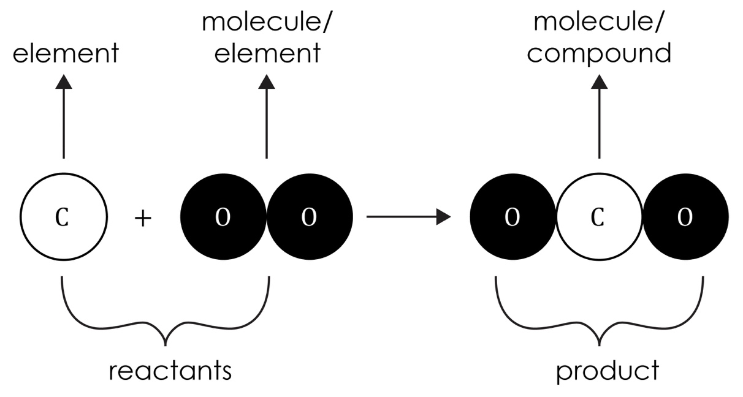
Guidance: There is a choice of labels here. Learners can label either of the three substances as molecule and either oxygen or hydrogen as element. More able learners will recognise there are alternatives. A common misunderstanding is thinking that all molecules are compounds and that all elements consist of uncombined atoms. The use of molecular model kits may help to reinforce ideas.

- scaffolded/partially scaffolded

The diagram in question 1.1 shows an equation summarising a reaction.
The products can be found on the right-hand side of the arrow. The reactants can be found on the left-hand side of the arrow. The reactants are hydrogen and oxygen.

unscaffolded
  - left-hand side
  - right-hand side
Guidance: Learners simply need to remember that reactants are on the left and that products are on the right. Everyday use of these words may help learners deduce their application here.
- scaffolded/partially scaffolded

The formula of the hydrogen molecule is H₂. The formula of the oxygen molecule is O₂. The formula of the water molecule is H₂O. Both the reactants are elements that contain one type of atom only. The product is a compound, which is a substance made up of two (or more) different atoms bonded together.

unscaffolded
  - hydrogen and oxygen
  - water
  - one
  - two or more
Guidance: The use of subscripts in formulas may need reinforcing as it is becoming everyday practice not to use them, such as in O2. Learners need to realise that a compound may contain, and usually does, more than two types of atom.

- scaffolded/partially scaffolded/unscaffolded

During a chemical reaction, atoms are neither created nor destroyed. Instead, the atoms are just rearranged to form a new substance. This means that the total mass of the products will be the same as the total mass of the reactants.
In this example, there are four atoms of hydrogen and two atoms of oxygen on both sides of the arrow. The equation is balanced and shows that the mass is conserved. The total mass stays the same during a chemical reaction. This is the law of conservation of mass.
Guidance: Molecular model kits can be used to reinforce these ideas. Learners can use models to make the reactants, then rearrange them to make the product, as in the equation.
The question assumes 100% yield, which never happens in reality. Some learners may be aware of this. However, it can be pointed out to learners that the total mass always stays the same.
There may be a conflict with some religions about the creation of matter.
This may need to be dealt with sensitively.

Quantitative chemistry: test myself
- scaffolded/partially scaffolded/unscaffolded

There are two atoms of hydrogen and one atom of oxygen in one molecule of water.
Guidance: Learners need to understand the use of subscripts in a chemical formula. Subscript 2 only applies to the atom immediately before the 2. There can be confusion when large numbers are used at the beginning of a formula in an equation, such as 2NH₃. Here, 2 doubles up the whole formula.
- scaffolded/partially scaffolded/unscaffolded

hydrogen + oxygen → water
Guidance: This a relatively simple word equation and there are several clues in previous questions. Learners may find that some sources still use a ‘=’ instead of ‘→’. The use of an arrow may need reinforcing.
- scaffolded/partially scaffolded/unscaffolded
H₂
Guidance: If learners do not read the question properly, they may miss the word ‘molecule’ and write H. Learners need to clearly show the 2 as a subscript. Many will write it as half-way between subscript and a large number.
- scaffolded/partially scaffolded
O₂
Guidance: See question 2.3.

unscaffolded
2H₂ + O₂ → 2H₂O
Guidance: The use of large numbers and subscripts causes problems for many learners. Using diagrammatic representation as in question 1.1, or molecular models, can help learners to visualise the equation. Some learners find writing the numbers of each type of atom underneath the formulas helpful.

- scaffolded/partially scaffolded
2H₂ + O₂ → H₂O
Guidance: See question 2.4, unscaffolded.

unscaffolded

During a chemical reaction, atoms are only rearranged; they cannot be lost and new ones cannot be made.
Guidance: Many learners will find it difficult to put these ideas into words, despite understanding the concept. Prompts may be required. Some learners may be aware that new atoms are made in the stars. These are nuclear reactions in which the nuclei of two smaller atoms fuse to create a new atom. Chemical reactions only involve the rearrangement of electrons in atoms.
There may be a religious conflict with the idea of creating matter, which will need to be handled sensitively.
- scaffolded/partially scaffolded

During a chemical reaction, atoms are only rearranged; they cannot be destroyed, and new ones are not made.
Guidance: There may be a religious conflict with the idea of creating matter, which will need to be handled sensitively.

unscaffolded
CH₄ + 2O₂ → CO₂ + 2H₂O
Guidance: See question 2.5, unscaffolded.
- scaffolded/partially scaffolded/unscaffolded
4 g + 32 g = 36 g
Guidance: These are reacting amounts in this question. Learners may find out how to calculate these in their GCSE or equivalent course. Some learners may realise that arbitrary amounts of reactants do not necessarily react exactly.
For example, 4 g hydrogen will not react with 8 g oxygen to give 12 g water because there is insufficient oxygen for the hydrogen to react with.

- scaffolded/partially scaffolded/unscaffolded
20 kg + 160 kg = 180 kg
Guidance: See question 2.7.
- scaffolded/partially scaffolded
54 g – 48 g = 6 g
Guidance: See question 2.7.

unscaffolded

8 protons
Guidance: Learners need to know that the atomic number equals the number of protons or electrons in one atom of an element. They can find atomic numbers in their Periodic table. Some will confuse the information provided by an atomic number with that provided by its relative atomic mass.
- scaffolded/partially scaffolded
28 g + 22 g = 50 g
Guidance: See question 2.7.

unscaffolded

8 neutrons
Guidance: Learners need to know that the number of neutrons in an atom
= mass number – atomic number. For oxygen, this is 16 – 8 = 8.

Quantitative chemistry: feeling confident?
- scaffolded/partially scaffolded/unscaffolded
Element | Symbol | Relative atomic mass
hydrogen | H | 1
oxygen | O | 16
chlorine | Cl | 35.5
carbon | C | 12
nitrogen | N | 14
iron | Fe | 56
sodium | Na | 23
magnesium | Mg | 24
copper | Cu | 63.5
sulfur | S | 32

Guidance: This is a fairly straightforward exercise, provided learners know which numbers are atomic numbers and which are relative atomic mass values. Most Periodic tables have a key that learners can use to identify the numbers.

- scaffolded/partially scaffolded/unscaffolded
Compound name | Chemical formula | Calculation | Relative formula mass
water | H₂O | (2 × H) + (1 × O)  (2 × 1) + (1 × 16) | 18
sodium chloride (salt) | NaCl | (1 × Na) + (1 × Cl)  23 + 35.5 | 58.5
carbon dioxide | CO₂ | (1 × C) + (2 × O)  12 + (2 x 16) | 44
methane | CH₄ | (1 × C) + (4 × H)  12 + (4 × 1) | 16
ammonia | NH₃ | (1 × N) + (3 × H)  14 + (3 × 1) | 17
copper sulfate | CuSO₄ | (1 × Cu) + (1 × S) + (4 × O)  63.5 + 32 + (4 × 16) | 159.5
glucose | C₆H₁₂O₆ | (6 × C) + (12 × H) + (6 × O)  (6 × 12) + (12 × 1) + (6 × 16) | 180
sodium carbonate | Na₂CO₃ | (2 × Na) + (1 × C) + (3 × O)  (2 × 23) + 12 + (3 × 16) | 106
magnesium hydroxide | Mg(OH)₂ | (1 × Mg) + (2 × O) + (2 × H)  = (1 × 24) + (2 × 16) + (2 × 1) | 58
ammonium sulfate | (NH₄)₂SO₄ | (2 × N) + (8 × H) + (1 × S) + (4 × O)  (2 × 14) + (8 × 1) + 32 + (4 × 16) | 132

Guidance: Learners need to understand the use of subscript numbers in chemical formulas to deduce the correct calculation. Simple computation skills are required, involving the use of brackets. Learners who use calculators may have problems adding numbers in brackets, with either standard or scientific calculators.
In the example given for magnesium hydroxide, ensure that learners realise that the ‘O’ represents the symbol for oxygen and is not the number zero.

Quantitative chemistry: what do I understand?
Mini-topic | Assessed via:
I understand that all substances are made up of atoms and molecules. | 1.1 (partially)
I can identify elements and compounds. | 1.1, 1.3
I can identify reactants and products in a chemical equation. | 1.1, 1.2, 1.3
I can write simple chemical formulas. | 1.3,  2.1, 2.3, 2.4
I can understand and use the law of conservation of mass. | 1.4  2.6
I can write simple word equations. | 2.2
I can write simple balanced symbol equations. | 2.5
I can calculate the mass of a reactant or product in a chemical reaction given all other reacting masses. | 2.7, 2.8, 2.9, 2.10
Feeling confident? topics | Assessed via:
I can use the Periodic table to find the relative atomic masses of named elements. | 3.1
I can calculate relative formula mass. | 3.2

