Structure determination

Learning objectives
- Analyse and interpret infrared, ¹³C NMR and ¹H NMR spectra
- Suggest chemical structures based on spectral evidence

Activity

Below are the skeletal structures for 7 compounds.

Decide which set of spectra sets A-G from the following pages belong to each compound.
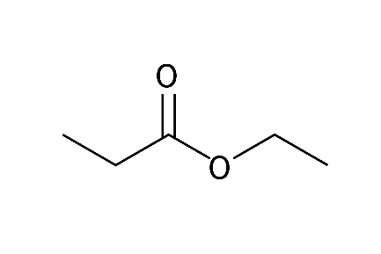  ethyl propanoate  Spectra set _____ | 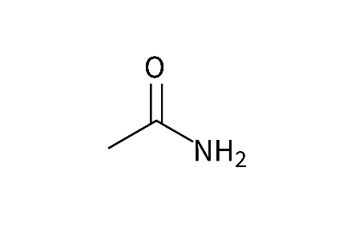  ethanamide  Spectra set _____ | 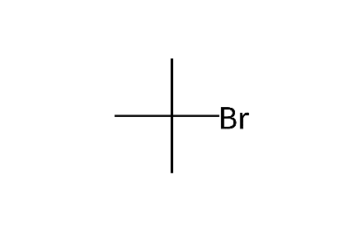  2-bromo-2-methyl propane  Spectra set _____
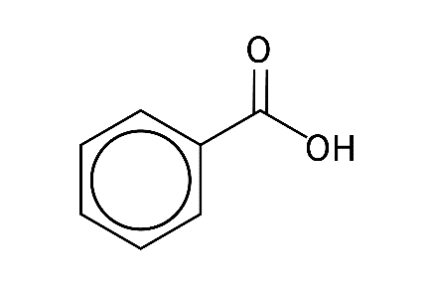  benzoic acid  Spectra set _____ | 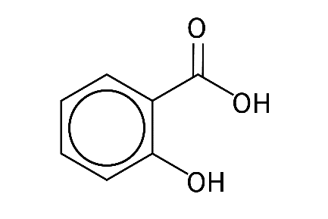  2-hydroxybenzoic acid  Spectra set _____ | 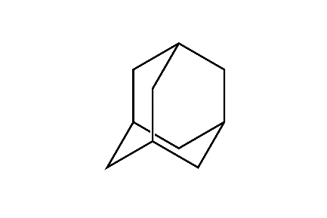  adamantane  Spectra set _____

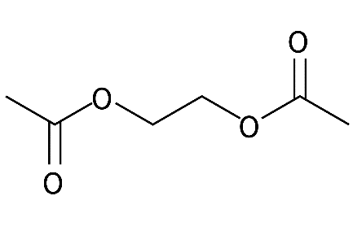
1,2-diacetoxyethane

Spectra set _____

Before you begin read the Helpful information on the next page.

Make sure you have a data book or sheet available to help you identify key bonds and groups present.

Helpful information
- In the ¹H NMR the relative height of the red line shows the integration of each of the peaks. Where peaks are split a zoomed in section of the spectrum is given to show the splitting pattern.

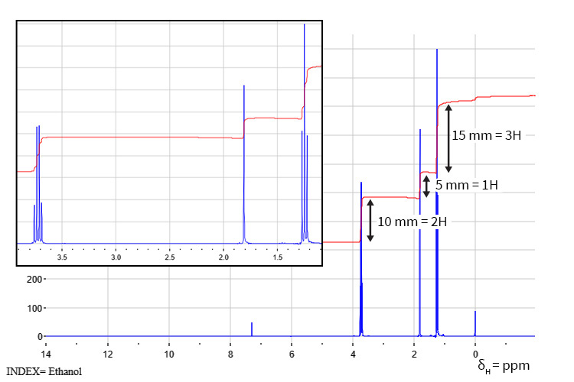

- These are real spectra so in some instances small peaks of impurities are seen.

- You may also see peaks owing to the solvent used to dissolve the sample.

CDCl₃ δ_{C} 77 ppm (three lines 1:1:1) and δ_{H} 7.25 ppm

DMSO δ_{C} 39.5 ppm (septet) and δ_{H} 2.50 ppm (quintet)

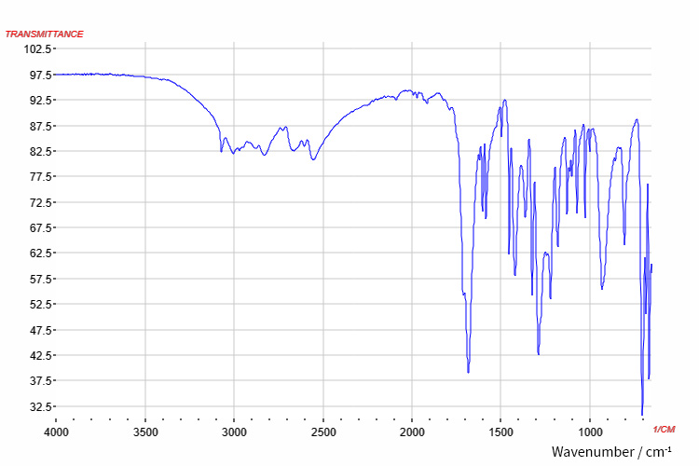
Spectra set A

Infrared

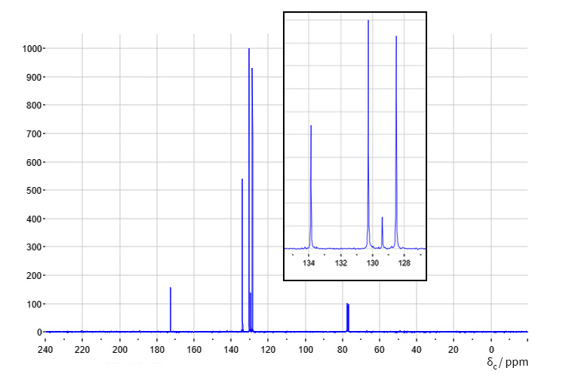

¹³C NMR

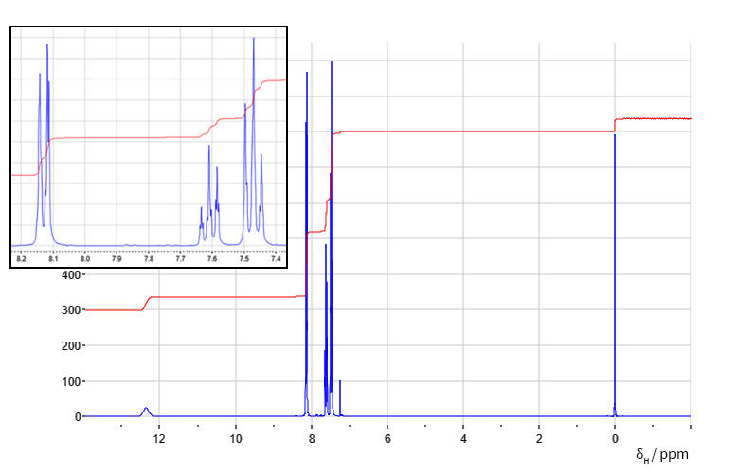

¹H NMR

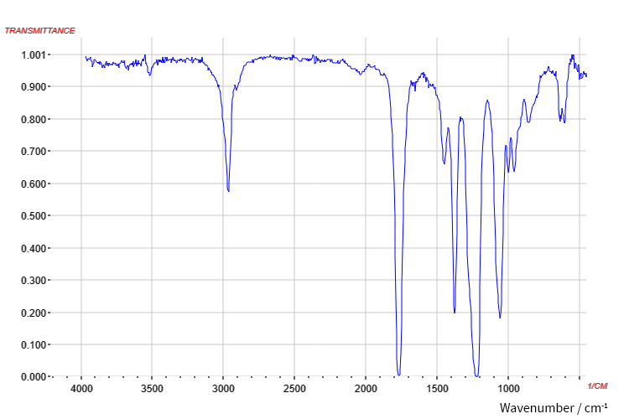
Spectra set B

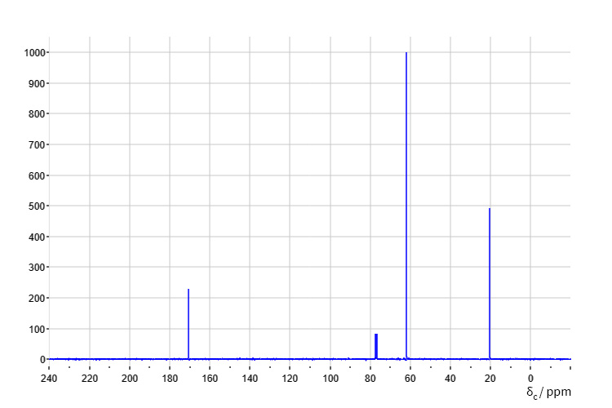
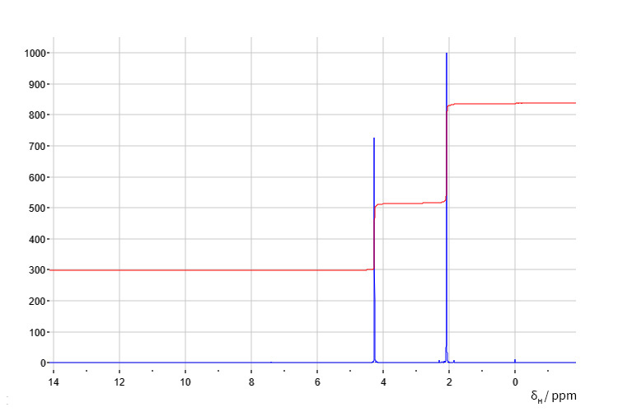
Infrared
¹³C NMR
¹H NMR

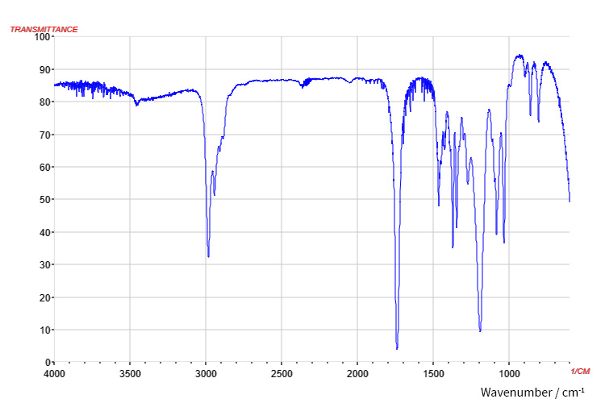
Spectra set C

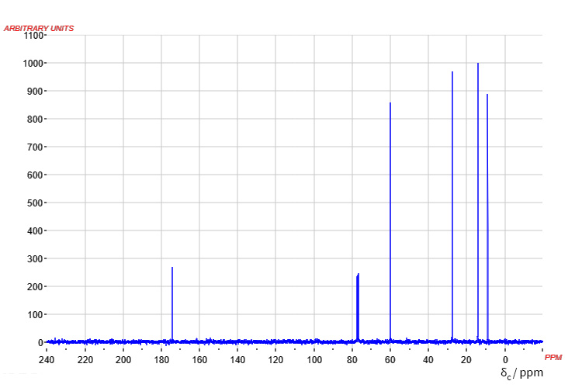
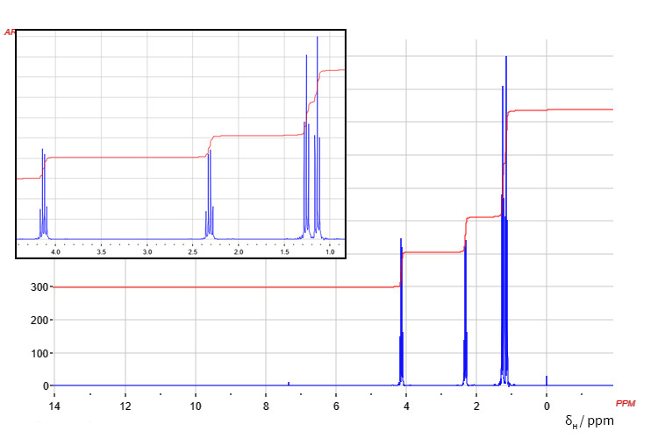
Infrared
¹³C NMR
¹H NMR

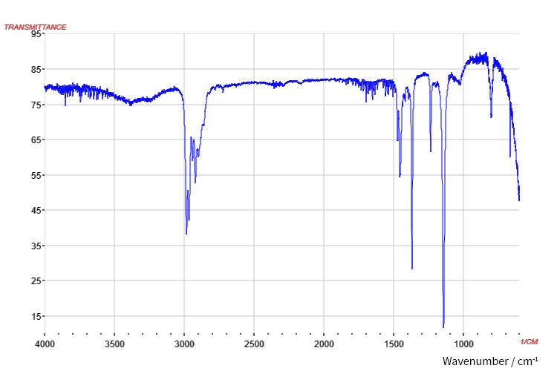
Spectra set D

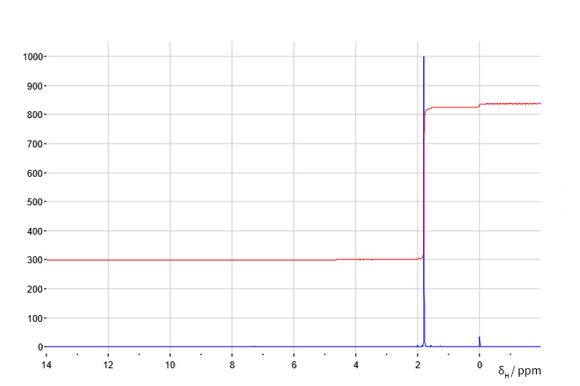
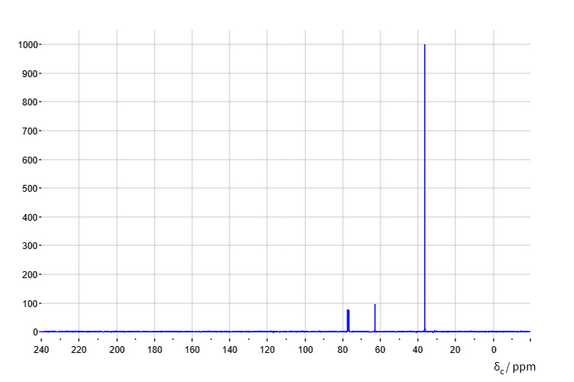
Infrared
¹³C NMR
¹H NMR

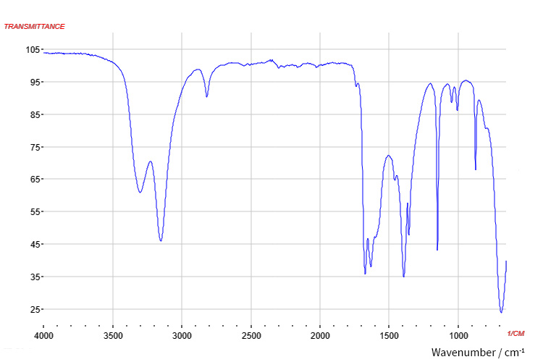
Spectra set E

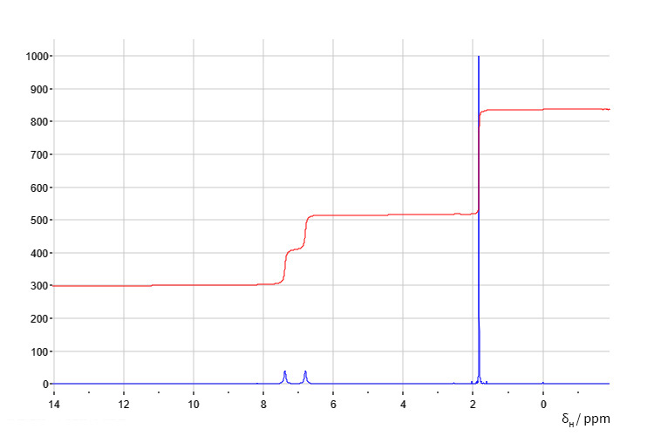
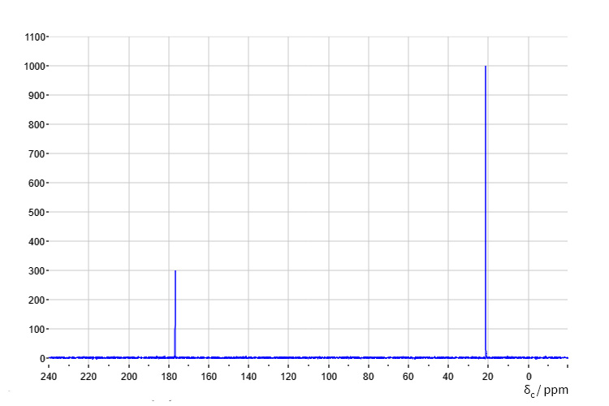
Infrared
¹³C NMR
¹H NMR

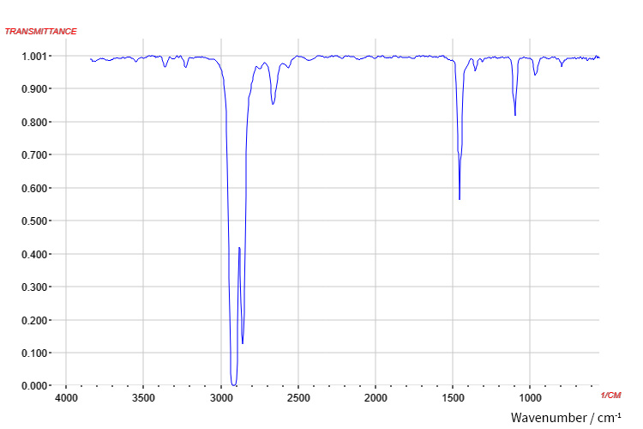
Spectra set F

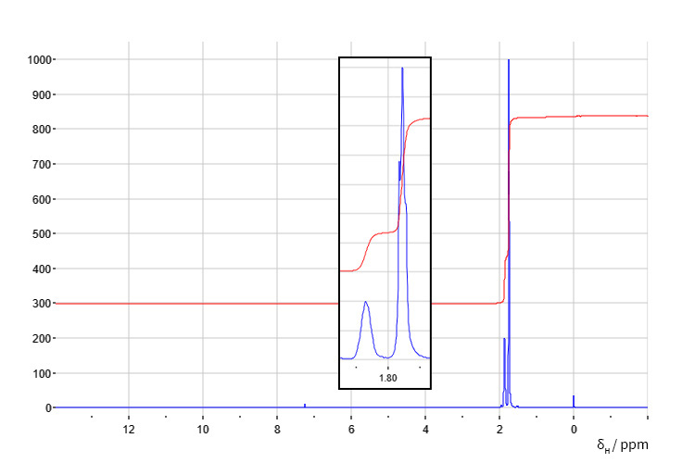
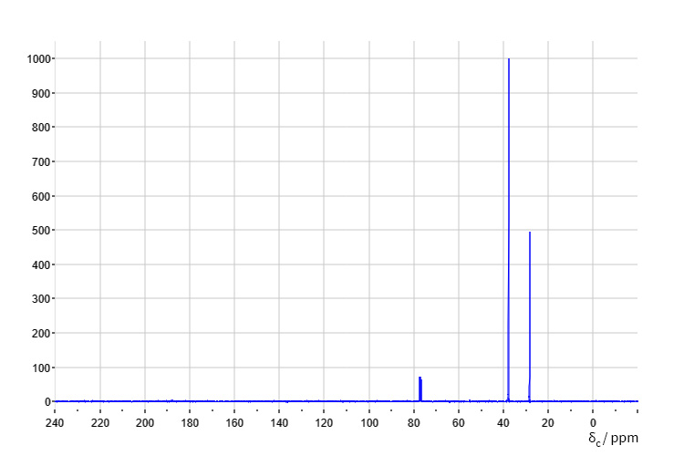
Infrared
¹³C NMR
¹H NMR

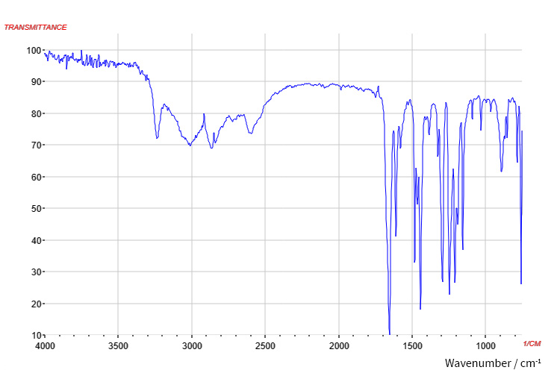
Spectra set G

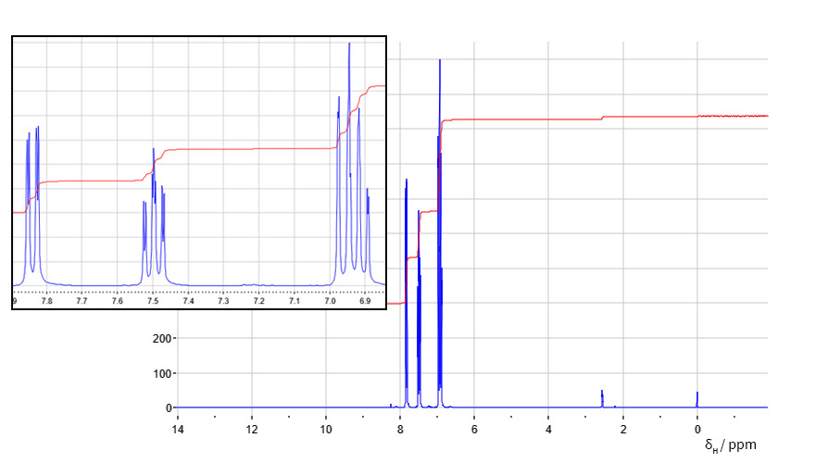
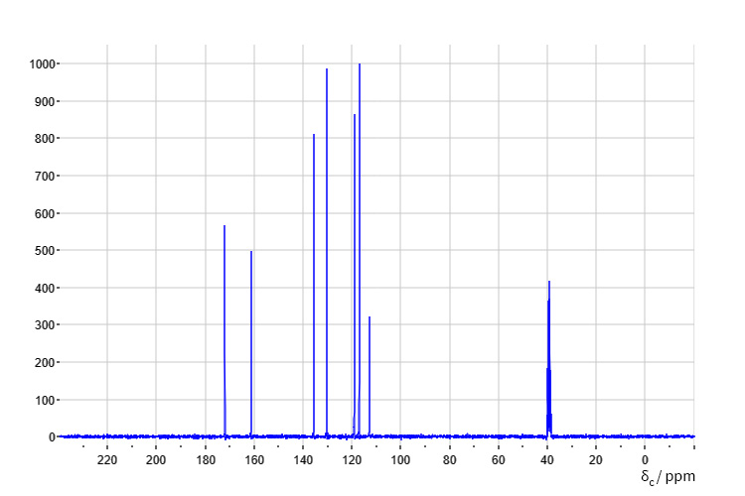
Infrared
¹³C NMR
¹H NMR

