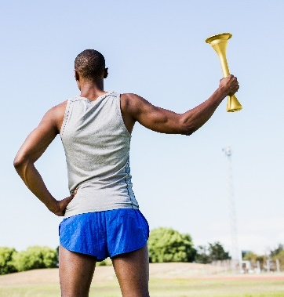
- The torch used to start the modern Olympic Games uses a mixture of propane and butane.
When propane and butane burn in air, they produce heat energy, and a flame.
- Propane and butane are chemical compounds.
Name the two elements that make these compounds.
Source: Envato Elements

- State the name of the compounds that contain the elements in part a).

- To which homologous series do propane and butane belong?

- Below are the incomplete molecular structures for propane and butane.
Complete these structures.

Butane
Propane

- Using your answers to part d), explain what is meant by the word ‘saturated’.

- When propane and butane burn in air, the same two products are made in each case.
State the names of the products formed.

- Complete the word equation to show what happens when these gases burn in air:

Propane + oxygen + .

Butane + + .
- The chemical formula for propane is C₃H₈.
Complete the symbol equation below to show propane burning in air.
C₃H₈ + 5O₂ + H₂O

The ratio in which propane and butane are mixed together as a fuel in the torch (by volume) is 2 : 1.
- What fraction of the fuel is butane?

- An Olympic torch contains 37.8 cm³ of fuel.
Calculate the volume of butane in the fuel.
Show your working.

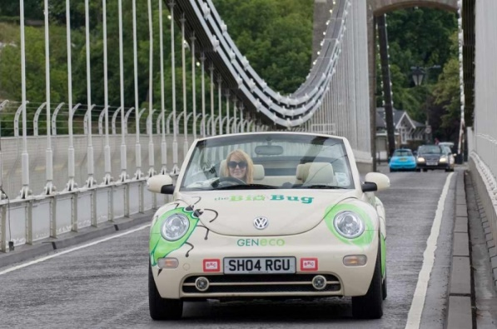
- The image to the right shows a car called the ‘Bio-Bug’.
You can find out more at www.geneco.uk.com/Case_study_Bio_bug/.
Solid human waste decomposes to make a gas that powers the car.
This gas is a hydrocarbon containing only one carbon atom.
The gas is the first member of the alkane homologous series.
Source: Wessex Water
- What is the name of the gas?

- State the chemical formula for the gas.

- Explain how the gas powers the car.

- Complete the symbol equation to show the gas burning in air.
+ oxygen + water
- Suggest why this car is considered to be more environmentally friendly, or ‘greener’, than a car that runs on petrol or diesel.

- When 16.0 g of methane burns, 890 kJ of heat energy is produced.
Calculate how much heat energy is produced when 1.00 kg of methane burns.
Give your answer in MJ and to 3 significant figures.
Show your working.

